**Archain — A New Kind of History in the Making**

[](https://arweave.medium.com/?source=post_page-----fd26cf00024e--------------------------------)

[The Arweave Project](https://arweave.medium.com/?source=post_page-----fd26cf00024e--------------------------------)

[Oct 4, 2017·3 min read](https://arweave.medium.com/archain-a-new-kind-of-history-in-the-making-fd26cf00024e?source=post_page-----fd26cf00024e--------------------------------)

I recently had the pleasure of visiting the British Museum. One of my favourite parts of the museum is the wing on Mesopotamia — to my mind the cradle of civilisation. The department that curates this wing houses the largest and most important collection of Cuneiform tablets in the world, with around 130,000 tablets in total. Developed by the Sumerians of Mesopotamia c. 3500 BCE, Cuneiform is one of the earliest systems of writing and scripts used to convey language. Of particular note to me was a collection of over 30,000 clay tablets named “*The* *Library of Ashurbanipal*”. Predating the Library of Alexandria, the Library of Ashurbanipalrepresents, what is speculated to be the earliest library of all of human knowledge — a *Universal Library*. The most well known document in the Library of Ashurbanipalis a twelve tablet copy of *The Epic of Gilgamesh*, widely regarded to be the earliest surviving great work of literature.

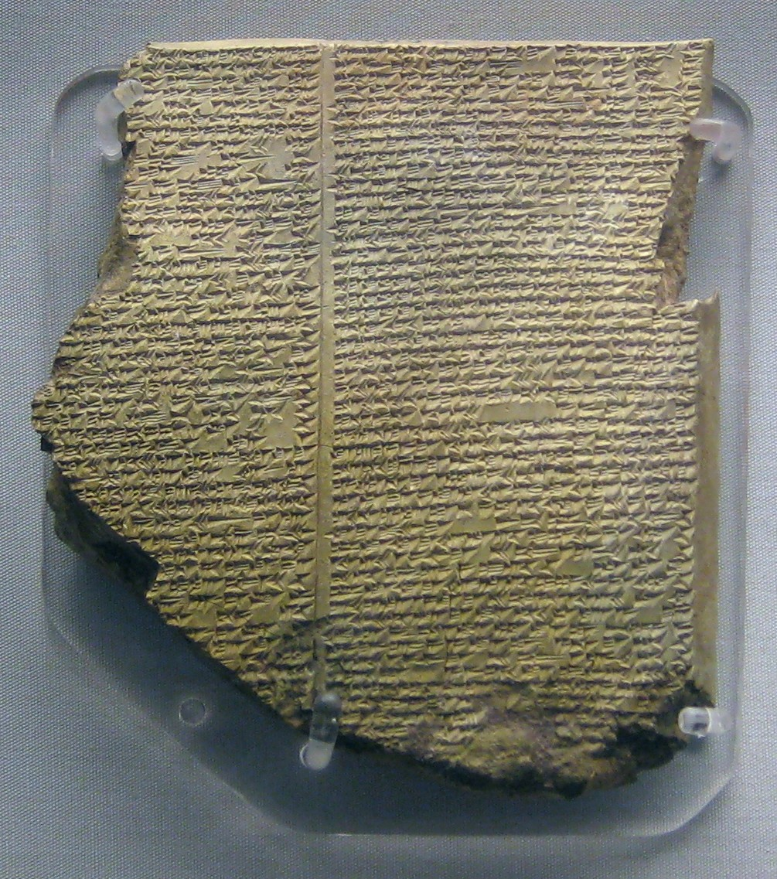

Tablet 11 of the Epic of Gilgamesh, part of the Library of Ashurbanipal (source: Wikipedia).

Seeing the Library of Ashurbanipal, I was struck by the parallels between it and what *Archain* is attempting to do. For as long as information encoding in terms of script has been around, Humans have been trying to store information for long periods of time. While, of course, it is incredibly impressive that the tablets that comprise the Library have survived over five millennia, they are fundamentally impermanent. However, we believe that the digital age and the internet at last affords us the technology to provide a solution to true permanent information storage at a wholesale level. By financially incentivising the mass storage of rare knowledge in a decentralised, distributed and verified fashion, it is indeed conceivable that Archain could be the platform on which the next Universal Library is built.

The digital archiving that Archain supports provides benefits over archives of physical media in a number of ways. The principal and most obvious was is that, while traditional media can be subject to destruction, information on the Archain cannot be destroyed. The use of our *Blockweave* data structure, a blockchain derivative, cryptographically ensures it is impossible to destroy archived data. Furthermore, the decentralisation and redundant data storage inherent to the use of the Blockweavemeans there is no central authority or source of data — further securing the Archive by avoiding the creation of any weak point. Cryptographic verification also means that the data cannot be vandalised, forged or otherwise mutated. This has particular implications for censorship and freedom of expression — once data is on the Archain *it cannot be altered*.

Not only does the Archain provide the infrastructure for true permanent information archiving, once populated, it yields access to new information in an novel manner — as a live feed of hand picked information that users find historically important, valuable or worthy of storage in some way. This abstract notion of having access to information that someone finds important enough to pay a small amount to store, in a live stream could have an unprecedented effect on data mining and trend prediction in terms of Geopolitics, stocks and shares and language and culture. Over time, as the resources on the weave expand, Archain will become the trustworthy oracle of history on the internet. As the internet is not just a resource of abstract knowledge but also a catalogue of human events and culture, Archain will naturally come to represent a store of human experience, politics and understanding over time.

The Library of Ashurbanipal represents the pinnacle of the world’s contemporary technology in terms of information storage. We hope that Archain will become the next logical step in the precedent set by the *Library*, millennia ago.

For more information on the Archain project, visit us at [archain.org](https://www.archain.org/), find us on [twitter](http://twitter.com/ArchainTeam/) or [email](mailto:team@archain.org) the team.

-archain-jon

**NO-VLNS: Simulating huge Archain networks on a single machine**

[](https://arweave.medium.com/?source=post_page-----d34bccf5045b--------------------------------)

[The Arweave Project](https://arweave.medium.com/?source=post_page-----d34bccf5045b--------------------------------)

[Oct 4, 2017·2 min read](https://arweave.medium.com/no-vlns-simulating-huge-archain-networks-on-a-single-machine-d34bccf5045b?source=post_page-----d34bccf5045b--------------------------------)

A novel component of the Archain project is our large-scale network simulation framework, with which one can test the behavior of an Archain network at-scale (including time-stretching), inside a single machine. We called this system NO-VLNS (The **N**ever **O**ff-**V**ery **L**arge **N**etwork **S**imulator). Enabled by the use of Erlang, to the best of our understanding it is the first time a blockchain technology startup has provided a tool to run full simulations at this scale, inside a single machine. NO-VLNS affords us the ability to launch hundreds of simultaneous runs with varied conditions, exposing 1 in a million emergent behaviour bugs before the private network phase even begins.

The architecture of the framework is as follows: the suite of tests are managed by a supervisor that launches predefined tests that run in parallel. Each test has an associated monitor that provides status updates and performs logging of simulated events. Should a test fail, the monitor logs the reason why and the supervisor re-launches the failed test. Tests themselves comprise launching simulated Archain users (clients) and miners (nodes) that interact with one another.

Tests are defined by a record that contains definitions of network properties and environment variables. In this way, we are able to define a network in terms of clients and miners and their connections as well as simulate realistic networks by defining factors such as latency, transfer speeds and the probability of packet loss over a network.

Through defining several of these network test records we are able to simulate a wide range of varied networks that run continuously, in parallel, until stopping and logging salient information upon exposing a bug. We are running a suite of tests every evening after integrating the days development work into production code.

In addition to this, we also have defined a number of smaller, static tests that test for specific behaviour (including fork recovery, double spending attacks, etc). In this way, we are able to comprehensively verify the correct functioning of a network in a general manner and for fine-grained, edge case behaviour.

You run the tests yourselves by checking out the [Archain Github](https://github.com/ArchainTeam/archain) repository and running make test_networks. The network definitions themselves are defined in src/ar_network_tests.hrl.

-archain-devs

**TNT — Exploding edge case bugs**

[](https://arweave.medium.com/?source=post_page-----42a36c36f15e--------------------------------)

[The Arweave Project](https://arweave.medium.com/?source=post_page-----42a36c36f15e--------------------------------)

[Oct 6, 2017·1 min read](https://arweave.medium.com/tnt-exploding-edge-case-bugs-42a36c36f15e?source=post_page-----42a36c36f15e--------------------------------)

Along with *NO-VLNS* (see our [blog](https://medium.com/@archain/no-vlns-simulating-huge-archain-networks-on-a-single-machine-d34bccf5045b)), *TNT* (**T**iny **N**etwork **T**ests) is the other half of Archain’s testing framework. While the strength of NO-VLNS is in the broadband nature of its bug detection in terms of being able to run large, time-scaled network simulations, TNT takes a fine-grained approach for the testing of specific, edge case behaviour. These two approaches combined yield a framework for comprehensive network testing.

TNT utilises *EUnit*, a unit testing system for Erlang, along with core, highly abstract, Archain network manipulation functions and network simulation abilities. The use of EUnit allows for a lightweight and unobtrusive means of easily launching tests while using the core Archain functions allows us to define a precise, non-automined test for specific behaviour without unnecessary overhead.

Below is an example test that can be found in ar_node.erl that sets up a network, mines a block, causes a node to forget the block and tests that a truncated node can still verify and accept new blocks correctly. The testis one of many designed to make sure sharding works correctly.

In this way, it is easy to build up a large library of tests that ensures that core functionality runs as expected.

You can run the tests yourself by checking out the Archain Github repository and running make tnt.

-archain-devs

# Measuring Semantic Drift on the Archain

[](https://arweave.medium.com/?source=post_page-----7229ecc9c029--------------------------------)

[The Arweave Project](https://arweave.medium.com/?source=post_page-----7229ecc9c029--------------------------------)

[Oct 13, 2017·5 min read](https://arweave.medium.com/measuring-semantic-drift-on-the-archain-7229ecc9c029?source=post_page-----7229ecc9c029--------------------------------)

# Semantic Drift

Traditionally, linguistic expressions have been viewed as meaningful because they relate to real world concepts in some objective manner. However, since modern linguistics and semiotics, it has been widely accepted that words and expressions are subjective and can drift in meaning and semantic interpretation over time. This evolution of the meaning and usage of words over time is known as Semantic Change or Semantic Drift.

A word or expression can undergo semantic drift in a number of ways, such as semantic expansion where a word comes to mean something broader than its prior meaning (e.g. middle english bridde meaning `small bird’ which has come to be the broader word bird.) or semantic restriction, the inverse of expansion, as in the middle english word mete and modern english meat.

Semantic drift is of course, a key interest in linguistics. However, its applications and usage go far beyond the academic. By being able to track and chart the usage and interpretation of words pertaining to business marketing, branding, company names etc. it is possible to gain novel and valuable, **quantitative insight into public perception of these words or concepts and make predictions about future public perception**. For example, being able to establish cultural codings (broadband public understanding and perception) of motorcyclists was essential to the [Department for Transport](http://www.signsalad.com/semiotics-explained/case-studies/case-studies-dft/)’s motorcycle awareness campaign[1] in terms of the cultural re-encoding of motorcycle riders in their advertising. Not only is it useful in this capacity but being able to **perform prediction about usage of business branding material** could provide a warning of negative association or predicted negative association allowing the business to counter the negative shift early.

By providing access to a real-time stream of history, The Archain presents an ideal platform to analyse and assess cultural codings, semantic drift and make predictions about future perceptions of words or expressions.

# Archain as a Platform for Measuring Semantic Drift

Archain is a distributed, permanent and cryptographically verified archive of information. Once populated, it yields access to new information in an novel manner — as a live feed of hand picked information that users find historically important, valuable or worthy of storage in some way. Data is stored on a sharded blockchain (the Blockweave )[2]- a cryptographically linked chain of blocks containing the information users desire to be stored. After a block is mined, the data in its transactions becomes available.

This real-time access to historical information allows for a real-time interpretation and analysis of history in terms of data stored in the block. An Archain monitor application built with the Application Developer Toolkit would provide a straightforward means of access to data in this way. You can find a video tutorial on how to build a simple monitor on our [youtube channel](https://www.youtube.com/watch?v=5-NvS-wgdTw).

Given that the change of any one word is independent and unaffected by the changes of other words, measuring semantic drift appears to be a prime candidate for the use markov chains to model and perform predictions about semantic drift.

# Mathematical Outline

The first step in performing the analysis is to transform the expression in question into a word cloud. A word cloud is a set of items, generated over a number of blocks, that relate to the expression in terms of connotation and denotation.

For example, a small word cloud for the word `car’ might be {`wheels’, `engine’, `fast’, `polluting’}. Note that the words in the cloud contain words without positive or negative association e.g. `wheels’ and words that may have positive or negative associations: `fast’, `polluting’.



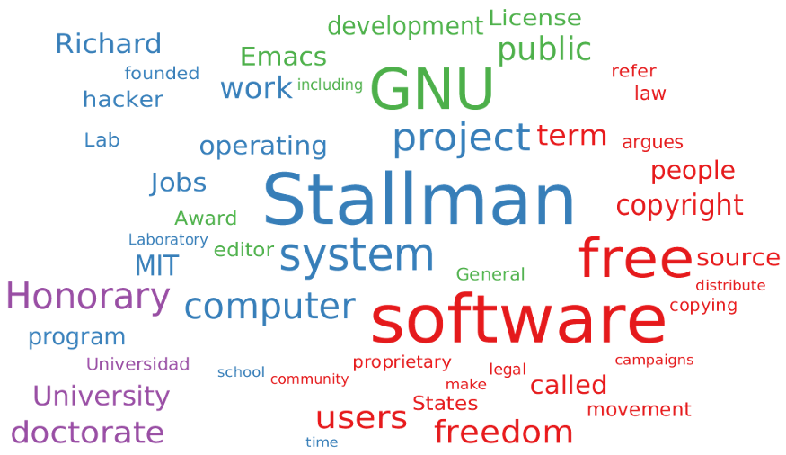

Fig 1: Word cloud for RMS wikipedia page, source: <http://wordcloud.cs.arizona.edu/>

Many algorithms exist for the generation of semantic word clouds. Generally, a text is parsed and tokenised, common words such as `a’ or `the’ removed, then words are weighted and grouped according to some factor such as co-occurrence in sentences. An outline of the algorithm used in the generation of Fig. 1, a semantic word cloud generated from the wikipedia article on Richard Stallman is given in [this paper](https://arxiv.org/abs/1311.4778) [3].

Now we are able to define a discrete-time markov chain over blocks on the blockweave:



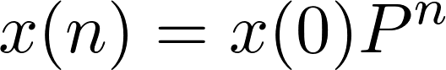

Where P is the matrix of transition probabilities (transition matrix) — the matrix of probabilities that a word will be featured in the word cloud of the next block based on historical data from the blockweave. In the general case, it will take the following form:



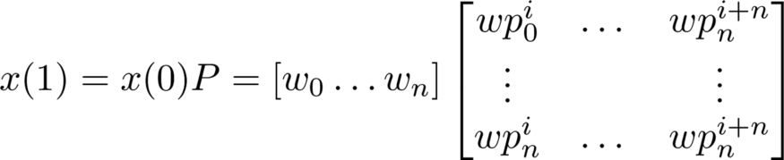

Such that w₀ through wn are binary values representing membership of words in the word field and wp₀ⁱ⁺₁ is the probability in the interval [0,1] of w₀ following wp₀ⁱ⁺₁. Using this definition it is possible to perform a prediction about the content of the next block.

On the release of a new block the markov chain is rebuilt along with the new word cloud and transition matrix. Starting from a suitably populated weave and having a real-time monitor app that performs the calculations each time a new block is mined would provide the user with the ability to track semantic word clouds for desired terms over time, detect trends by comparing word clouds and transition matrices and utilise the markov chain’s predictive capability.

# Conclusions

In this article we have presented a means of tracking semantic drift using a real-time **Archain ADT monitor application** that implements a markov chain approach. Such an application would provide the ability to **detect trends over time and provide some predictive capability**. We have presented a sample use case and explained the benefits of using the Archain in solving the problems of the use case.

The model and implementation is still relatively naive. A better implementation might use a multi-dimentional matrix as the representation for a block’s semantic word cloud — utilising the extra variables such as importance and sentence co-ocurrence as seen in Fig. 1 and described in [3]. This would provide a better description of the state with more information. Tracking semantic drift remains but one of the many applications where blockweave technology might prove effective, however, it contains ideas that could well bear fruit in the future.

For more information on the Archain project, visit us at [archain.org](https://www.archain.org/), find us on [twitter](http://twitter.com/ArchainTeam/) or [email](mailto:team@archain.org) the team.

-archain-jon

## **References**

[1] Sign Salad: Case studies DfT ‘Think! Biker’, <http://www.signsalad.com/semiotics-explained/case-studies/case-studies-dft/>

[2] Archain: An Open, Irrevocable, Unforgeable and Uncensorable Archive for the Internet, S Williams, W Jones, <https://www.archain.org/whitepaper.pdf>

[3] Semantic Word Cloud Representations: Hardness and Approximation Algorithms, Barth et al., <https://arxiv.org/abs/1311.4778>

# Verified, Decentralised Communication on the Archain

[](https://arweave.medium.com/?source=post_page-----ff05a6dc9269--------------------------------)

[The Arweave Project](https://arweave.medium.com/?source=post_page-----ff05a6dc9269--------------------------------)

[Oct 20, 2017·2 min read](https://arweave.medium.com/social-applications-on-the-archain-ff05a6dc9269?source=post_page-----ff05a6dc9269--------------------------------)

We have already discussed one possible use of an Archain Application Developer Toolkit (ADT) monitor app as means of [detecting and monitoring Semantic Drift](https://medium.com/@archain/measuring-semantic-drift-on-the-archain-7229ecc9c029) and its business usage in predicting public perception in marketing. In this short blogpost I’d like to outline some of the benefits of cryptographically verified message storage and the use of Archain as a platform for hosting social applications. Archain is a distributed, immutable and cryptographically verified store of digital information on a paranet. Once information is stored on the Archain it cannot be altered or removed. We envisage that many social applications will be built on the Archain, for example a permanent and decentralised email replacement, making use of this technology.

For many, [PGP](https://en.wikipedia.org/wiki/Pretty_Good_Privacy) is a tool indispensable to communication, providing a means of encrypting and signing messages. Archain employs similar encryption technologies to verify that information stored on the network is indeed what it is purported to be. This already enables one service provided by PGP. However, storing verified, encrypted messages on the Archain provides an additional benefit — messages have a verified timestamp and are guaranteed to be retrievable in the future. It is easy to see how proof of a message being sent at a certain point in time might be useful, for example in the creation and enforcement of contracts. In effect, social applications on the Archain have the utility of PGP with the added benefits of permanence.

Communication over Archain based social apps is also fully decentralised, preventing a [Lavabit-style fiasco](https://techcrunch.com/2016/06/24/ladar-levison-finally-confirms-snowden-was-target-of-lavabit-investigation/) where Ladar Levison, Lavabit’s creator was forced to hand over private keys by the FBI in order for them to monitor Edward Snowden’s email. No centralisation means that social apps running on the Archain or employing blockweave technology cannot be subject to such interference. This protects users, miners and the weave as a whole.

In addition to the above, the cryptocurrency built on top of the Archain network allows for the possibility of value transfer alongside messages.

If you are interested in learning more about blockweave technology you can visit us at [archain.org](http://archain.org/), read our [whitepaper](http://archain.org/whitepaper.pdf) or, for implementation details on how to build Archain ADT applications that culminates in a tutorial on building a Twitter-like platform, you can view the Archain masterclass playlist on our [youtube channel](https://www.youtube.com/watch?v=C76RLiTrweg&list=PL2nQaVnO6V_PILywxF9D9EhHXVHCgXfwa). You can also reach us on [Twitter](https://twitter.com/ArchainTeam/), [Reddit](https://www.reddit.com/r/Archain/), [Facebook](https://www.facebook.com/ArchainTeam/) or [email the team](mailto:team@archain.org).

-archain-jon

# The First Archain App Competition

[](https://arweave.medium.com/?source=post_page-----56312e13116--------------------------------)

[The Arweave Project](https://arweave.medium.com/?source=post_page-----56312e13116--------------------------------)

[Oct 27, 2017·2 min read](https://arweave.medium.com/the-first-archain-app-competition-56312e13116?source=post_page-----56312e13116--------------------------------)

**Have you got an idea for a killer app driven by information permanence? Are you driven by cutting edge blockchain technologies? Are you interested in**[**building an app on top of a live feed of history**](https://medium.com/@archain/measuring-semantic-drift-on-the-archain-7229ecc9c029)**?**

Well, take note. In this blogpost we are proud and very excited to announce the first Archain Application Development contest. Developers will compete for an investment pool of **250,000 ARC** and **$10,000** to kick-start their Archain app idea into a fully fledged business!

Using Archain’s App Developer Toolkit (ADT), developers can easily build and run custom nodes in the Archain network. Archain apps receive a constant, hand-collated stream of historically important information. This data can be used to support a broad range of applications, stretching from automated stock traders, to uncensorable social networks. Archain apps are not only deeply flexible and powerful, but are also extremely easy to write in either Erlang or Elixir.

We see this competition as the perfect opportunity to spread the word about Archain while providing a platform and motivation for interested developers to get hands on experience building with Archain’s Permanence as a Service features.

The investment pool of $10,000 will be split among the best submissions in terms of idea and implementation. Should you be deemed a winner, Archain will offer you a prize in exchange for a 6% stake of equity in the resulting business — meaning that you would have a direct line to us, the Archain dev team, in order to help develop your app further. The ARC prizes will also allow developers to fuel their apps in the early stages.

Full details and rules will be announced next week — look out for a post here on Medium!

As always, for questions and comments you can reach us on [Twitter](https://twitter.com/archainteam), [Reddit](https://www.reddit.com/r/Archain/), [Facebook](https://www.facebook.com/ArchainTeam/) or [email](mailto:team@archain.org) the team.

You can get going with Archain app development by checking out our [GitHub repository](http://www.github.com/ArchainTeam/archain). We hope you have as much fun developing with Archain as we have building it.

-archain-team

# ARC -> ar.cash

[](https://arweave.medium.com/?source=post_page-----f1647c3f456f--------------------------------)

[The Arweave Project](https://arweave.medium.com/?source=post_page-----f1647c3f456f--------------------------------)

[Oct 30, 2017·1 min read](https://arweave.medium.com/arc-ar-cash-f1647c3f456f?source=post_page-----f1647c3f456f--------------------------------)

**Important announcement**: Archain is changing — but just a little.

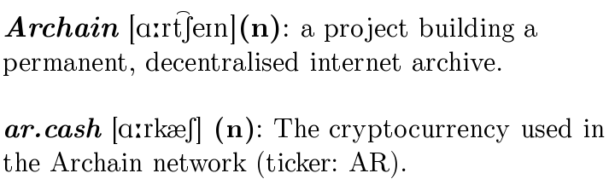

In this blogpost we’d like to inform you of a small change that is happening to Archain. Our cryptocurrency, that you know as ARC tokens (currency code ARC), from Monday, November the 6th will become ar.cash (currency code AR). You’ll still be able to find the project at archain.org but we will also be rebasing to https://ar.cash as our new home on the web. We have also invited our backers to take part in a poll to decide our new ar.cash logo. Check your inbox for details.

If you’ve already purchased ARC, don’t worry — nothing else will change. You’ll still have the same number of tokens but now you’ll be the proud owner of ar.cash rather than ARC.

This small change to our token’s name is a first in a number of exciting developments that we have planned for the Archain project and we’re looking forward to sharing them with you soon.

If you have any questions about this name change, or about anything else, don’t hesitate to contact us via [twitter](https://twitter.com/ArchainTeam), [facebook](https://www.facebook.com/ArchainTeam/), [reddit](https://www.reddit.com/r/Archain/) or [email the team](mailto:team@archain.org).

-archain-team

# The First Archain App Development Competition is Officially Open for Submissions!

[](https://arweave.medium.com/?source=post_page-----ea43a9bd86b2--------------------------------)

[The Arweave Project](https://arweave.medium.com/?source=post_page-----ea43a9bd86b2--------------------------------)

[Nov 3, 2017·3 min read](https://arweave.medium.com/the-first-archain-app-development-competition-ea43a9bd86b2?source=post_page-----ea43a9bd86b2--------------------------------)



**Have you got an idea for a killer app driven by information permanence? Are you driven by cutting edge blockchain technologies? Are you interested in**[**building apps on top of a live feed of history**](https://medium.com/@archain/measuring-semantic-drift-on-the-archain-7229ecc9c029)**?**

Well, take note! We are very proud to announce the first Archain Project Application Development Competition! The Archain project is providing an investment pool of $10,000 USD, a prize of 125,000 AR, and two runner up prizes of 62,500 AR, **plus**, as a thank you for taking part, all entrants will receive 100 AR!

**Introducing Archain Apps**

At Archain we are firm believers in the vision of a world of decentralised applications. Unfortunately, previous platforms have fallen short of allowing developers to fulfil this vision. The Archain project presents a radically different approach. Performing computation itself on a blockchain has proven slow, difficult, and often impractical. Instead of hosting the computation, Archain replaces the role of traditional data storage mechanisms in applications. This means that developers can program in their favourite languages while taking full advantage of most of the benefits of decentralised applications. Developers can achieve this via a simple RESTful HTTP or Erlang interface.

On top of the benefits of traditional decentralised applications, Archain offers the opportunity to monitor a live feed of hand-curated human history. The uses for this data are virtually endless, from automated stock traders to brand management and machine learning systems.

We are incredibly excited to see what innovative applications the development community can discover and create utilising the Archain network!

**Prizes**

Developers will compete for an investment pool of $10,000 USD to kick-start their application idea into a fully fledged business.

In addition to this, the developer(s) behind the winning application will receive a prize of 125,000 AR. The developers behind the two runner up applications will also receive 62,500 AR each, to help fuel their applications on the Archain network.

**Eligibility**

The competition is open worldwide to all developers, using any programming languages. You can submit an entry as an individual or as a team, and you can even submit more than one application, if you’re feeling particularly inspired!

To be eligible for prizes and rewards, all applications must interface with the Archain network in some manner.

**Deadline**

All entries must be submitted by midnight (GMT) on the 3rd of August 2018. Winners will be notified via email within 30 days of the competition close date.

**How to Enter**

To enter the competition you should email [team@archain.org](mailto:team@archain.org) before the deadline with a short description of your project (no more than 500 words), along with either a web address at which the application is running, or a repository with simple-to-follow instructions for running the application ourselves.

The entry must conform to the [official rules of the Archain Project Application Development Competition](https://medium.com/@archain/official-rules-of-the-archain-project-application-development-competition-2017-18-3760aeb1532).

**Support from the Archain project team**

As always, the Archain project team is available to answer any and all queries at [team@archain.org](mailto:team@archain.org). Please don’t hesitate to let us know your thoughts, feedback, and any questions you may have!

We can’t wait to see what you come up with!

-archain-team

# Official Rules of the Archain Project Application Development Competition 2017–18

[](https://arweave.medium.com/?source=post_page-----3760aeb1532--------------------------------)

[The Arweave Project](https://arweave.medium.com/?source=post_page-----3760aeb1532--------------------------------)

[Nov 3, 2017·4 min read](https://arweave.medium.com/official-rules-of-the-archain-project-application-development-competition-2017-18-3760aeb1532?source=post_page-----3760aeb1532--------------------------------)

By submitting an entry into the competition, entrants agree to the rules laid out herein.

This competition is run from the United Kingdom and is subject to UK law.

Submission of an application to the Archain Project Application Development Competition does **not** forfeit any of the developers’ intellectual property rights to the application they have created.

**How to enter**

To enter the competition you should email [team@archain.org](mailto:team@archain.org) before the deadline with a short description of your project (no more than 500 words), along with either a web address at which the application is running, or a repository with simple-to-follow instructions for running the application ourselves.

**AR prizes (125,000AR, 62,500AR, and 62,500AR, plus 100AR to all entrants)**

Three prizes of AR will be awarded to the development team(s) responsible for the best three applications submitted during the contest. The three prize-winning applications will be selected by a judging panel comprised of Archain project team members and backers of the Archain project, and made on the strength of the application’s concept and its execution. The decision of the judging panel is final.

The development team who created the first place winning application will receive 125,000 AR, and development team(s) who created the two runner up applications will also receive 62,500 AR each.

Applications can be created by an individual developer or a team of developers, but teams must select an appointed nominee who will serve as the point of contact between the Archain project team, judging panel, and the rest of their development team. When submitting a team entry to this competition, the appointed nominee should send the initial entrance email from their preferred email address. All future communications about this team entry, including any notification of investment opportunity and competition prizes, will be sent to the nominee’s email address as provided at the time of submission. Prizes will be awarded per application, regardless of the size of the development team.

Multiple unique entries from the same individual or team are permitted.

Every unique and non-trivial application submission (at the discretion of the judging panel) will receive 100 AR, as a ‘thank you’ for participation in the competition and your interest in the Archain project.

Winners will be notified via email on or before the 3rd of September 2018 (30 days after the closing date of the competition, at midnight GMT on the 3rd of August 2018).

**Investment pool awards and opportunities**

The investment pool of $10,000 (USD) will be distributed at the discretion of the Archain project team, and the pool may be distributed between more than one developer or developer team. Funds from the investment pool are to be offered in exchange for a percentage stake in the resultant business, the specifics of which will be negotiated between the Archain project team and the developer(s) involved.

**Notifying entrants of prizes and investment opportunities**

The Archain project team will contact prize winners and investment opportunity recipients via the email address used to submit the competition entry. These developers will be notified of their success via email between 3rd of August 2018 (the competition’s close date) and the 3rd of September 2018. The entrants awarded AR prizes will be contacted by the Archain project team via the email address originally used to submit their competition entry. If competition winners or runners up do not respond to this notification email within one calendar month of the notification email being sent, this will cause the prize to be forfeit, and the judging panel will be required to select a different competition entry to receive said prize. Where a winning entry was submitted by a team of developers, the team’s appointed nominee will be contacted via their provided email address with details of their success. As with individual developer entries, if a response to this notification email is not received by the Archain project team within one calendar month of the notification email being sent, the AR prize(s) will be forfeit and re-distributed.

Developers will also be approached regarding receipt of investment pool funds via email at the email address they originally used to submit their competition entry. As with receipt of AR prizes, if a response to this notification email is not received within one calendar month of the notification email being sent, this investment opportunity may be forfeited, and may also be offered to other competition entrants.

**Disqualification**

The Archain project team reserves the right to disqualify any entrant should it be concluded by the judging panel that an entrant has tampered with the entry process or other operation of the competition, acted illegally in any part of the submission process, acted towards the Archain project or another entrant in an unfair, threatening, harassing, or otherwise unreasonably disruptive manner.

-archain-team

**The Archain backer alpha test network is live!**

[](https://arweave.medium.com/?source=post_page-----130a0a1dec11--------------------------------)

[The Arweave Project](https://arweave.medium.com/?source=post_page-----130a0a1dec11--------------------------------)

[Nov 6, 2017·2 min read](https://arweave.medium.com/the-archain-backer-alpha-test-network-is-live-130a0a1dec11?source=post_page-----130a0a1dec11--------------------------------)

Today we are pleased to be launching the Archain Backer Alpha Test Network (the BATN), a full 8 weeks ahead of schedule.

The support of our backers has allowed us to reach this milestone so quickly, and we look forward to continuing our shared journey towards creating a permanent archive parallel to the internet.

Before we get started with the details of how to get involved with the BATN, we want to make very clear that this is truly an ‘alpha’ release: there will be many bugs, issues, and network resets on the road to the release of the main network. The reason we are launching this testnet is to find and solve those bugs, and iterate on the software until we reach a reliable and stable network. We are excited to receive any and all of the bug reports, feedback, and suggestions from the community!

**Web extension**

You can download the Archain BATN-compatible [web extension today for Chrome](https://chrome.google.com/webstore/detail/archain-alpha-test-networ/fknfnadpihbhdhmfhogfacalpabfdlpg) and the extension for Firefox is coming soon. When you download this BATN-compatible extension you will be able to enter your existing public key and view your AR wallet balance and network information in real time from the testnet.

In order to safeguard your real public and private keys, we have currently disabled transaction generation on the BATN-compatible web extension. We will soon send eligible backers a link to generate a test public & private key purely for use with BATN — keep an eye on your inbox! These measures have been taken to protect your real private & public keys from any bugs discovered with the alpha network.

**Mining the BATN**

Eligible Archain backers can now take part in mining the blockweave by following these instructions.

We want to make clear that the mining process is not currently very user-friendly, and we will be continuously improving on this user experience between now and the launch of the main network.

1. A working Erlang (R20 or above) environment must be established on a MacOS or Linux platform (support for Windows is on its way).
2. Pull the [GitHub repository](https://github.com/ArchainTeam/archain).
3. Run the following command to start an Archain mining node:

./archain-server peer [ip_from_email] mine

Eligible backers have been provided with details of the initial node IP address via email.

**Future updates**

We will continue to keep the Archain community up-to-date about developments to the alpha test network and mining process through our blog here on Medium. In the future we will also be opening up the alpha test network to the public, so stay tuned for details!

—

As always, the Archain project team is available to answer any and all queries at [team@archain.org](mailto:team@archain.org). Please don’t hesitate to let us know your thoughts, feedback, and ask any questions you may have — we’d love to hear from you!

- archain-team

# GENESIS : Art, Anti-Censorship, and Archain

[](https://arweave.medium.com/?source=post_page-----684df5792072--------------------------------)

[The Arweave Project](https://arweave.medium.com/?source=post_page-----684df5792072--------------------------------)

[Nov 16, 2017·4 min read](https://arweave.medium.com/genesis-art-anti-censorship-and-archain-684df5792072?source=post_page-----684df5792072--------------------------------)



**Event**: GENESIS — Art, Anti-Censorship, and Archain

**Venue**: St Ethelburga’s, 78 Bishopsgate, London, EC2N 4AG

**Opening Night**: 15th December 2017, open to the public from 8pm until 10pm

**Final Night**: 16th December 2017, open to the public from 7pm until 10pm

You may have seen our cryptic tweets about [GENESIS](https://twitter.com/archainteam) over the past few weeks and wondered what we were planning… Well, the wait is now over! The Archain project’s GENESIS event is officially one month away, and we’re thrilled to share the details with everyone here today.

In a unique fusion of cutting edge cryptocurrency technology and visual arts, the Archain project will be hosting GENESIS, a free public art exhibition in the heart of the City of London, on the 15th and 16th of December 2017. A venture designed to bring the vision of the Archain project to a wide and varied audience, the GENESIS event will bring into sharp focus the urgent need to bolster our online freedoms.

Threats to our digital rights and internet freedoms press in from all sides, encroaching on and eroding our ability to freely access and share knowledge. These rights and liberties are of vital importance to the future of the internet, and are essential protection against both subtle invasions of our freedom of expression, and against the future development of authoritarian regimes.

We have all experienced the loss or alteration of online information — whether by accidental or purposeful means, whether by individuals or governments, and whether for nefarious or innocent reasons.

As so many of our backers and readers of this blog are already aware, the Archain project offers a solution to the problems of online data loss and alteration through the creation of a permanent, decentralised archive parallel to the internet.

GENESIS will celebrate the artistic and technological communities’ shared values of creativity and innovation, freedom of expression, and liberty from censorship. Presenting uncompromising works of illustration and poetry in dialogue around the themes of censorship and control, GENESIS represents the core values and principles that prompted the creation of the Archain project.

Innovative and highly successful artists [Nathan Hassall](https://www.nathanhassall.co.uk/) and [John Speed](https://www.rebelyuth.com/) (Rebel Yuth) have created a series of artistic works inspired by and **incorporating all of the Genesis block messages contributed by the Archain project’s crowdfunding backers**. Ultimately, every single one of these uncensored messages will be stored eternally on the Genesis block of the Archain network. These permanently-stored messages offer future generations an honest and often touching insight into how passionately people today feel about their digital rights and freedoms.

GENESIS will be hosted within the heart of the City of London, in the historic Grade 1 listed venue St Ethelburga’s, 78 Bishopsgate. Originally built in the 14th century, this inspiring location serves as a perfect setting from which to explore themes of permanence and resilience, symbolising the enduring power of shared human history.

**To reflect the Archain project’s principles of freedom of access to knowledge and information for all, both nights of the GENESIS exhibition will be open to all members of the public and press, entirely free of charge.** Refreshments will be provided throughout the evening to welcome all attendees. Pre-sale contributors to the project of tier ‘Custodian’ or above will soon receive a formal invitation to an early opening of the GENESIS event on the 15th of December, providing an exciting opportunity for our team to personally meet with many of our early-stage supporters and contributors (we’re very excited!).

**Artist Biographies**

Nathan Hassall, writer and poet, is author and co-founder of experimental literary magazine Guttural, and an editor for The Luxenbourg Review. Hassall has had poetry published in an array of print media, including Episteme, The Thumb Print, Failed Haiku, cattails, and Yellow Chair Review. Following Hassall’s three previous full-length poetry collections, his most recent surrealist chapbook, The Flesh and Mortar Prophecy, was published in September 2017.

John Speed (Rebel Yuth), artist and illustrator, has collaborated with a multitude of brands and companies, including: Basement Approved, Schott NYC, Blackscale, Lightwork, Bench Sportswear, Caterpillar Boots, Adidas Originals, Stylecreep Menswear, Trainerspotter and S.O.O.N (Porky’s BBQ House). Speed’s previous projects include murals, editorial illustration, graphic design, international campaigns, and exhibitions at prestigious galleries such as Hoxton. Speed has also been interviewed, featured, and spotlighted in various publications such as Highsnobiety, Complex Boiler Room, Breaks Magazine, and I-D magazine.

We hope to see you in London!  
-archain-team

# BATN.2: Archiving The Internet

[](https://arweave.medium.com/?source=post_page-----3b0311ea8311--------------------------------)

[The Arweave Project](https://arweave.medium.com/?source=post_page-----3b0311ea8311--------------------------------)

[Nov 22, 2017·2 min read](https://arweave.medium.com/batn-2-archiving-the-internet-3b0311ea8311?source=post_page-----3b0311ea8311--------------------------------)

BATN.2 marks the second major release of Archain’s Backer Alpha Test Network and represents a significant update to the features of our test network. This release, critically, **now supports archiving of the internet for the first time** — yet another significant milestone on our journey towards a permanent, immutable paranet.

# Release notes for BATN.2

**Client-Side**

As previously mentioned, those of you with test wallets — distributed to backers at developer tier or higher — will now be able to begin archiving internet pages. The archiving web extension will updated soon. Your test wallets will contain the same amount of AR as your main net wallets will have upon final release. However, given that we remain in an alpha stage, we will only support the archiving of text and any and all archiving will cost exactly 1 AR. Please note that this is not reflective of our final release and your real, non test-net wallets will remain entirely unaffected. This said, we look forward to seeing what you choose to archive on BATN.2!

**Server-Side**

The BATN.2 release also introduces a number of key features and developments to maximise stability and client accessibility. Archain now has support for systems without port forwarding by means of a block polling system. We have vastly improved the way nodes join the network and recover from blockweave forks and through radical code optimisation increased node stability and responsiveness on the network. We can also count at least eight major bug fixes since the release of BATN.1 among our commits. You can check these out yourself on our [github](http://github.com/ArchainTeam/archain).

**Debian and Ubuntu Linux Easy Launch**

As part of our aim to make Archain as easy for you to use, we have written a script to install and launch the Archain codebase, all necessary dependencies and automatically begin mining for you. From your Debian or Ubuntu installation it’s as easy as copying and pasting into your terminal the following command:

curl <https://gist.githubusercontent.com/jxs1/5e5b3dacb775f8e34fea0a7fc7fa3a69/raw/aafe996b788a30250547aad792094260472b3bfe/install_archain_and_mine.sh> | bash && cd archain && ./archain-server peer XXX.XXX.XXX.XXX mine

Don’t forget to change xxx.xxx.xxx.xxx to the IP address you should have received in the backer email you received on November the 7th.

If you want to know exactly what this is doing you can see in the gist below.

SHA256 of script:

3b946e6619bde7c430e3cee3efd44574d00aa8c03af4ec38b15d5c3be674b963

Look forward to similar scripts for other platforms in the future.

As always, you can find us on [Twitter](https://twitter.com/ArchainTeam), [Reddit](http://reddit.com/r/Archain), [Facebook](https://en-gb.facebook.com/ArchainTeam/) or [email the team](mailto:team@archain.org).

-archain-team

# ArchiveIt! Zero-fuss permanent file storage.

[](https://arweave.medium.com/?source=post_page-----d849de5233f3--------------------------------)

[The Arweave Project](https://arweave.medium.com/?source=post_page-----d849de5233f3--------------------------------)

[Dec 11, 2017·2 min read](https://arweave.medium.com/archiveit-zero-fuss-permanent-file-storage-d849de5233f3?source=post_page-----d849de5233f3--------------------------------)

Despite the hype and buzz, traditional decentralised application platforms (like Ethereum) have universally failed to produce ‘killer’ applications with broad market appeal. It is notable that Ethereum’s most successful application is about [trading images of cute, imaginary cats](https://www.cryptokitties.co/). Ethereum’s market capitalisation sits at $45.3bn at time of writing.

At the Archain project, we believe that mass-market appeal will be the key to growth and adoption of decentralised application platforms. It is with that in mind that we are proud to present the alpha of the second major application built on top of the Archain network: ‘ArchiveIt!’ (working title). ArchiveIt! provides zero fuss, permanent file archiving and recall facilities, at low cost. Simply drag and drop a file that you want to archive onto the app, then retreive it at any time with the click of a button.

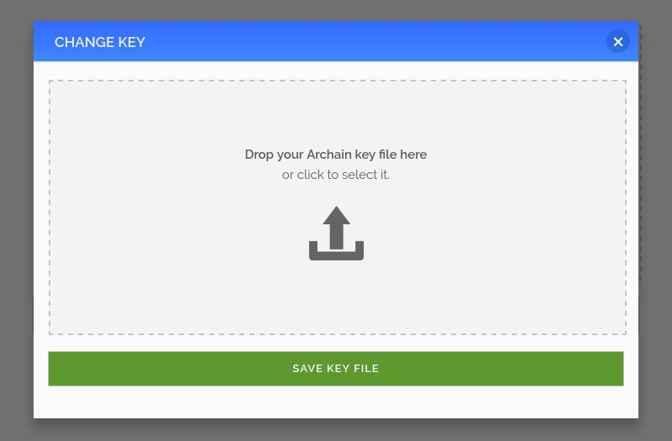

ArchiveIt! is designed for both you and your least tech savvy friend, alike. Powered by the Archain, ArchiveIt! provides true information permanence (once the main network is live) through an extremely simple and effective user interface. We have attempted to build the application such that every piece of functionality is accessible within two clicks.

We hope that the simplicity of ArchiveIt!, and it’s instantly applicable functionality will help to demonstrate the flexibility, depth and intrinsic usefulness of the Archain project as an application platform.

You can download the ALPHA version of ArchiveIt! for Windows and Linux (Mac OS coming soon!) below:

Windows: [download](http://archain.org/bin/archiveit-win-alpha-1.zip) (sha256sum: 541bec620515b78f78f2acf46dd3a3ff6259abf00db3f18a9896b0b7bd6d1fca)  
Linux: [download](http://archain.org/bin/archiveit-linux-alpha-1.tar.gz) (sha256sum: b26b51ae8a294a2f1742dfa97aabb18e60d9732db3ea617c5225856a7f5ae0fb)

**Please note:**Uploaded files are not currently encrypted. File encryption will be optional in future releases. Please do not use the ArchiveIt! alpha to store any personal or confidential information.

**Remember**: Archain test networks are occasionally reset — please do not use the test network for serious archiving before the main network has launched.

Backers will be able to use their test network keys to try out this alpha. There are still many features and UI changes to make before ArchiveIt! is production-ready. Please give it a go and let us know your feedback!

If you have an idea for a killer decentralised app, or are interested in Archain app development in general, be sure to check out the [Archain App Development Competition](https://medium.com/@archain/the-first-archain-app-development-competition-ea43a9bd86b2)!

-archain-team

# ****Frequently Asked Questions about Arweave****

[](https://arweave.medium.com/?source=post_page-----2c72b3db872f--------------------------------)

[The Arweave Project](https://arweave.medium.com/?source=post_page-----2c72b3db872f--------------------------------)

[Jan 22, 2018·3 min read](https://arweave.medium.com/frequently-asked-questions-about-archain-2c72b3db872f?source=post_page-----2c72b3db872f--------------------------------)

**Q: What is Arweave?**

A: The Arweave project, previously known as Archain, is creating a permanent, decentralised, and uncensorable information archive, parallel to the internet. Built on the first truly scalable cryptocurrency, the Arweave’s novel ‘blockweave’ technology allows for efficient, self-organising data storage that ensures data in the network will be available for many years, many decades, even centuries to come, untouched by accidental or intentional data alteration.

If you are interested in knowing more about our technological innovations, you may wish to [visit our website](https://archain.org/) or [read our whitepaper](https://archain.org/whitepaper.pdf).

**Q: What is AR.cash/AR?**

A: AR.cash (often shortened to ‘AR’) are the tokens used to pay for information to be permanently archived on the Arweave. These token payments are distributed as rewards to the ‘miners’ who choose to store and maintain the information on the Arweave.

**Q: How can I start archiving web pages on the Arweave?**

A: Users who purchased AR.cash tokens in our pre-sale event are able to immediately queue webpages for archiving on the main network after its launch. Pre-sale backers can queue pages by installing the Arweave [web extension for Google Chrome](https://chrome.google.com/webstore/detail/archain/ndohcjmbfbjlkpllekbmadekkhalkdek), entering their public key obtained during the pre-sale. From then on, users can simply press one button to queue a web page for archiving once the main Arweave network launches. For details of network release dates, please see our dedicated [timeline blog post](https://medium.com/p/935a44a43318).

Alternatively, pre-sale backers can try out the archiving function by installing the Arweave [alpha test network web extension](https://chrome.google.com/webstore/detail/archain-alpha-client/fknfnadpihbhdhmfhogfacalpabfdlpg). It’s important to note that web pages submitted to the test network via the alpha test network web extension will not be archived on the main network automatically.

At the moment, the Arweave web extensions are accessible only with the Google Chrome web browser, though in the future additional browser support will be added.

**Q: When and how will I be able to view information archived on the Arweave network?**

A: Arweave will be releasing an online ‘blockweave explorer’ later this year, which will allow users to review information archived on the Arweave. Additionally, when information is archived on the Arweave, it is given a unique transaction identifier, allowing anyone to retrieve that information from the network at any later point.

**Q: I purchased tokens during the Arweave pre-sale. When can I access my tokens?**

A: After the main Arweave network has been launched, individuals will be able to access their tokens for use, transfer, and trade on the Arweave network.

**Q: Can I load my AR.cash tokens/keys into a third party wallet (e.g. MyEtherWallet)?**

A: Due to the unique scaling benefits of the Arweave network and the novel technology on which it is based, the Arweave is developed on an entirely new platform. AR.cash tokens are therefore not currently compatible with other wallet programs such as MyEtherWallet or Jaxx. Arweave tokens will be usable through the Arweave web extension, the details of which you can read about in [our whitepaper.](https://archain.org/whitepaper.pdf)

**Q: This sounds exciting! How do I start mining for myself?**

If you participated in the Arweave pre-sale at the ‘Developer’ tier or higher , you can begin mining on the Arweave test network immediately. You may want to mine on the test network now to ensure that you have your mining environment fully established and ready to go when the main network launches.

After the first non-backer alpha test network has launched ([see our timeline blog post for details](https://medium.com/p/935a44a43318)), those not involved in the Arweave pre-sale will also be able to participate in mining.

**Q: What is the difference between the test networks and the ‘main’ Arweave network?**

The Arweave test network releases are purely for purposes of ensuring network correctness. Any activities that take place on the test networks will be subject to loss on network reset. Once the main network has been released and the testing phase has been finished, no more hard-resets on the network will be performed, meaning that all activities (archiving, transfers, mining, etc.) will persist indefinitely.

**Q: I want to build apps based on the Arweave, how can I get started?**

A: A huge benefit of Arweave for developers is that you can write your applications as usual, in any programming language you desire, while utilising the Arweave as a permanent backend data storage system through a simple HTTP API.

If you are interested in building apps on the Arweave, you should consider submitting your application to the [Arweave app competition](https://medium.com/@archain/the-first-archain-app-competition-56312e13116).

We will be updating these FAQs frequently, as we receive more questions from the community. If you have further questions about the Arweave project, we can always be reached at [team@arweave.org](mailto:team@arweave.org).

-arweave-team

# Archain Timeline Winter-Spring 2018

[](https://arweave.medium.com/?source=post_page-----935a44a43318--------------------------------)

[The Arweave Project](https://arweave.medium.com/?source=post_page-----935a44a43318--------------------------------)

[Jan 22, 2018·3 min read](https://arweave.medium.com/archain-timeline-winter-spring-2018-935a44a43318?source=post_page-----935a44a43318--------------------------------)

As you have probably read in our [announcement blog post](https://medium.com/p/f4ed609355c4), we are very proud to reveal that Archain has joined the Techstars Berlin city 2018 programme! In order to take full advantage of the vast array of time-intensive project development and growth opportunities provided by Techstars, we have updated our release timeline, the details of which you can see below. Our team is passionate about delivering the best possible value to supporters of the Archain project, and although the main network release date has been altered, we’re truly thrilled about what Techstars will mean for both our supporters and the whole Archain community.

1st February 2018 — **Final release of the backer-exclusive alpha test network** (BATN.4)

This will be the next and final release of the backer-exclusive alpha test network, where pre-sale Archain contributors can participate in test mining on the Archain network.

22th February 2018 — **Release of the first version of the alpha test network** (ATN.1)

The first version of the Archain alpha test network available for use by the general cryptocurrency community. Until this release of ATN.1, only pre-sale backers above a certain contribution level have been able to test mine on the Archain alpha test network. However, with this release (and all future releases), anyone who wishes to join our mining community can join the network.

5th March 2018 — **Details of the main Archain token sale will be published**

Specific details of the Archain project’s main sale period will be announced on this date, including the pricing model, confirmation of the sale platform, and confirmation of accepted payment methods. The details will be published on this Medium blog.

15th March 2018 — **Release of the second version of the alpha test network**(ATN.2)

The second major public release of the Archain alpha test network.

5th April 2018 — **Release of the first beta version of the test network**(TN.1)

The test network moves out of its alpha phase with this beta release of the first version of the full Archain test network.

19th April 2018 — **Beginning of Archain’s main sale period**

The start of the Archain project’s main token sale period.

28th May 2018 — **End of Archain’s main sale period**

The final day of the main token sale period, the last opportunity to buy AR.cash until the tokens are listed on exchanges after the main Archain network launches.

8th June 2018 — **Release of the main Archain network (N.1), permanent internet archiving functionality, and ArchiveIt!, the Archain’s on-demand permanent storage system.**

After this date, storage on the Archain’s main network will be truly permanent, fulfilling the original goal of the Archain project. Once the main network has launched, backers will be able to use, trade, and sell their AR.cash tokens. This release will coincide with the 69th anniversary of the publication of George Orwell’s Nineteen Eighty-Four.

Joining the Techstars family is a pivotal milestone in Archain’s journey towards building information permanence, and an uncensorable, hand-curated archive of human history. We believe the array of opportunities provided by the Techstars programme, including intensive mentoring, broadening the Archain’s financial network, and community building opportunities, will be hugely beneficial for the entire Archain community, both existing and future.

We are excited to have you join us on this amazing journey!

-archain-team

# Archain + Techstars

[](https://arweave.medium.com/?source=post_page-----f4ed609355c4--------------------------------)

[The Arweave Project](https://arweave.medium.com/?source=post_page-----f4ed609355c4--------------------------------)

[Jan 22, 2018·2 min read](https://arweave.medium.com/archain-techstars-f4ed609355c4?source=post_page-----f4ed609355c4--------------------------------)



Today we are very proud and excited to announce our eagerly-awaited news… After a lengthy selection process and fierce competition Archain is now officially a member of the TechStars Berlin city 2018 startup accelerator programme! TechStars is an incredibly successful and respected family of startup accelerators designed to incubate small or developing technology businesses, helping hundreds of companies improve their products and raise billions of dollars. Techstars offers 13 weeks of intensive mentoring and project development opportunities, including connecting companies like Archain with an array of world-renowned specialists.

With TechStars’ backing, we are extremely excited that we will be able to rapidly grow Archain and propel it to prominence in the cryptocurrency and information freedom communities. We are thrilled to have this opportunity to fulfil our community’s aspirations for an immutable, uncensorable archive of human history and to bring the project to a vast and diverse audience.

**Archain**

The Archain project is a globally distributed archiving system that uses modified cryptocurrency technologies to make permanent information storage a reality for the first time. To read more about Archain and our novel technologies, please [visit our website](https://archain.org/), or [read our whitepaper](https://archain.org/whitepaper.pdf).

**Techstars**

As many of you will be keenly aware, Techstars is among the world’s most successful and respected startup accelerators, designed to promote rapid growth of budding technology companies. We are honoured to have the backing of Techstars, who are excited to help us fulfil the vision of the Archain project by providing the marketing, business development, and expert guidance Archain needs to reach its ambitious potential.

**The Future**

The Techstars Berlin programme will offer Archain an unprecedented opportunity to bring our innovative blockweave and information permanence technology to a huge global audience, both inside and outside the technology and startup communities. We are thrilled to be part of the TechStars family, alongside such esteemed alumni such as Uber, DigitalOcean, SendGrid, Twilio, Timehop, and Cloudability, amongst [many, many more](https://www.techstars.com/companies/).

**Summary**

The whole Archain team wants to offer our sincere thanks to our long-standing supporters, and our highly active, engaged, and enthusiastic community. Your belief in the Archain project and our shared goals of freedom of information and anti-censorship has helped us achieve this highly significant milestone, and bring Archain and our mission to a massive audience.

If you would like to read more about the underlying technological innovations, such as our blockweave technology, we would encourage you to [visit our website](https://archain.org/), [read our whitepaper](https://archain.org/whitepaper.pdf), or visit our [frequently asked questions blog post](https://medium.com/@archain/archain-timeline-winter-spring-2018-935a44a43318). To read about the other esteemed companies enrolled in the Techstars Berlin cohort, visit the [official Techstars announcement here](https://www.techstars.com/content/accelerators/techstars-berlin-announces-companies-fourth-program/).

To view all upcoming Archain events, including information on how Techstars enrolment will affect our timeline of project milestones, please visit our second blog post dedicated to [our Winter-Spring 2018 timeline](https://medium.com/p/935a44a43318).

-archain-team

# Archain now known as Arweave

[](https://arweave.medium.com/?source=post_page-----432f0708eed0--------------------------------)

[The Arweave Project](https://arweave.medium.com/?source=post_page-----432f0708eed0--------------------------------)

[Feb 22, 2018·1 min read](https://arweave.medium.com/archain-now-known-as-arweave-432f0708eed0?source=post_page-----432f0708eed0--------------------------------)

From today onwards, we will be changing our project name from ‘Archain’ to ‘Arweave’, and we will be found at our brand new homepage of [www.arweave.org](http://www.arweave.org/).

We are making this move in order to unquestionably differentiate our project from similarly named cryptocurrency projects (Rchain and Achain, for example), and take that opportunity to place the project’s unique blockweave technology at the heart of our proposition. From a timing perspective, this is the ideal opportunity to unveil and promote the new name as we ramp up our marketing campaign towards our main sale and main network launch.

The tokens used in the system will remain known as AR.cash (ticker: AR), and there is absolutely no change or impact to the tokens held by our backers.

Rest assured that we are totally committed to our mission of building a universal platform for information permanence. Same team, same vision, same technology — just a new name.

We have been tremendously excited during our time here at Techstars at the number of new partners who share that vision with us, and recognise the value that this carries. We are really looking forward to sharing news on a number of these new partnerships and developments with you over the coming weeks and months.

Please do get in touch if you have any questions (via [team@arweave.org](mailto:team@arweave.org)), and we sincerely look forward to sharing this journey with you.

The Arweave Team

# [Register to participate in the Arweave token sale](https://arweave.medium.com/register-to-participate-in-the-arweave-token-sale-6c39f3d9b6fb?source=user_profile---------108----------------------------)

Today we are happy to announce the start of the registration period for the upcoming Arweave token sale.

Due to high demand, we will be asking all potential AR cash token buyers to participate in our simple registration process by completing the short form found [here](https://arweave.typeform.com/to/FuMqe9).

Thank you for your interest in Arweave! If you have any questions or would like more information, please send us an email at [team@arweave.org](mailto:team@arweave.org).

-arweave-team

# ****Arweave + New Advisor Jeremy Epstein****

[](https://arweave.medium.com/?source=post_page-----cdbfc381f854--------------------------------)

[The Arweave Project](https://arweave.medium.com/?source=post_page-----cdbfc381f854--------------------------------)

[Mar 23, 2018·2 min read](https://arweave.medium.com/arweave-new-advisor-jeremy-epstein-cdbfc381f854?source=post_page-----cdbfc381f854--------------------------------)



We’re thrilled to be bringing Jeremy Epstein, one of the most experienced and well-regarded thought-leaders in the blockchain and cryptocurrency world, into the Arweave family. Jeremy will join our existing team of [expert advisors](https://arweave.org/#team), focusing his efforts on enhancing Arweave’s communications and marketing strategy.

Jeremy’s unrivalled wealth of experience in blockchain technologies speaks for itself, just take a look at his LinkedIn [profile](https://www.linkedin.com/in/jer979/). Currently President of the Crypto Explorers Association and CEO of Never Stop Marketing, Jeremy has also held a variety of senior marketing and community management roles at Microsoft, Johnson & Johnson, and Sprinklr. Neeraj Agrawal, a partner at Battery Ventures and a consistent member of the Midas 100 list of top global venture capitalists said of Jeremy, “there are only about 100–150 people in the world who have this type of experience.”. In high-demand both as an advisor and as a speaker on blockchain topics, Jeremy has delivered hundreds of speeches globally to crypto audiences, and has advised esteemed projects such as IOTA and ARK, placing Arweave in great company in the crypto industry!

Jeremy’s expertise is exemplified by his co-authorship of cutting-edge publications such as ‘[The CMO Primer for the Blockchain World](https://www.neverstopmarketing.com/wp-content/uploads/2017/07/CMO-Primer-For-The-Blockchain-World-NSM.pdf)’, and the ebook ‘[Blockchains in the Mainstream: When Will Everyone Else Know?](http://www.neverstopmarketing.com/blockchainebook/)’. A [voracious](https://www.neverstopmarketing.com/blog/) [blogger](https://medium.com/@jer979) on blockchain and crypto matters, Jeremy also often contributes to publications including VentureBeat, Bitcoin Magazine, and Distributed Magazine.

Specifically, Jeremy will collaborate with the existing Arweave team of staff and advisors to highlight the technological innovations of the blockweave and our unique proof of access algorithm. Jeremy’s skills and expertise will help us accelerate adoption of the Arweave, its cryptocurrency, and its technology, propelling the project to a mainstream audience.

We hope that you’re as pleased as we are to welcome Jeremy into the wider Arweave community!

-arweave-team

# ****Arweave + Charité staff: Solving the reproducibility crisis with the blockweave****

[](https://arweave.medium.com/?source=post_page-----a9c946315d6b--------------------------------)

[The Arweave Project](https://arweave.medium.com/?source=post_page-----a9c946315d6b--------------------------------)

[Mar 26, 2018·3 min read](https://arweave.medium.com/arweave-charit%C3%A9-staff-solving-the-reproducibility-crisis-with-the-blockweave-a9c946315d6b?source=post_page-----a9c946315d6b--------------------------------)

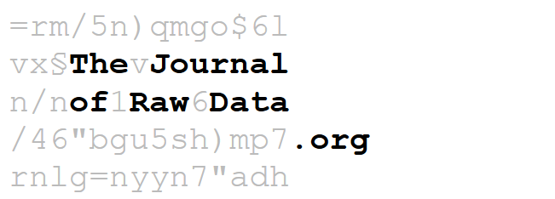

Arweave will be collaborating with biomedical scientists from [Charité](https://www.charite.de/en/), one of the largest university hospitals in Europe, to create a brand-new open access scientific journal. The Journal of Raw Data will be an online-only open access peer-reviewed biomedical data journal, utilising the Arweave network for truly permanent data storage.

Arweave is a permanent decentralised knowledge-storage system that is built to withstand everything from nuclear war to political censorship. You can learn more about the Arweave project on our [website](https://arweave.org/).

Established over 300 years ago, Charité is one of the most esteemed research institutions in Europe, laying claim to over half of all German Nobel prize winners in Medicine and Physiology. Charité and its staff have a sincere dedication to making scientific knowledge accessible to all. Coupled with Arweave’s own passion and commitment for freedom of information and dissemination of knowledge, we are truly thrilled to partner with staff from such a respected institution so aligned with our own values.

The creation of JoRD aims to address key problems contributing to the current [‘reproducibility crisis’](https://www.nature.com/news/1-500-scientists-lift-the-lid-on-reproducibility-1.19970) in biomedical sciences, where a vast majority of scientific studies’ findings cannot be reproduced when the studies are repeated. Suggested explanations for the crisis include inappropriate or flawed study protocol design, mistakes made during data collection or analysis, and failure to report studies’ results without bias or omissions.

JoRD offers a solution to these concerns, through strongly promoting the adoption of ‘open science’ and ‘open data’ behaviours. Through rewarding scientists for high quality study design and conduct, we are taking the first step towards separating research study design and data acquisition from data analysis, in order to improve scientific quality overall.

By minimising the required effort and maximising the scientific reward, scientists are incentivised to publish their raw data in the journal. The use of the Arweave’s permanent, distributed data storage features guarantees reliable access to this vital scientific data for generations far into the future, with any forgery or censorship possible. This permanent storage capability means that future scientists and researchers will be able to re-analyse the data. These re-analyses provide an important check against ‘data fishing’, searching for significant results in a dataset regardless of the original hypotheses of the study. Additionally, Arweave’s scalability features guarantee that the journal’s database can grow to vast sizes, accommodating all future submissions.

Incentives and benefits of JoRD are fully detailed in the [whitepaper](https://www.arweave.org/files/jord-whitepaper.pdf), produced by our partners at Charité.

We hope that you will join us in our excitement about this momentous and innovative collaboration! We hope that this will be the first of many open science initiatives utilising the Arweave. We’re thrilled to push forward our shared [mission](https://www.charite.de/en/the_charite/about_us/principles/) of increased public access to uncensorable data and information through the creation of this journal, and hope you will join us on our journey.

If you’d like to get in touch with our team, or get involved with JoRD, just drop us an email at [team@arweave.org](mailto:team@arweave.org) — we’re always happy to discuss feedback and answer questions!

You can also follow us on social media: [Twitter](https://twitter.com/ArweaveTeam), [Facebook](https://www.facebook.com/ArweaveTeam/), [Telegram](https://t.me/arweave), [Reddit](https://www.reddit.com/r/Arweave/), or [Discord](https://discord.gg/R7JGzyX).

-arweave-team

# Arweave + Shelf.Network: Providing data storage for a decentralised auction house

[](https://arweave.medium.com/?source=post_page-----ae10352a4145--------------------------------)

[The Arweave Project](https://arweave.medium.com/?source=post_page-----ae10352a4145--------------------------------)

[Apr 3, 2018·2 min read](https://arweave.medium.com/arweave-shelf-network-providing-data-storage-for-a-decentralised-auction-house-ae10352a4145?source=post_page-----ae10352a4145--------------------------------)

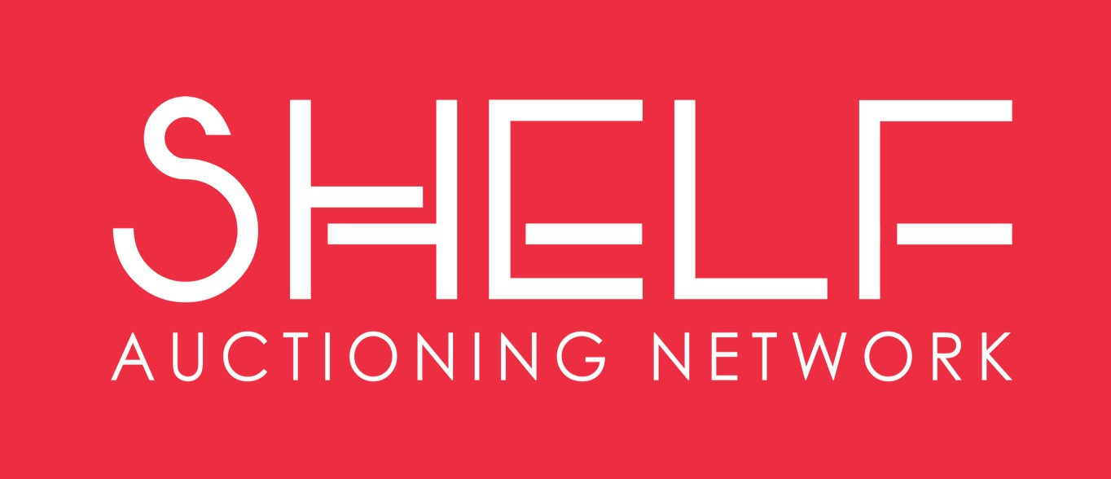

Arweave is proud to announce our partnership with [Shelf.Network](https://www.shelf.network/), the innovative decentralised auction house network.

Also a member of the [Techstars family](https://www.techstars.com/content/accelerators/techstars-berlin-announces-companies-fourth-program/), Shelf.Network utilises blockchain technology to let users place one auction listing on multiple online marketplaces simultaneously. This creates a shared inventory pool, allowing sellers to reach more potential buyers, thereby increasing liquidity for sellers, and convenience for them and their customers. This is achieved simply and subtly, with no added complexity for the end user.

Auction listings contain a relatively large volume of data, making using blockchain technology alone challenging and restrictive. To solve this problem Shelf.Network will utilise Arweave’s massively-scalable blockweave data structure to store the auction listings, as it can handle the large data sizes that traditional blockchains cannot. Then, a reference to the Arweave data is stored on the Shelf.Network’s own blockchain. While previously blockchain projects have needed to resort to centralised and temporary cloud storage solutions for storage of large data, it is no longer necessary to take the risk of storing your data non-permanently like this. Arweave allows full decentralisation of the system, while ensuring data is still verifiable from start to finish, forever.

We anticipate that this pattern of using the Arweave as a supplementary data store for other blockchain-based applications will occur more and more frequently. Arweave perfectly supplements other blockchain-based systems, by maintaining all the normal benefits of blockchain technology, but allowing it to scale to massive storage sizes, without depending on any centralised infrastructure.

We’re looking forward to a very productive partnership with Shelf.Network, bringing all the benefits of the blockchain and blockweave to online marketplaces in the very near future.

You can get in touch with us via email at [team@arweave.org](mailto:team@arweave.org), and of course you can follow us on social media: [Twitter](https://twitter.com/ArweaveTeam), [Facebook](https://www.facebook.com/ArweaveTeam/), [Telegram](https://t.me/arweave), [Reddit](https://www.reddit.com/r/Arweave/), or [Discord](https://discord.gg/R7JGzyX).

-arweave-team

# ****Arweave Says Farewell to Techstars Berlin****

[](https://arweave.medium.com/?source=post_page-----a8c947f50d63--------------------------------)

[The Arweave Project](https://arweave.medium.com/?source=post_page-----a8c947f50d63--------------------------------)

[Apr 18, 2018·2 min read](https://arweave.medium.com/arweave-says-farewell-to-techstars-berlin-a8c947f50d63?source=post_page-----a8c947f50d63--------------------------------)

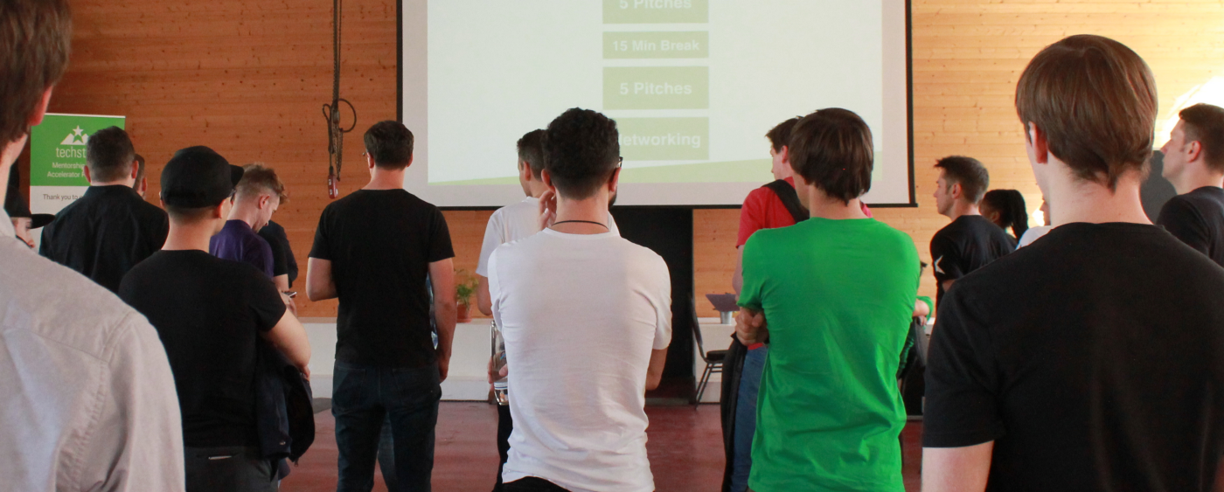

Dress rehearsal for Techstars Berin 2018 demo day — 10 tables of investors, 10 pitches!

Arweave is a high-throughput, low cost, permanent storage solution for the internet. The team is currently finishing up Techstars Berlin with a demo this Thursday for over 100 technology investors from Berlin and beyond.

While not typically known for accelerating blockchain companies, Techstars Berlin welcomed the Arweave project from the UK into their esteemed mentorship program. At the time of starting the programme, we had already launched an alpha version of the Arweave protocol and were then operating under the name Archain. With a focus on scaling up our technical progress, notably the “blockweave”, development has been progressing at a rapid pace. During the programme we have additionally concentrated on consistent branding and community, and Archain was swiftly rebranded to Arweave to further differentiate ourselves from other similarly named blockchain-related projects. Techstars has provided extra inspiration and energy, keeping us excited and on schedule for mainnet launch — now only 50 days away!

“The Techstars programme and mentorship has been fantastic, and the companies and individuals we have met are truly inspirational” — said Sam Williams, CEO of Arweave.

Arweave has also expanded its advisory panel since the beginning of the programme, through connections forged through Techstars’ enthusiastic emphasis on mentorship. These new advisors bring a vast wealth of industry experience to the project, and assist in areas such as business strategy, marketing, and in the implementation of Arweave’s vision.

This week the Arweave team will conclude our time in the three-month Techstars programme by presenting a demonstration to many expert investors. A fantastic opportunity to welcome new high-level supporters into the Arweave community, our team is excited for everything that the future will bring!

-arweave-team

**What is Arweave? Explain Like I’m Five**

[](https://arweave.medium.com/?source=post_page-----425362144eb5--------------------------------)

[The Arweave Project](https://arweave.medium.com/?source=post_page-----425362144eb5--------------------------------)

[Apr 26, 2018·6 min read](https://arweave.medium.com/what-is-arweave-explain-like-im-five-425362144eb5?source=post_page-----425362144eb5--------------------------------)

***“Who controls the past controls the future: who controls the present controls the past.”***

The original vision for the internet was a platform to communicate freely. As the power of what we created was realised it became a place where people could be monitored, controlled, and censored.

Censorship will soon be a forgotten word.

To fight against the direction in which the internet has been taken we’ve created a truly tyranny- and censorship-free new data storage protocol on a blockchain-like structure called the blockweave. The blockweave is based on a novel proof of access consensus mechanism that makes truly permanent, low-cost data storage available for the first time.

Unlike other blockchains, we’ve created truly scalable infrastructure to be the backbone for the data economy, because we’re able to reach up to 5000 transactions per second (TPS), and store data at a fraction of the cost of Filecoin, Siacoin, and Storj.

The blockweave solves two fundamental problems currently associated with public decentralised blockchains:

● On-chain storage constraints; and

● Unsustainable consensus mechanisms

New protocols have had to be built on top of existing infrastructure because fees are too costly for storage on-chain. It’s like reapplying a bandage over, and over again instead of just letting the wound heal. This means there is always going to be a cost to access content, and that content is never stored permanently, and never will be. As the demand for data storage grows exponentially, the need for a decentralized low-cost data storage protocol that permanently stores that data is a necessity.

In this article we explain why it’s important that this problem be solved, for humanity, and for the blockchain ecosystem. More specifically, we explain how we solve these issues in an easy to understand way, because our novel technology has the potential to confuse people reading about it for the first time.

We’ll also touch on our unique token economic structure for miners that means we can guarantee uptime for data with lightning-fast delivery speeds, our beloved SAO (Semi-Autonomous Organisation), as well as examples of unique real world use cases that are currently being built out by our partners, and people like yourself.

**So, Why Now?**

**“With the development of television, and the technical advance which made it possible to receive and transmit simultaneously on the same instrument, private life came to an end. Every citizen, or at least every citizen important enough to be worth watching, could be kept for twenty-four hours a day under the eyes of the police.”**

Last year, $20bn was spent on new data centers alone, nearly double what was spent in 2016… and it’s not slowing down anytime soon.

Throughout technological shifts in history, humans are exponentially creating and storing enormous amounts of data. We started with floppy discs, graduated to CDs, and have now progressed all the way to semiconductor chips capable of storing data in thousands of tiny transistors.

Now just imagine what happens when the next wave of technology comes online and we’re producing data at an exponentially increasing rate.

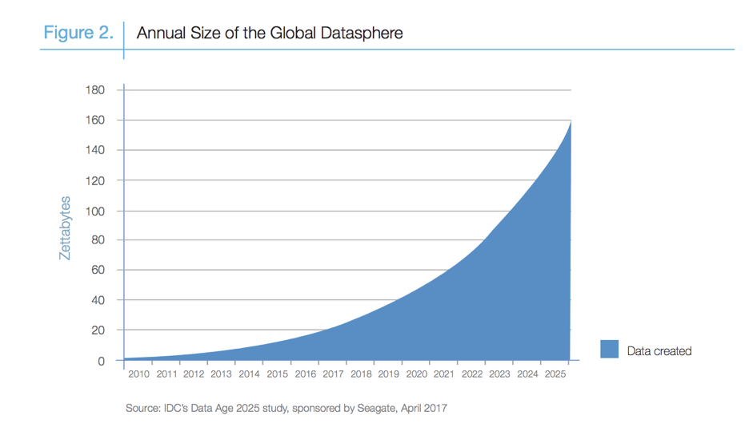

Growing size of the global data economy

As seen above we’re going to be creating 160 zettabytes’ worth of data by 2025.

We’re in a time where we can’t currently keep up with the amount of data being produced and stored in a cost-efficient manner.

With the movement towards decentralisation in full swing, in which a network of peers self-organize to act collectively without large concentrated power centres is rapidly occurring that we’re excited to be a part of. We have been finally able to create a truly public, open, borderless, decentralised, new form of blockchain that will allow anyone to create for our collective future.

**We’ve Solved This with the Blockweave**

The blockweave is a blockchain-like structure designed to enable scalable on-chain storage in a cost efficient manner for the first time. As the amount of data stored in the system increases, the amount of hashing needed for consensus decreases, thus reducing the cost to store data. When compared to the number of miners currently on SiaCoin, Arweave would be able to increase TPS many fold, and lower the long-term cost of storage dramatically.

**Proof of Access**

We realised that current consensus mechanisms (like Bitcoin’s) were unsustainable with their ridiculous energy usage just to keep the system alive. We then came to the further realisation that you could produce a positive externality instead of a negative one to form consensus.

Proof of access is a novel consensus mechanism that produces a positive externality of data storage. Instead of competing to burn as much electricity as possible, miners compete to provide as many replications of the data held in the system as they can. Further, as the blockweave expands in size, the amount of electricity expended in the mining process decreases.

**Wildfire**

Wildfire is the Arweave’s self-organising network topology system. Wildfire ensures that miners are selfishly incentivised to store and share data as quickly as possible with other miners in the network, in order to build a positive reputation.

While more complex under the hood, Wildfire can be summarised as: ‘if you share with me, I will share with you’. As nodes in blockweave networks require fast access to data in order to mine efficiently, they are selfishly-incentivised to give data to other members of the network promptly and continuously, autonomously improving the sharing to lightning-fast speeds.

**Blockshadows**

In order to support a network that allows for long-term on-chain data storage, the Arweave needs a system that supports unlimited sized blocks. The Arweave achieves this by using a system that decouples transaction distribution from that of block distribution in the network. This allows only a ‘shadow’ of the block to be moved around the system (the instructions necessary to rebuild the block from its constituent transactions), rather than full block itself. This means that the information required to process large blocks can be distributed across the network in just a few kilobytes

**Use Cases and Apps**

In broad terms, Arweave is the killer decentralised blockchain whenever large amounts of data need to be stored, because of the unique proof of access consensus mechanism.

By thinking about some core applications that are currently being built, and those that are soon-to-be built, we can run through:

1. **Decentralised data storage:**

Now personal and corporate files can be stored for one single fee, instead of the monthly ongoing costs associated with other storage protocols, making the data immutable, verifiable, and truly censorship-resistant. Depending on the lifetime of storage, the price for the AR tokens can be cheaper than monthly fees for competitors such as Filecoin or AWS. In addition, the blockweave further ensures the availability of data near instantly by its design, with 100% guaranteed uptime through the incentive mechanisms for miners.

**2. Decentralized data sharing:**

With Arweave, any content can be uploaded anonymously and shared to anybody. Imagine a peer-to-peer torrent network where there is always at least 1 seeder, no matter what. As opposed to derivative applications such as Filecoin or Sia, Arweave’s protocol design has an embedded mathematical pricing function, load-balancing demand and supply at fair prices. Any file can now be published anonymously to the world, and stored forever without powerful third parties able to take them down.

**3. Decentralized data collaboration:**

The archaic academic publishing market is currently at $25bn per year, with the market leader Elsevier having higher profits margins than Apple.

Approximately 80% of research papers are non-replicable, due to (among other factors) an unclear connection with the dependent historical research papers, and a lack of availability of previous experimental datasets. Arweave enables the initiation of an immutable decentralized database, opening data to anybody wishing to review and challenge its quality. Cooperation of scientists becomes borderless even for highly regulated data. Every research project can be rewarded by its true impact factor. Arweave has already built a partnership with staff from Charité (the largest university hospital in Germany) to develop a revolutionary new scientific journal.

**4. Decentralized data Identity/Protection:**

Today, valuable content is created online. While the future of content creation is clearly decentralised, proof of its origin, ownership, and its impact is still centralised by regulators and lawyers. With Arweave, every piece of content can be captured with a timestamp and archived in the blockweave providing a clear (and defensible) claim of IP and/or ownership.

If you would like to stay up to date with all the latest Arweave developments, you can find us in the following places: [Telegram](http://t.me/arweave), [Twitter](https://twitter.com/ArweaveTeam), [Facebook](https://www.facebook.com/ArweaveTeam/), [Discord](https://discord.gg/XUQv8Qg), and [Reddit](https://www.reddit.com/r/Arweave/).

As always, if you have any questions you can drop us an email at [team@arweave.org](mailto:team@arweave.org).

-arweave-team

# ****Announcing: The Arweave Community Token Sale, Part Two****

[](https://arweave.medium.com/?source=post_page-----28f2b37c73d6--------------------------------)

[The Arweave Project](https://arweave.medium.com/?source=post_page-----28f2b37c73d6--------------------------------)

[May 18, 2018·7 min read](https://arweave.medium.com/announcing-the-arweave-community-token-sale-part-two-28f2b37c73d6?source=post_page-----28f2b37c73d6--------------------------------)

The Arweave journey began over a year ago, and since then we have built an amazing community that believes in the project, and our goal of building information permanence.

We’re very pleased to announce that we have now successfully completed our community token sale part one, dedicated to those community members who have been there since the beginning of our journey. We allotted over £650,000 (~$900k) worth of tokens from our private sale to these community contributions, because we wanted to make sure as many of our long-term supporters as possible had the chance to participate.

Over the past year we have flown largely under the radar, allowing our team to maintain their focus on shipping our innovative technology ahead of our mainnet launch on the 8th of June (just under 3 weeks now!). Throughout this time, we haven’t undertaken much marketing activity, and so just now the wider blockchain community has begun to discover our exciting project and understand the unique features and solutions we provide. Now, we have over 1,000 people joining the Arweave community every day! As a team we had to sit down and work hard to determine the fairest way to include these new community members in the upcoming sale, which we are calling the community sale part two.

Many people asked us to simply cancel the upcoming sale altogether, and airdrop the tokens instead. However, we realise that denying people that have recently found the project the chance to participate would be frustrating. We considered increasing the overall hardcap of our token sales, but decided against this. We are sticking with our £6.4m (~$8.6m) total hardcap for the combined token sales. Although high hardcaps are quite common in the wider cryptocurrency community, the truth of the matter is that many projects do not need the amount of money they are raising. For example, Ethereum was able to change the entire blockchain world, while enriching an entire community instead of just their own founding team, based on initial contributions of only around $18mm.

After talking to numerous founders of top projects, and taking their expert advice into consideration, we have decided to re-allocate space from the private sale to the upcoming community token sale part two to accommodate additional community members. This ‘community sale part two’ will have a cap of £500,000 GBP (~$675k USD), and will be dedicated to community members who have recently discovered the project. This additional allocation has been taken from what was originally allocated to institutional investors in our private sale, because we want to take care of our community above all. You’re the ones that are going to continue telling your friends and the crypto community about Arweave, so we want to thank you for that.

This still leaves us with the question of how to let thousands of people participate fairly in the community sale part two.

**That’s why we’re instituting a ‘proof of interest’ system for our community token sale part two**

This community sale part two is designed to include community members, as they believe in what we are building, and want to help make our goals a reality in the long-term.

This sale will have a hardcap of £500,000 GBP (~$675k USD), much of which was originally allocated to strategic and institutional token buyers in our private token sale. These institutional partners have already introduced the Arweave project to many potential partner-projects and other services that will help the project grow. In order to make room for the community sale part two, we have pushed the institutional AR purchasers down to the smallest quantities possible. £500,000 GBP (~$675k USD) may not seem like much, but along with the community sale part one, and the seed sale last year, the community accounts for a large portion of the combined sale hardcap.

**So, what is ‘proof of interest’?**

We don’t want there to be a ‘gas war’ as people try to enter our sale, as this isn’t beneficial to individuals, the project, or the community as a whole. We understood by the thousands of whitelisting applicants we’ve received that without designing a solution, gas wars or other unwanted outcomes would have been inevitable.

Let’s start with a story of how this idea came to life. Over the past weeks, our community Telegram group has grown from 3,000 people to over 25,000 people! These are a group of people that care about the project in the most amazing ways.

People from all corners of the globe have approached us, bringing ideas of what to build on top of the Arweave, ways to spread the word through blog posts explaining what we’re building, and many other exciting ways to build and strengthen our community even further. These are the people that have already demonstrated they’re here to build a genuine community through education, and creation.

Arweave is not a short-term project, instead growing in strength year-on-year as together we continue to expand the network and build up the volume of information stored on the blockweave. That’s why we’ve decided to add an additional step to whitelisting for our community sale part two that will help prioritize our dedicated community of Arweavers, who are here with us for the long-term. Because we are implementing this system, we’re no longer referring to this token sale as a ‘public’ sale, but as an extension of our ‘community’ sale, as allocations will only be available to committed members of the Arweave ecosystem.

In order to help us reward and prioritise the members of the community that will help grow the project, we are splitting applicants into the following categories:

**Creators**Arweave’s unique technological features allow many applications and pieces of software to be created for the very first time. Many developers have already approached us with suggestions of apps and software that they would like to build on top of the Arweave. The creators category isn’t just for developers, though — already, people are writing blog posts, creating videos or podcasts, and showcasing the unique use cases that Arweave helps to enable, and we would love to encourage this!

**Archivers**Arweave’s provision of truly permanent storage offers a vast range of opportunities for collecting and preserving vital pieces of information. We want to encourage archivers to build a vast trove of human knowledge and experience inside the Arweave, such that it is permanently available to all those that will follow in the future.

**Traders**  
This describes people who primarily want to buy, sell, or hold AR tokens. Traders form an important part of the token ecosystem, as they provide tokens to those who want to purchase tokens to use for data storage on the Arweave network.

**Miners**Many people are already preparing to start mining activities on the network, vital work for the perpetuation of all the important information stored on the blockweave. Mining activities on the Arweave network are a little different than with traditional blockchains, due to our proof of access consensus mechanism. You can read more about this in our explanatory blog post [here](https://medium.com/@arweave/what-is-arweave-explain-like-im-five-425362144eb5).

Already people are asking to store amazingly sentimental belongings and information on the Arweave, so that they can be perpetuated forever. All of this is in addition to the more traditional types of information that people may seek to archive — for example, historically or societally important documents and records, scientific or research data, and many more possibilities.

Help us get the word out by creating and sharing blog posts, tweets, articles, videos, about anything you want archived permanently on our genesis block.

To help us understand how you plan to contribute to the Arweave community you’ll need to submit your proofs via our ‘proof of interest’ form. After you complete the initial whitelisting application via [our website](https://arweave.org/), you will receive an email with instructions and a link for completing the proof of interest form. If you have already completed the initial whitelisting process via our website, you will be receiving an email shortly containing instructions and a link for completing the proof of interest process.

Once we have received all of the applications, we will contact individuals with information about what allocations we can offer.

We are excited to support you all as we work together to make the Arweave a success!

Best regards,  
-arweave-team

Below we’ve included the most commonly asked questions about the community sale part two, which we will keep updating to make your life easier.

**When will the community sale part two happen?**The token sale allocations will be announced once the proof of interest applications have been received and decisions made. After we make allocation offers the transfer period for making payments will run for 4 days.The sale will conclude before our mainnet launches in the 8th of June.

We are not currently accepting any payments, so please be aware of scammers! If you are in any doubt or have questions about anything, please email us directly at [team@arweave.org](mailto:team@arweave.org).

**What countries cannot participate?**As per advice from our legal team, we cannot accept funds from the USA, China, North Korea, or Iran.

**Will there be a lockup period on tokens purchased in the sale?**No.

**When will tokens be released?**After the main Arweave network launches on June 8th.

**What is the minimum or maximum you can purchase?**We will let individuals know about their specific allocations via email in the near future.

**Is AR an ERC-20 token?**No. Arweave is a new form of blockchain protocol and so we will be issuing native tokens at mainnet launch.

**Hardcap?**The combined hardcap for all Arweave token sales is £6.4mil GBP (approximately $8.7mil USD). The hardcap for the community sale part two specifically is £500,000 GBP (approximately $675,000 USD).

**When will you close the whitelist for the sale?**The whitelist will be closed shortly before we make our allocation decisions, so that we can consider all applications fairly and in detail.

# ****Arweave Network Launch Report****

[](https://arweave.medium.com/?source=post_page-----b7e7ffac0f75--------------------------------)

[The Arweave Project](https://arweave.medium.com/?source=post_page-----b7e7ffac0f75--------------------------------)

[Jul 13, 2018·3 min read](https://arweave.medium.com/arweave-network-launch-report-b7e7ffac0f75?source=post_page-----b7e7ffac0f75--------------------------------)

It’s a success… Welcome to Arweave!

We wanted to say a big thank you to everyone that was involved in getting Arweave mainnet off the ground!

We realise that our community is the number one reason for success or failure in distributed networks, so unlike a lot of sales who just let in institutional backers, we opened multiple rounds to our dedicated and dynamic community.

Just before the sale we had over 15,000 people complete a double opt-in process for the whitelist to purchase AR tokens from a total whitelist of over 30,000 unique people.

**1,800 hand-picked participants from over 150 countries.**

Because we decided to do a small sale we offered allocations to a mix of institutional token buyers and community members, all of whom can help us and support the project over the long term.

This was especially important given the fact we had a small amount of tokens available, and 30,000 people trying to purchase them!

Given the very high demand for tokens, we decided to implement a multi-step application process to determine who was going to be able to drive adoption and utility for the Arweave ecosystem.

We’re lucky enough to have a highly engaged and creative community that contributed some amazing ideas about how they wanted to use the Arweave. We had people creating Arweave graffiti, Arweave dApp creators building prototype applications, and archivists digitising vintage Soviet magazines and newspapers that were thought to be have been gone forever!



One user spread the word about Arweave in a unique way!

Another of our favourite submissions was from Brian and his family from South Africa, who shared with us their deep desire to permanently preserve Brian’s grandfather’s war diaries on the Arweave. This will also be part of our upcoming community stories that we will be releasing.

In addition to individual community members, we are proud to have brought a wide array of great institutional partners, as well as some very influential individuals in the space who will all be helping Arweave out for the long term.

These include 1kx, JD Capital, Arrington XRP Capital, KuCoin Capital, Connect Capital, iAngels, Signum, Factblock, GBIC, Bixin, Nirvana, AlphaBlock, Coefficient Ventures, Block0, Columbus, Juno Capital, 160 Capital, QCP Capital, One Block, Chainfund Capital, and TLDR, to name just a few. As well as some very influential individuals in the space.

**Every single decision we make is focused on the long-term.**

Now, many of you may want to read that sentence again because it’s core to how we operate.

The road to success is long, which many people will overlook. Sometimes we’re going to make decisions as a company that may not make sense for the short term community members, but are the best decisions for the project over the long term. This may not make sense all the time to some people, however this is our approach.

This long term value creation endeavour will be fundamental to our long term success, and our decisions will be weighed based on a community first approach.

We must remind everyone that this a new world. Since Arweave was founded we’ve learnt a lot about decentralised networks and we will be continuing to innovate in the future. In the front of our minds is the need to move quickly and be ahead of the pack, just as we have been by launching mainnet so promptly and before most other networks.

We are thrilled that you are joining us on our journey into the future, for the many years and decades to come.

To keep up to date with all the latest Arweave developments, join our announcements channel [here](https://t.me/arweaveannouncements) on Telegram.

-arweave-team

# Building the Decentralised Web — Part One: The Problem

[](https://arweave.medium.com/?source=post_page-----9766f1987c91--------------------------------)

[The Arweave Project](https://arweave.medium.com/?source=post_page-----9766f1987c91--------------------------------)

[Jul 27, 2018·3 min read](https://arweave.medium.com/building-the-decentralised-web-part-one-the-problem-9766f1987c91?source=post_page-----9766f1987c91--------------------------------)

This is the first in a series of blog posts that will define the Arweave organisation’s strategy for building a new, decentralised, immutable web. This first installment will discuss the problems with the existing web, and in later posts we will detail our proposed solutions to said problems.

The road to this new type of decentralised web will almost certainly be as surprising and chaotic as the original web. What we lay out in these blog posts is just a starting point. No doubt plans, communities, and utilisation of the technology will change between today and the eventual integration of this new system into the mainstream. The role of the institutions at the heart of the Arweave project is not to dictate how this new system should work or how people should use it — attempts to do so would surely fail. Our job, instead, is to provide the catalyst necessary to get the ecosystem up and running, then step back and support the community’s desires as best as we can, letting them take the reins.

So, without further ado:

# ****The Problem****

Power over the internet has become centralised in the hands of a small number of people, often working against the wishes of the majority. Simultaneously the web has become so central to our way of life, that it has become an integrated part of our thinking and decision making. What started as a grand experiment in the free-flow of information has become increasingly controlled, monitored, and modified by a powerful minority of actors.

The core issues include:

## **Mutability of information access**

Information available today may not be available tomorrow. Publication on the web used to be synonymous with making that information permanently available. While this idea was never wholly accurate, it has become decreasingly so over time — content is [lost](https://www.theatlantic.com/technology/archive/2015/10/raiders-of-the-lost-web/409210/), [censored](https://futurism.com/unsafe-vaccines-china-blockchain/), and [altered](https://www.nytimes.com/2016/09/25/public-editor/liz-spayd-new-york-times-public-editor.html) at an alarming rate on the modern web. The fact that the HTTP status code ‘404’ has now entered the mainstream vocabulary is a testament to how common this phenomenon is.

## **Control over publishing and free flow of ideas**

Free expression on the internet is now mediated by a small number of centralised parties. Say something they don’t want to hear? Expect to have your content removed. Increasingly, social networks, blogging, and other publishing mechanisms are enforcing stringent rules on content that sometimes cause censorship of valuable [information](https://www.theguardian.com/technology/2017/mar/20/lgbt-community-anger-over-youtube-restrictions-which-make-their-videos-invisible).

## **Pervasive surveillance**

Governments and corporations alike now monitor and log your web searches, the content you read, and the posts you make. This would not be important perhaps, if it wasn’t for the fact that the web has become an extension of most people’s brains.

Corporations sell this data about your inner thoughts to advertisers that use it to make you more likely to buy their products (it really works — just check out Google’s [market cap](https://www.google.com/search?q=NASDAQ:GOOG&tbm=fin#scso=uid_OzBbW5ecDuzjkgWHtY-ADg_6:0)).

Governments store this data in bulk, building a fuzzy record of your thoughts and psyche over time. Many people trust their current governments, and subsequently do not view this surveillance as a concern. The issue then, is perhaps not what your current government will do with the data, but what a future government might do with it. Are you totally confident that a government you do not trust with your inner thoughts and feelings will never come to power in your country? A large number of recent elections in the western world show us that even the most democratic nations can be unpredictable in their choices.

Now we have specified some of the problems the next web needs to address, our next blog post will describe the components that will be needed to embed this system in our wider culture.

If you would like to keep up with the Arweave project, please drop us your email on our [website](https://arweave.org/).

-arweave-team

# ****Building the Decentralised Web — Part Two: The Components****

[](https://arweave.medium.com/?source=post_page-----97409d1fe545--------------------------------)

[The Arweave Project](https://arweave.medium.com/?source=post_page-----97409d1fe545--------------------------------)

[Sep 4, 2018·4 min read](https://arweave.medium.com/building-the-decentralised-web-part-two-the-components-97409d1fe545?source=post_page-----97409d1fe545--------------------------------)

This blog post is the second in a series about Arweave’s plans to build a decentralised, immutable web. If you would like to read the first part, click [here](https://medium.com/@arweave/building-the-decentralised-web-part-one-the-problem-9766f1987c91). In this second instalment of the series, we will be discussing the necessary components of the decentralised web, and how the Arweave project is attempting to build them.

Want to hear more about the Arweave decentralised web? Come and join us in Berlin for [Dezentral](https://www.dezentral.io/) and Kiev for [Blockchain UA](https://www.dezentral.io/) this month, where Arweave CEO Sam Williams will be speaking!

**Data Storage and Retrieval**

The web as we understand it today is largely a system of data storage and retrieval. A publisher stores data onto a server that then feeds this information back to users that request it. The user’s web browser then formats and displays the data, where it is then viewed by the user before they move onto another page, repeating the cycle. As mentioned in our first blog post, the current web is increasingly centralised — controlled and governed by selected but unelected groups. The Arweave, through mechanisms outlined in our [lightpaper](https://arweave.org/files/arweave-lightpaper.pdf), can already achieve the data storage and retrieval functions of a web in a completely decentralised manner: data is submitted to miners on the Arweave, who come to consensus about its contents and then the miners store said data in a block.

The fee submitted by the publisher is dispersed over time to miners in the network that maintain copies of the data and serve them to users’ browsers on request. Rather than just emulating the existing web in a decentralised way, the Arweave solves one of the major problems identified in part one of this series — mutability of information availability.

The Arweave uses cryptography and decentralised incentives to ensure that all of the data in the Arweave is available in an unmodified form, all of the time. In short: we replace the useless energy expenditure associated with Bitcoin with valuable storage and serving of data.

**Querying**

The vast majority of websites on the internet that are not simple data storage and retrieval mechanisms, under the hood, are dynamic database applications that query and return data to the user in a styled format. Facebook, Twitter, Medium, etc, all follow this basic principle. In order to support these kinds of applications in a totally decentralised manner, Arweave nodes optionally expose an ArQL service that user applications can query to find and return data from the blockweave (for example, tweets, blogs, and other user data).

A common pattern we anticipate with the Arweave’s decentralised web is that web applications (bundled HTML, CSS and Javascript) will be stored on the Arweave, and they will then make queries to ArQL nodes, retrieving application data that is stored on the weave, as necessary. Users will then be able to post data onto the weave, from their web apps, using their wallet and an Arweave node’s HTTP service. This pattern allows the developer to build an entirely decentralised application easily, with their normal programming languages and tools.

**Accessibility**

In order for the decentralised web to be adopted by the mainstream, wide, simple accessibility will be key. In order to address this, we have engineered the Arweave using standard web protocols, accessible in any modern browser. When a link on the Arweave network is created, it will always be available, and will always serve the same data to you.

In order to allow users who have yet to install the Arweave web extension access to the data held on the weave, we will be providing a special domain that will forward users to an Arweave node serving the data. When users with our web extension visit one of these links, they will automatically be transferred by their browser straight to an Arweave node — avoiding the point of centralisation. This means that users can be introduced to the ecosystem of the decentralised web without having to install or change anything about their setups.

**Incentives**

In order for data to remain freely accessible to everyone somebody, somewhere must have an incentive to serve it. In the case of the current web, Google, Facebook, etc, are incentivised to store, perform queries on, and return your data, because they can use your personal data to generate revenue. In the decentralised web on the Arweave, we have taken the ‘proof of work’ system at the core of Bitcoin and Ethereum, and modified it so that it has a positive utility: the serving of web pages. This system provides Arweave miners with a selfish incentive to store your data without compromising your privacy, solving one of the key issues described in part one of this series. Encrypted data stored on the Arweave is accessible to you and only you — and the people serving you the data are incentivised to give it to you.

While all of these components will be necessary for the decentralised web, they will likely not be sufficient alone. The Arweave project intends to be adaptive to the emergent needs and requirements of our new ecosystem as they arrive.

If you are interested in hearing more about the Arweave’s decentralised web make sure to subscribe to our Medium blog here for the next instalment in this series, and other updates and news.

# Arweave Autumn 2018 Update — N.1.5 Release Approaches!

[](https://arweave.medium.com/?source=post_page-----fcdd9c4114af--------------------------------)

[The Arweave Project](https://arweave.medium.com/?source=post_page-----fcdd9c4114af--------------------------------)

[Sep 19, 2018·4 min read](https://arweave.medium.com/arweave-autumn-2018-update-n-1-5-release-approaches-fcdd9c4114af?source=post_page-----fcdd9c4114af--------------------------------)

Today we’re very pleased to share the Arweave Autumn 2018 update. Here, we will give you an overview of what we have been focused on recently, and which exciting new developments and releases are right around the corner.

# Arweave version 1.5 is coming very soon!

After a Herculean effort from our development team, the Arweave network version 1.5 is nearing release! This version builds considerably on the initial main network release, refining a large portion of the codebase and delivering much faster data access, a more resilient network, and a smoother, more efficient experience for our mining community! This has been the focus on our dev team’s work since mainnet launch (we just passed over 1000 commits to our open source GitHub repository!) so we’re really excited to get this shipped. Looking forward, the team is also starting to make plans for the N.2.0 release, the first protocol upgrade for the Arweave network.

Miners should expect to see a test version available to use very soon — we will contact everyone on our mining mailing list when it becomes available. To sign up to the mining mailing list, drop us an email at [team@arweave.org](mailto:team@arweave.org), and we will also send you a copy of the ‘getting started’ mining guide.

# Block explorer release later this week

The first external Arweave block explorer will be released later this week! The explorer has been in internal beta for a while now, and we’re very excited to share it with you all as it moves into its public beta phase this week. With a sleek, simple user interface, range of features, and efficient user experience, we think you’ll love it.

Stay tuned to our Telegram announcements channel [here](https://t.me/arweaveannouncements) to be notified of its release!

# New and improved Arweave web extension wallet

Soon we’ll be pushing out a major update to the Arweave web extension, offering our community a wide range of new features, a sleeker user interface, and overall making it more robust and even easier to use.

Here are some sneak peeks of the new user interfaces…



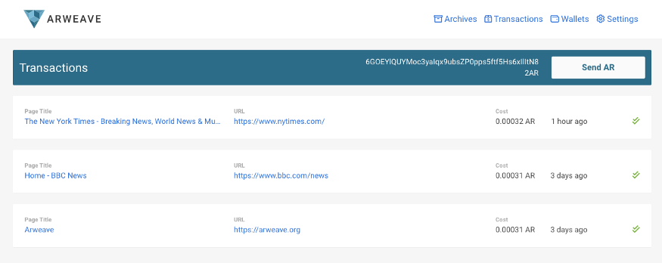



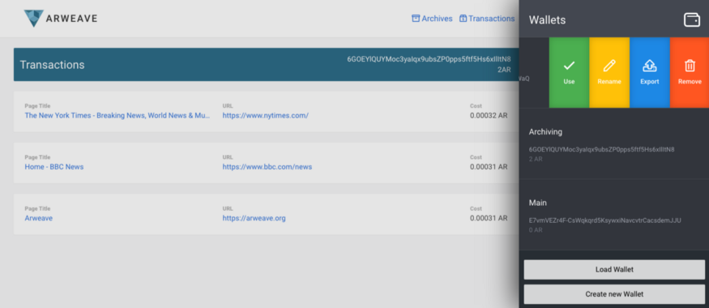

Thank you to those who offered feedback and feature suggestions — we appreciate you taking the time to contribute to the project, and we believe you will be very pleased with the new extension! We look forward to hearing your future feedback, too — [keep in touch](mailto:team@arweave.org)!

# We’ve been spreading the message of Arweave across the world!

Our CEO Sam Williams recently delivered great talks about Arweave and our new technological advancements at Dezentral in Berlin, and Blockchain UA in Kiev, and gave a range of interviews with exciting individuals and organisations. Follow us on [Twitter](https://twitter.com/ArweaveTeam) for links to all videos, articles, and appearances as they are released!



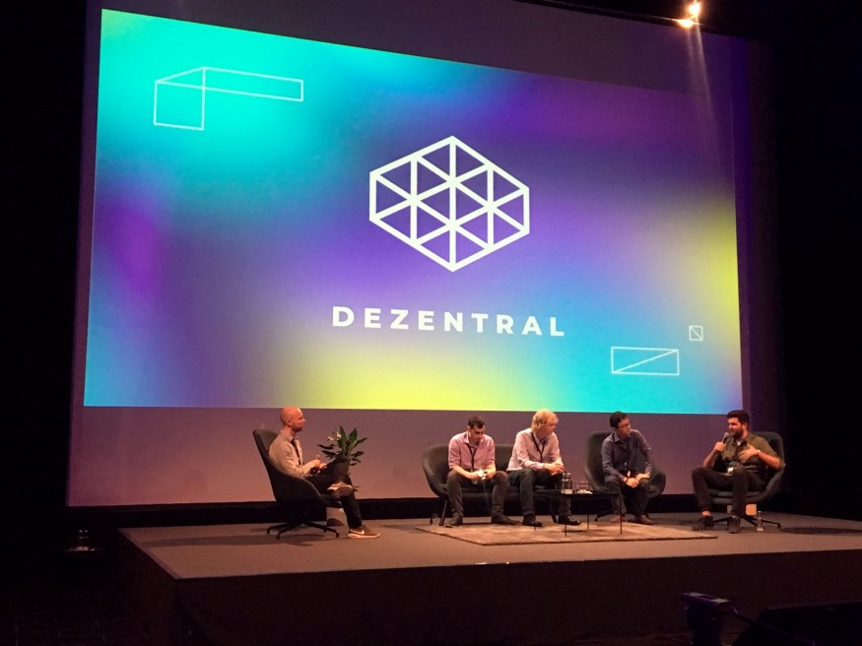

Arweave CEO Sam Williams alongside leaders of Zilliqa, Parity Technology’s Polkadot, Zen Protocol, and FOAM Protocol for the Dezentral Special Purpose Blockchains panel discussion.

Our CEO has several more upcoming appearances soon, including with [The Blockchain Society in Berlin](https://www.eventbrite.ca/e/the-blockchain-society-berlin-conference-w-ocean-protocol-xain-arweave-tickets-49718746108), and presenting Arweave at a [blockchain developer meetup](https://generalassemb.ly/education/meet-the-berlin-crypto-community-polkadot-gnosis-arweave-oscoin/san-francisco/60007) for Blockchain Week in San Francisco in October. Stay tuned to our Twitter or Telegram announcements channel to hear more. We sincerely hope we’ll see many of our community members there — looking forward to chatting with you!

# The ArchiveIt! permanent backup app progresses

Our team continues to work on new features and UX/UI improvements for Arweave’s own file storage and backup app. The permanent backup system will allow everyone to use AR tokens to simply and permanently store their files on the blockweave. Never worry about losing family photos or important notes again!

# Our strong team is growing even stronger

We recently took on four new employees, and we are looking to fill two further roles in the near future. Our team is still small, but we are relentlessly pushing forward and continuing to prioritise concrete products, milestones, and achievements above all else. We’re looking forward to having more team members to help us achieve our ambitious goals!

# Decentralised Public Library initiative launching soon

Later this week we will be releasing details of a brand new initiative as part of the wider Arweave project — the Decentralised Public Library! The DPL will work to fulfil Arweave’s long-term goal of building a permanent, verifiable, and censorship-resistant archive of human history and knowledge by collaborating with a wide range of institutions and individuals. DPL will be laser-focused on storing unique or vulnerable information on the Arweave, building up the permanent store of data and the backbone of [the new immutaweb](https://medium.com/@arweave/building-the-decentralised-web-part-one-the-problem-9766f1987c91). This is part of our long term mission for making Arweave humanity’s go-to store of valuable information for many generations to come.

Further information about the DPL is coming soon! Stay tuned to us here on Medium for all the latest news.

As always, thanks for being part of the Arweave community! Keep in touch [via email](mailto:team@arweave.org), in [our Telegram group](https://t.me/arweave), and on our [dedicated Discord server](https://discord.gg/DzNZPaZ). To hear all the latest Arweave news, follow us here on Medium, and join us on [Twitter](https://twitter.com/ArweaveTeam)!

-arweave-team

**Announcing the Decentralised Public Library!**

[](https://arweave.medium.com/?source=post_page-----cc3dd0235d3--------------------------------)

[The Arweave Project](https://arweave.medium.com/?source=post_page-----cc3dd0235d3--------------------------------)

[Sep 28, 2018·4 min read](https://arweave.medium.com/announcing-the-decentralised-public-library-cc3dd0235d3?source=post_page-----cc3dd0235d3--------------------------------)

Today we are thrilled to announce a brand new initiative — the Decentralised Public Library (DPL)! A component of the wider Arweave project, the DPL will be laser-focused on creating a truly permanent hand-curated archive of human history.

The DPL will permanently preserve vital pieces of human knowledge, utilising the unique features of the blockweave to safeguard this data, ensuring reliable access for all future generations.

Why launch the DPL?

Simply put, information in archives, libraries, data centres, online, and even in our own homes is surprisingly [vulnerable](https://thestack.com/data-centre/2016/08/10/data-centres-are-we-underestimating-physical-risk/) to accidental or intentional damage and loss. Just like any physical building, libraries, archives, and data centres suffer [from](https://en.wikinews.org/wiki/Fire_ravages_large_academic_library_in_Moscow) [fires](https://blog.archive.org/2013/11/06/scanning-center-fire-please-help-rebuild/), theft, and [natural disasters](https://www.theregister.co.uk/2009/06/12/lightning_strikes_amazon_cloud/), despite their best efforts.





Results of a fire in the Institute of Scientific Information on Social Sciences of Russian Academy of Sciences, Moscow, on the 31st January 2015

Sadly, even using a cloud storage service doesn’t guarantee your data’s safety. With a cloud provider, your data can become inaccessible, changed, or even lost for a lot of different reasons, including if:

* The company stops offering the storage service or goes [bankrupt](https://techcrunch.com/2013/09/27/its-official-the-nirvanix-cloud-storage-service-is-shutting-down/)
* The data is found to contradict their [storage policies](https://upthere.com/legal/terms-of-service)
* Their servers are subject to [malicious attack](https://www.wired.com/2012/08/apple-amazon-mat-honan-hacking/)
* Their data centres are [physically damaged](https://www.zdnet.com/article/tokyo-earthquake-tsunami-puts-data-centers-cloud-services-at-risk/)
* They have a [service outage](https://www.theregister.co.uk/2018/07/04/ibm_cloud_outage/)
* A member of staff [accidentally](https://www.theregister.co.uk/2017/08/06/cisco_meraki_data_loss/) [deletes](https://www.zdnet.com/article/aws-cloud-accidentally-deletes-customer-data/) your data
* You stop paying their service fees
* They experience a [technical glitch](https://www.zdnet.com/article/dropbox-sync-glitch-results-in-lost-data-for-some-subscribers/)

So, although cloud storage services are simple to use, they don’t provide a truly reliable and permanent means of securing humanity’s collective knowledge-base.

As well as accidental damage, information is also vulnerable to purposeful attack. For example, there are [many](https://www.ushmm.org/collections/bibliography/1933-book-burnings) [examples](https://www.freedomforuminstitute.org/first-amendment-center/topics/freedom-of-speech-2/libraries-first-amendment-overview/banned-books/) from history when information in archives and libraries has been [censored](https://newseumed.org/artifact/photographic-lies-in-stalins-russia-online-exhibit/) and [destroyed](https://en.wikipedia.org/wiki/2014_unrest_in_Bosnia_and_Herzegovina#Damages) by [government](http://www.beaconforfreedom.org/liste.html?tid=415&art_id=555) or [other political forces](https://www.independent.co.uk/news/world/middle-east/isis-burns-thousands-of-rare-books-and-manuscripts-from-mosuls-libraries-10068408.html). Sadly, these problems continue today. For example, the Cambridge University Press complied with a branch of the Chinese government and [censored hundreds](https://www.rfa.org/english/news/china/journal-08182017122317.html) of academic articles, which now can’t be accessed from China.



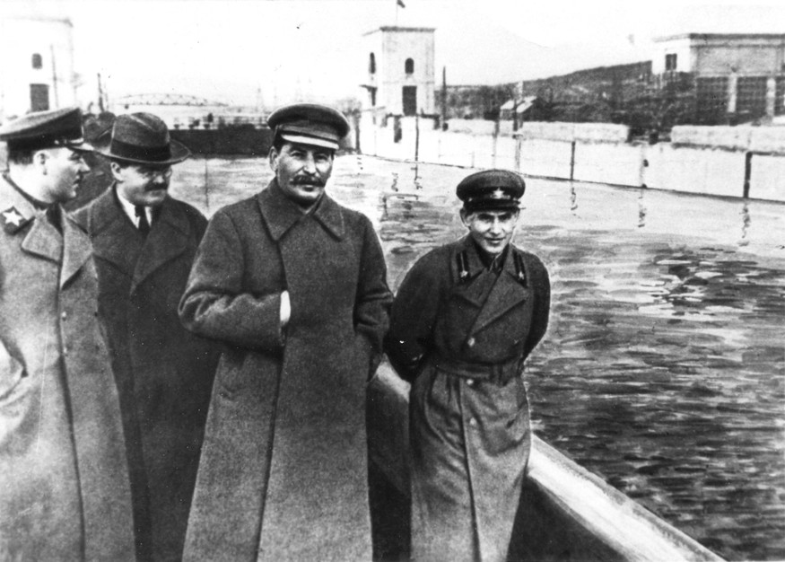





Before (top) and after (bottom) secret police official Nikolai Yezhov was removed from official images by USSR government censors, following his fall from Stalin’s favour.

If you’re interested in how Arweave combats political censorship, check out this talk by our CEO Sam Williams titled ‘[Fighting Authoritarianism With Blockchain and Blockweaves](https://youtu.be/hd8IQRm0Q1k)’.

Therefore, although many organisations collect and store information, traditional technology can’t guarantee the safety of this data for future generations.

The DPL will solve this problem by utilising Arweave’s decentralised blockweave technology, to build a permanent archive of human knowledge and history!

To learn more about how the blockweave works, you can check out our explanatory blog post [here](https://medium.com/@arweave/what-is-arweave-explain-like-im-five-425362144eb5).

What is the goal of the DPL?

In short, the goal of the DPL is to ‘**defeat data death**’ — that is, to prevent the accidental or intentional loss of information from human consciousness. **We want to make information immortal, and we have the technology available to do so.**

The DPL work closely with large information sources such as libraries and archives, but also with small and unique sources of primary data sources. For example, if you or a family member have a special collection of documents — perhaps your grandfather’s war diaries, an array of vintage newspapers, or even an old hard drive stocked full of internet memes — the DPL will [want to speak with you](mailto:team@arweave.org)! The aim is to make the process cost-free, simple, and convenient for those providing data, making it easy as possible to get this information preserved. The aim is to collect a wide array of data from across the globe, though for practicality reasons we will focus on English-language data sources initially, looking at expansion in the future.

The Arweave project itself will donate storage space on the blockweave for use by the DPL, offering the permanent back-up of historically important or obscure data at no additional cost.

How does this affect AR token holders?

As the DPL matures and grows, more and more valuable data will be held on the blockweave and will be intrinsically linked to the AR tokens that you hold. This will drive further growth, adoption, and awareness, especially when information has been altered or removed elsewhere on the internet, but remains in its original form on the weave. In turn, increased awareness will bring even more archivers storing information, developers creating apps, and more miners providing vital storage!

We firmly believe that this will boost mainstream awareness of Arweave as the blockweave becomes the primary, most reliable source of historically and socially important information. This feeds into the long-term mission of the wider Arweave project — the creation of a truly permanent hand-curated archive of human history.

If you have interesting data that you think the DPL should store, please get in touch! You can drop us an email at [team@arweave.org](mailto:team@arweave.org) any time — we would love to speak to you!

If you are interested in reading more about how Arweave achieves truly permanent data store in a ‘pay once, access forever’ model, check out our explanatory blog post [here](https://medium.com/@arweave/what-is-arweave-explain-like-im-five-425362144eb5)!

As always, if you want to keep up to date with the Arweave project follow us here on Medium and also over [on Twitter](https://twitter.com/ArweaveTeam).

-arweave-team

# ntroducing the Arweave web extension 2.0!

[](https://arweave.medium.com/?source=post_page-----dd706d1c9523--------------------------------)

[The Arweave Project](https://arweave.medium.com/?source=post_page-----dd706d1c9523--------------------------------)

[Nov 1, 2018·9 min read](https://arweave.medium.com/introducing-the-arweave-web-extension-2-0-dd706d1c9523?source=post_page-----dd706d1c9523--------------------------------)

We are super excited to announce the release of our updated Arweave web extension wallet, which you can [download here](https://go.arweave.org/e4u1-chrome-wallet). If you have an existing wallet you should already be familiar with the basics, however if it’s your first venture into the wonderful world of Arweave: don’t sweat it, because we’ve put together a step-by-step guide to ensure that you can get up and running in no time.

## **Getting Started**

Setting up your wallet is super easy, simply click the Arweave icon in your browser menu to get started. If you’re a first time user select Create a new wallet, and if you have an existing Arweave key file, you can select Import an existing wallet. For those of you with existing wallets, you can jump to the ‘Existing Users’ section further down the page.



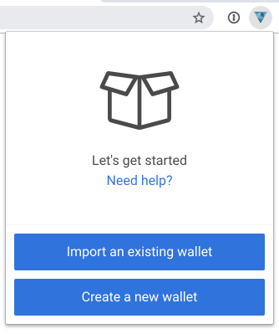

## **New Users : Generating Your Wallet**

If you’re using the Arweave wallet for the first time and have selected Create a new wallet, this will prompt the Arweave extension to open and automatically download your key file.

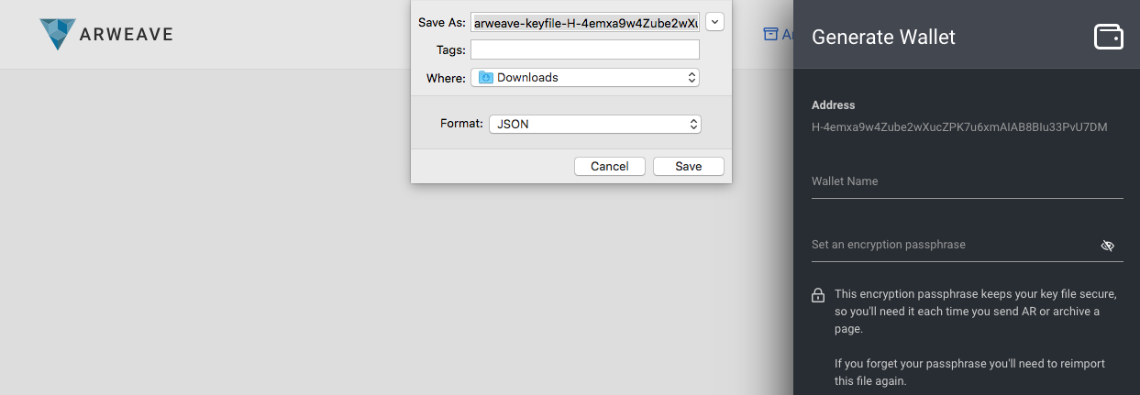

This key file is for your newly generated Arweave wallet that **you must keep safe and secure**. By safe and secure, we mean keeping it protected from loss or misplacement as it’s not possible to regenerate. In simpler terms: once it’s gone, it’s gone! We always recommend storing it in a safe location on multiple (at least 3) devices. We also recommend that you encrypt the file, as anyone who has access to it also has access to your wallet. For more information, check out the encryption tips section at the bottom of this post.

You only have one chance to download the key file, however if for some reason the download couldn’t be completed, you can start the process all over again and a fresh wallet will be generated.

## **New Users: Protecting Your Wallet**

Once you’ve given your wallet a name and set an encryption passphrase, click Continue.

**This encryption passphrase is only used for the copy of the key file stored in the Chrome extension, it is in no way related to the JSON file you first downloaded — this downloaded file will remain unencrypted unless you choose to encrypt it! For more information, check out the encryption tips section at the bottom of this post.**



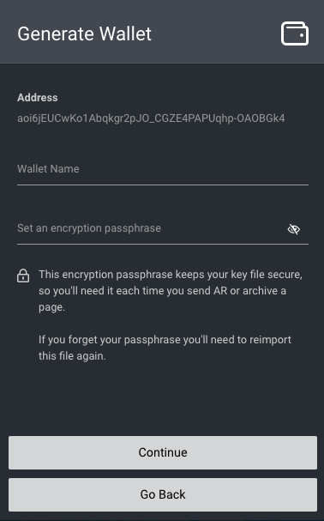

**New Users: Your Encryption Passphrase**

In addition to downloading the key file to your computer/hard drive, a copy of the file will also exist in the web extension. Don’t worry though, your browser storage is secure and there are lots of mechanisms to stop malicious content (like websites and other extensions) from accessing it. However, this doesn’t stop anybody with physical access to your machine, so setting an encryption passphrase adds an additional layer of protection.

Note: using your chosen encryption passphrase is the only way to decrypt your wallet again, meaning that you’ll be prompted for it each time you perform actions such as archiving a web page, or sending AR to another user/wallet. If you forget this passphrase there is no way to reset it, you must re-import the file (as explained in the ‘Existing users: Loading your wallet’ section below).

Your wallet is now loaded, secured, and ready to go! Cue fanfare! 🎉

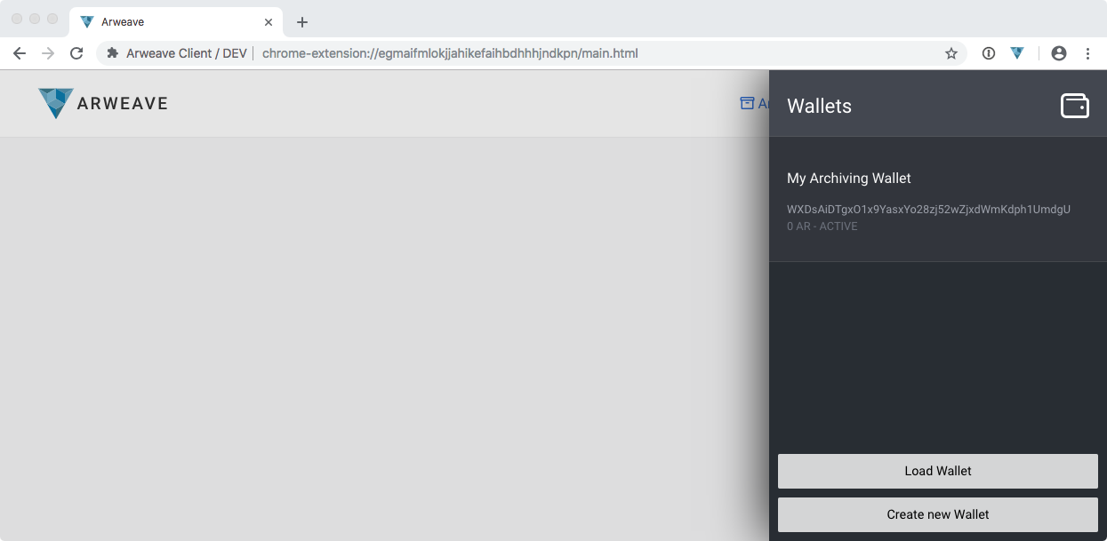

To navigate back to the wallet menu or add another wallet, click any of the two options below:

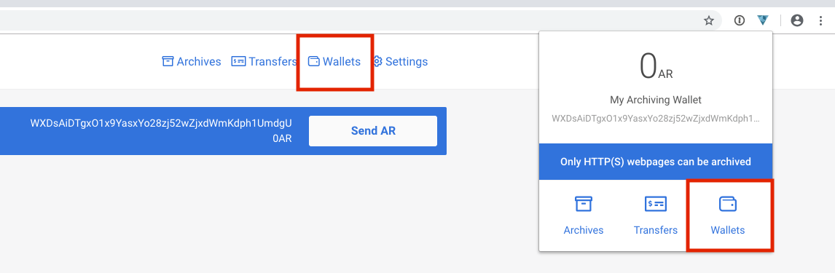

## **Existing Users: Loading Your Wallet**

If you already have an Arweave key file, you can dive straight into loading your wallet by clicking the Arweave icon in the Chrome browser menu, then selecting Import an existing wallet.

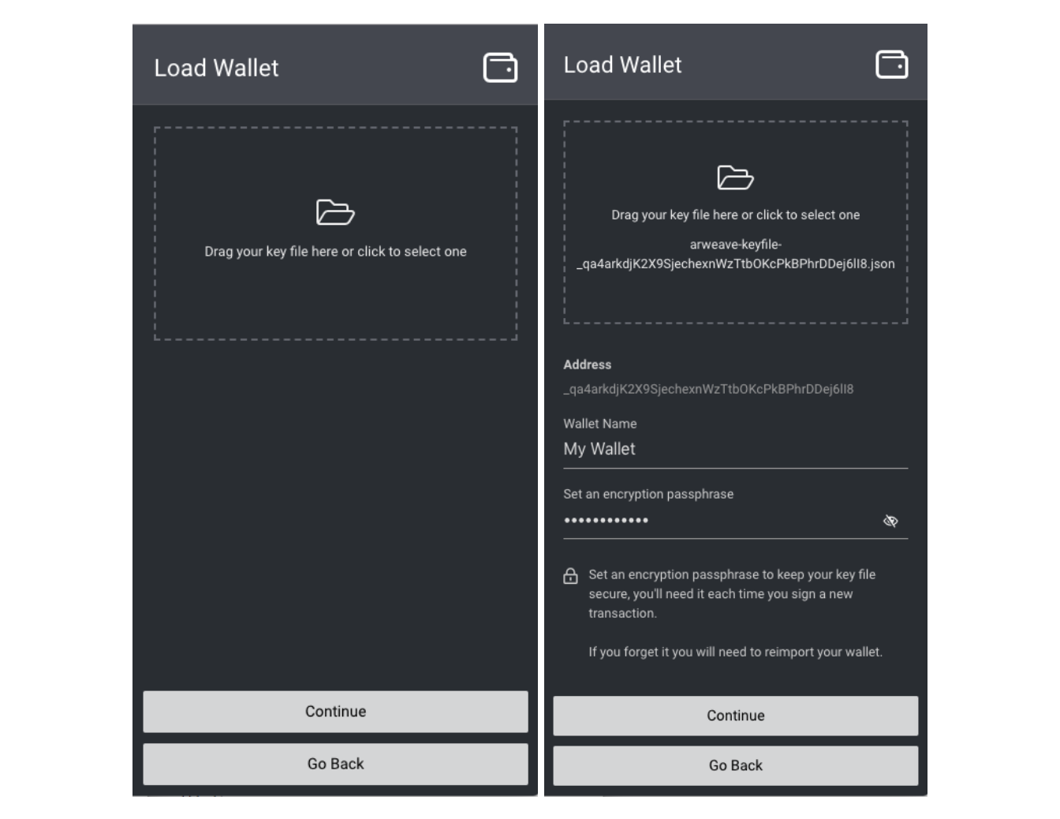

Load your existing key file by clicking the folder icon, or by dragging and dropping it into the highlighted box. You are also required to give your wallet a name and set an encryption passphrase, as this keeps your wallet secure while it is loaded into your web extension - preventing anyone apart from yourself from sending tokens or archiving content.

**This encryption passphrase is only used for the copy of the key file stored in the Chrome extension, it is in no way related to the JSON file you first downloaded — this downloaded file will remain unencrypted unless you choose to encrypt it! For more information, check out the encryption tips section at the bottom of this post.**

Click Continue and you’re done! Hooray 🎉

## **Wallet Options & Multiple Wallets**

You can load multiple wallets into the web extension at any time, by simply heading to the wallets menu and clicking Load Wallet or Generate New Wallet — the process is exactly the same as the first wallet.

To switch between wallets, left-click the extension icon, then select the ‘Wallets’ tab

To switch between the currently active wallet used to archive pages or send AR from, just click the wallet, then select Use.

This menu also has options for renaming, exporting, and removing wallets.

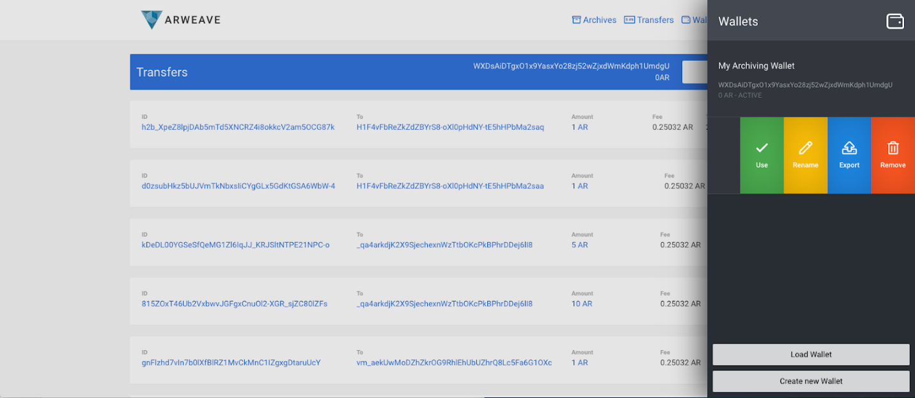

When you change your active wallet, you will also see the address change on the ‘transfers’ page and in the ‘wallets’ popup window.

# ****Archiving****

Let’s go: it’s time to make history. By this, we mean archiving the web. Archiving is easy, simply browse whichever page you’d like to archive and click Archive this Page.

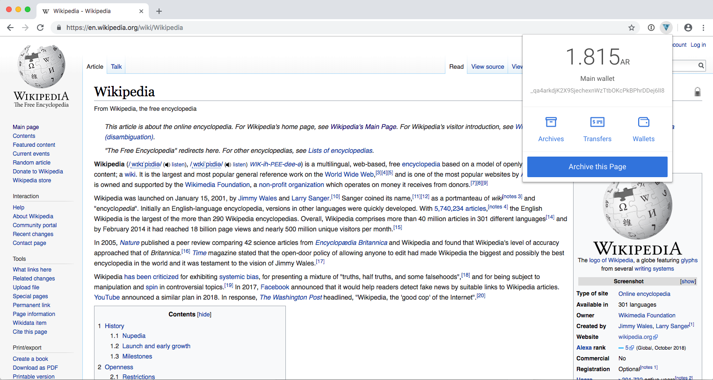

Did we mention it’s that easy?!

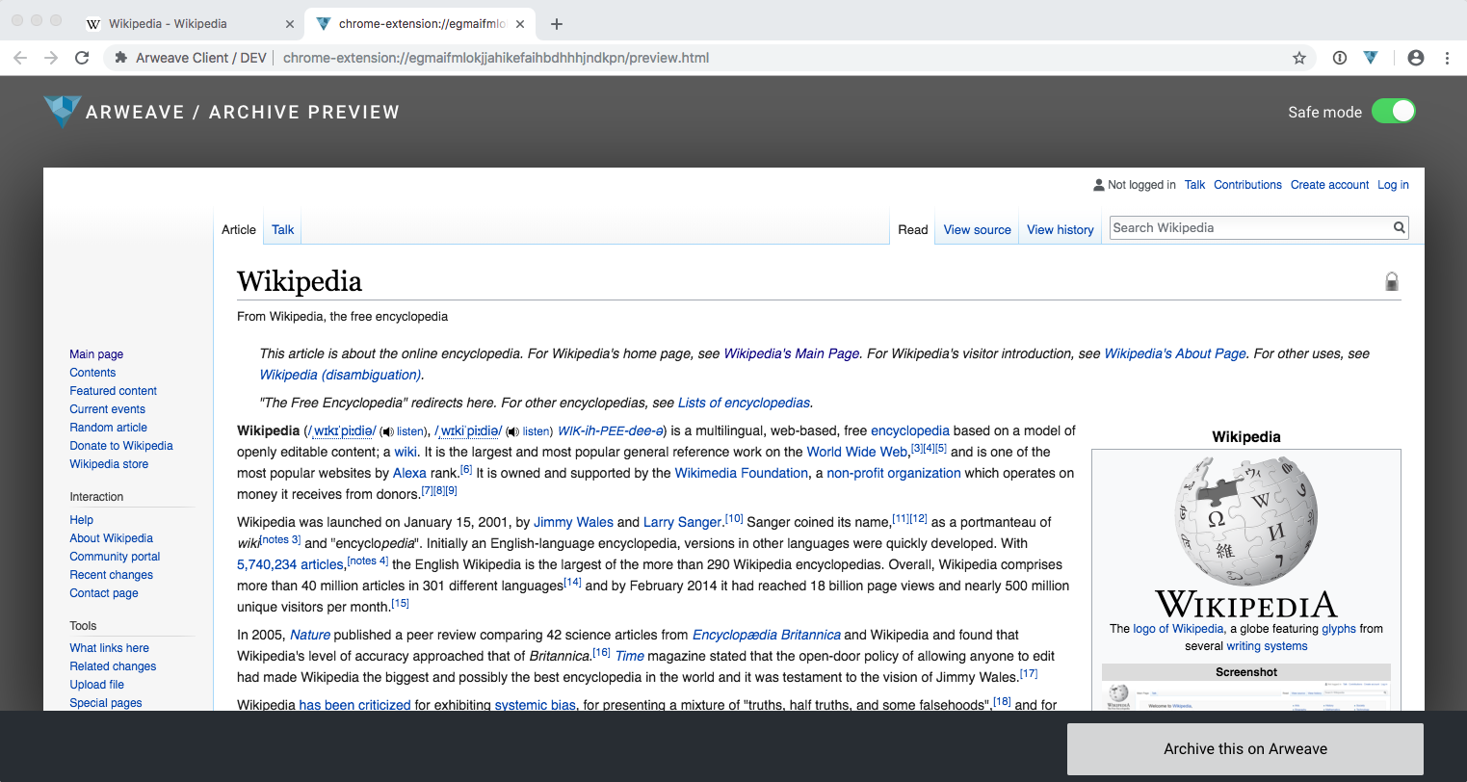

Before your page is archived, you’ll see a preview of how the page will look. You may notice some slight differences from the original page, this is for a few reasons:

1) **Javascript is disabled**and completely stripped from the page; this is for your own safety, as running JavaScript can compromise browser security.

2) **Assets like images and CSS will be embedded** directly in the archived page itself, instead of remaining on the original website server. This means that even if the website goes down in future, the page will still render correctly as it’s now is a self-contained package.

3) **Safe mode is on by default.**You can read about safe mode below.

We’re continually working to make the archiving process more resilient, which means progressively reducing web pages’ reliance on outside sources to function. For example, by including CSS (the code that styles web pages) within archived pages, we are ensuring that pages always display correctly even if the CSS outside of the archived page is altered.

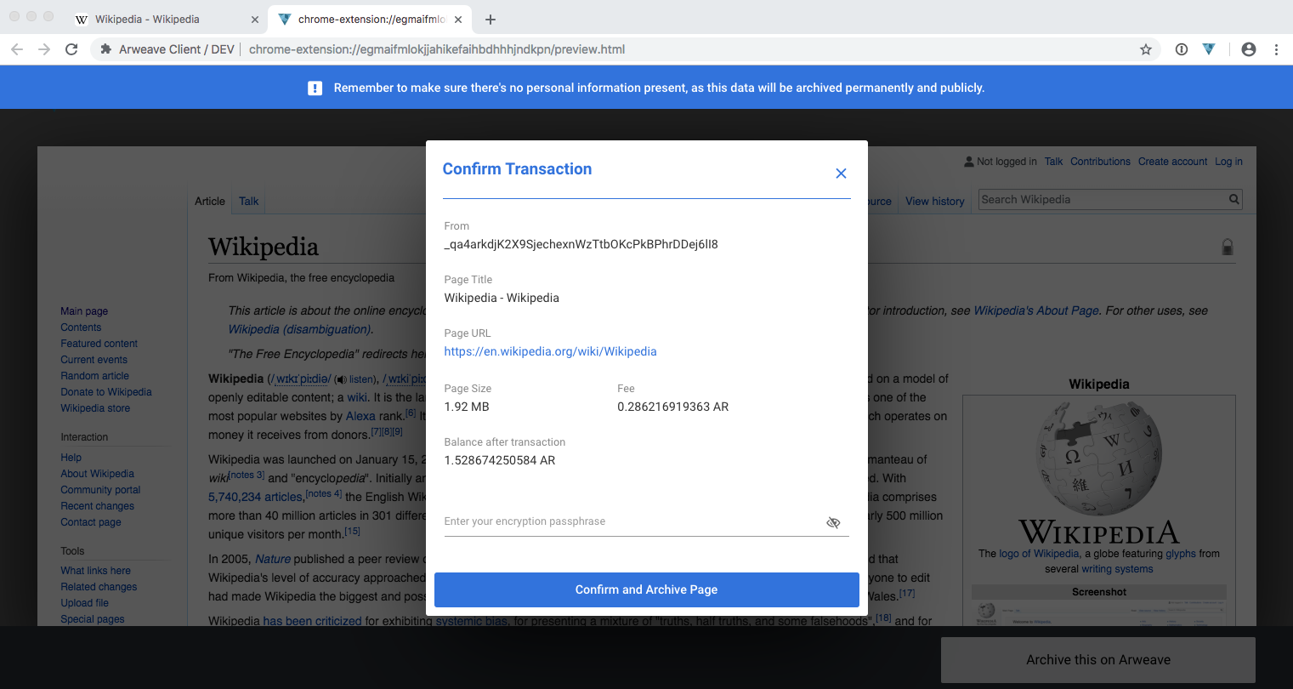

Once you’re happy with the preview, click Archive this on Arweave; review the information and price, enter your wallet encryption passphrase, then hit confirm.

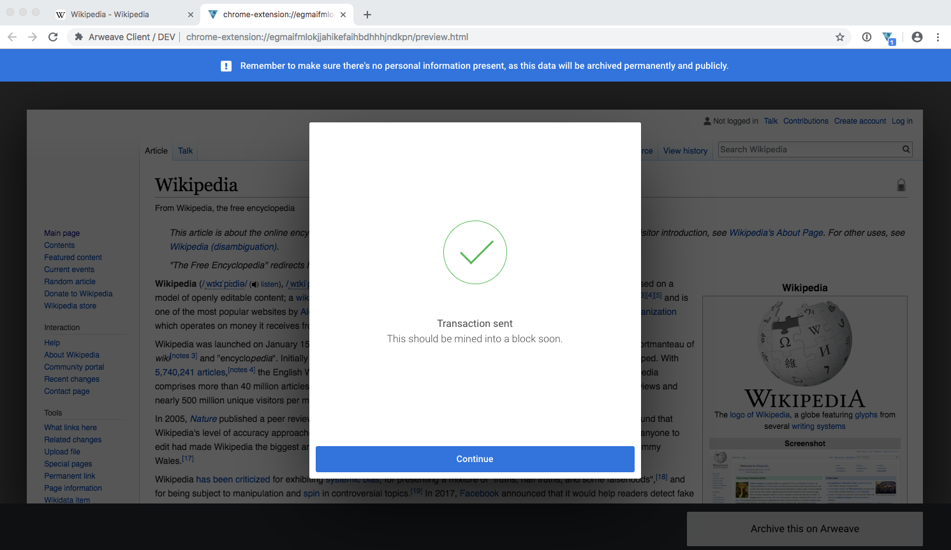

It should only take a few seconds to submit your transaction to the network, however this depends on a few factors such as the current network state, your internet connection speed, and the size of the page you’re archiving. Once you’re done, you’ll see the screen that says ‘Transaction sent — This should be mined into a block soon.’

# ****Safe mode****

## **What is it?**

Many websites employ various means of customising content for users by tracking their online activity — ever noticed after browsing those pair of shoes how many spooky ads follow you around the web?! Yup, this is what we’re talking about!

This means that when you archive a page from a browser which contains personal information (e.g. you’re logged into Google Suite, Amazon, Facebook), you may also end up archiving tiny artifacts about yourself, such as your browsing habits. Because some of these artifacts are subtle and are often hidden or embedded within the source code, it’s important to make sure you protect your information by archiving in safe mode.

Here’s an example: Imagine you’re logged into amazon.co.uk and information such as your name, postal code, account age, number of items in basket, and recent Prime Video streams are on display, as seen in the screenshot below.

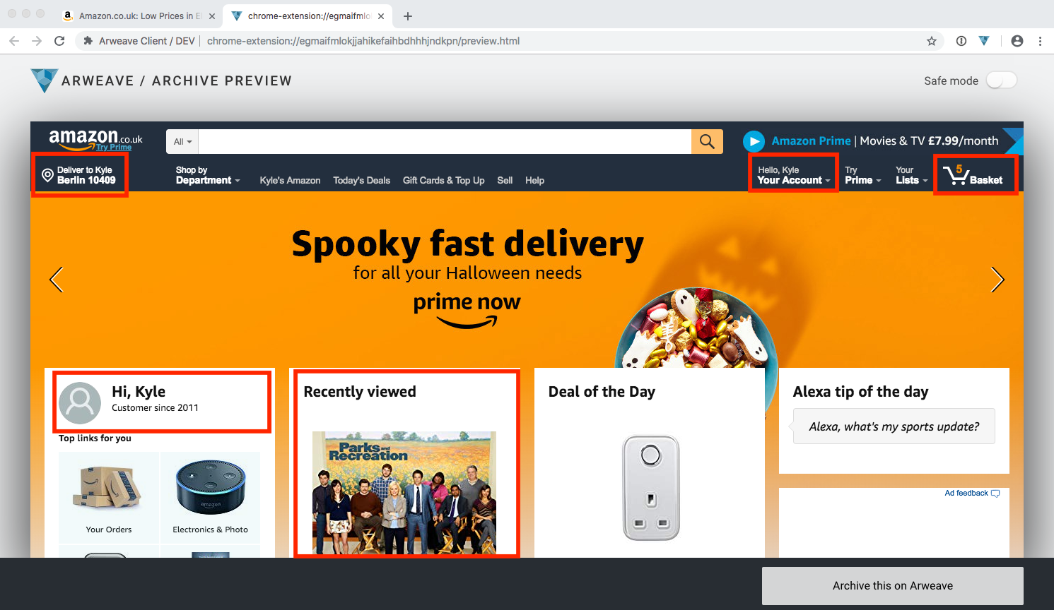

During safe mode, all of your personal information becomes invisible — as you can see in the screenshot below.

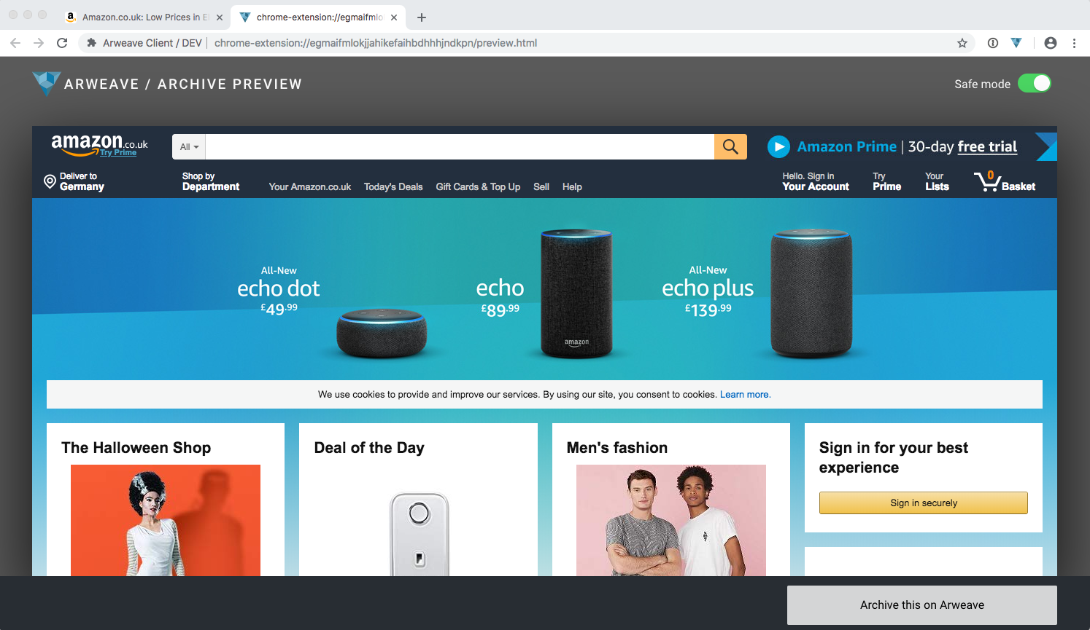

## **How does it work?**

Safe mode works similar to ‘Incognito Mode’ which you may be familiar with from using the Google Chrome browser. When archiving in safe mode a fresh request copy of the URL is made without any cookies, meaning your archive only exposes the minimum amount of information possible about your browser session.

Here’s a redacted view of the HTTP headers sent on the original amazon.co.uk request — you can see it sends a bunch of tracking information about your session.

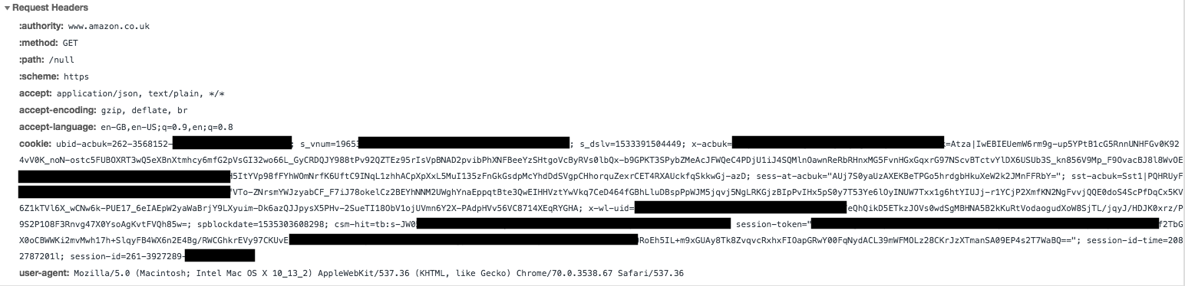

With safe mode turned on, we only send the minimum amount of information required to render the page. The cookie and session data is now gone, and this is a much safer way to archive pages.

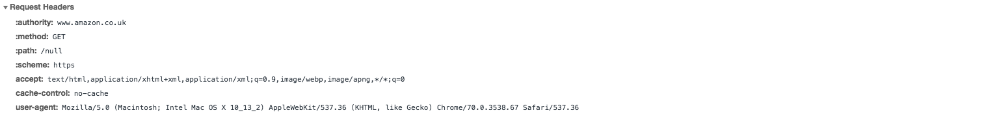

## **Why is this the default?**

Safe mode is turned on by default to prevent the accidental archiving of personal or sensitive information. Imagine you open your bank account and click archive — during safe mode you’ll only see the login page of your bank, but should you turn safe mode off, you’ll see all of your account details/activity. We feel that safe mode is the safest way to enable quick archiving from your browser.

## **What about paywalls or other “gated” content? How do I turn it off?**

Some content may only be visible if you’re logged in (like newspapers that use paywalls). With safe mode turned on, you might not be able to archive these pages and after all, the point of safe mode is to mask your identity so the website you’re visiting doesn’t know if you’re logged in or not!

You can toggle safe mode on and off by clicking the Safe Mode switch on the preview page. When you turn safe mode off, the preview will switch to the content pulled directly from the tab you archived.

## **Useful Tips:**

**Encryption:** If you already use an encrypted password manager like 1password then this is a quick and easy way to secure the file.

**Key Files:** Your key file will be called something like arweave-keyfile-abc123.json and the ‘abc123’ part is your unique wallet address. Wallet addresses are 43 characters long and can contain any alphanumeric characters, as wall as dashes and underscores (a-z0–9-_). Your key file is a standardised and interoperable format called JSON Web Key, which you can[read more about here](https://tools.ietf.org/html/rfc7517).

As always, we welcome all community feedback and suggestions! Just drop us an email at [team@arweave.org](mailto:team@arweave.org) any time. You can also join us on [Telegram](https://t.me/arweave), [Discord](https://discord.gg/DzNZPaZ), and follow us on [Twitter](https://twitter.com/ArweaveTeam) and in our [Telegram announcements channel](https://t.me/arweaveannouncements) for all project updates.

-arweave-team

**Arweave November 2018 Update**

[](https://arweave.medium.com/?source=post_page-----c7795280b8c8--------------------------------)

[The Arweave Project](https://arweave.medium.com/?source=post_page-----c7795280b8c8--------------------------------)

[Nov 2, 2018·3 min read](https://arweave.medium.com/arweave-november-2018-update-c7795280b8c8?source=post_page-----c7795280b8c8--------------------------------)

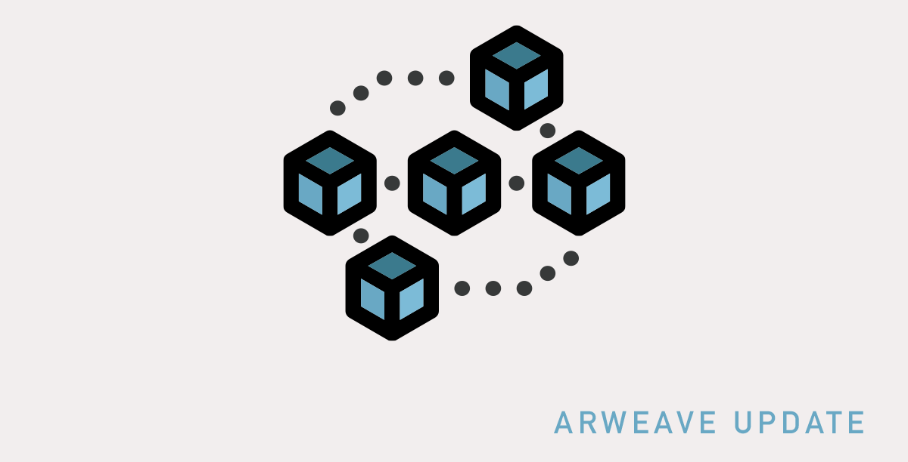

Today we’re very pleased to update you on all the latest news and developments with the Arweave project! Let’s get right into it.

Release of Arweave web extension 2.0!

This week we released a brand new version of the Arweave web extension, which can be [downloaded here](https://go.arweave.org/e4u1-chrome-wallet)!

The new extension continues to offer AR wallet and web archiving capabilities, plus:

* A brand new & radically improved UI
* Support for multiple AR wallets
* Much faster loading times
* A new archiving ‘safe mode’

View the complete user guide detailing all the new features [right here](https://medium.com/@arweave/introducing-the-arweave-web-extension-2-0-dd706d1c9523) on Medium. Let us know what you think by [dropping us an email](mailto:team@arweave.org) — we welcome all feedback, suggestions, and comments!

Mining rewards have begun

As of last week, mining rewards have begun! Many, many more nodes are now supporting the network, providing significantly more storage for our users.

The onboarding experience for miners is also much improved, and will be getting even better with network version N.1.6. Our development team have been working hard to support new and existing miners over on [our Discord server](https://discord.gg/bAaUgAK), the hub of our mining and development communities.

If you’d like to serve the weave and get involved in mining, please [email us at team@arweave.org](mailto:team@arweave.org) and let us know you’d like to become an Arweave miner! We can then provide you with a mining guide and help you get set up.

Node development powers ahead

Since our last update blog on in mid-September, the network has successfully upgraded to version 1.5, a massive improvement in network efficiency and in community experience.

Our node development team is still very hard at work however, and now version 1.6 is approaching with its development proceeding many weeks ahead of schedule. This will be where our node development team continues to focus their efforts at the moment.

Spreading the news about Arweave worldwide

Recently, our CEO Sam Williams has given a wide range of interesting talks, demonstrations, and appearances covering various topics, spreading the news far and wide about Arweave. Recordings of some of these appearances are now available to share with our online community too, including:

* Appearance on [the CoinInsider podcast](https://soundcloud.com/coininsider/interview-with-sam-williams-arweave-coin-dive-episode-12-brought-to-you-by-techstars)
* [Interview](https://blockspoint.com/articles/interview/arweave-ceo-on-new-way-of-blockchain-information-management) with BlocksPoint at Blockchain UA, Kiev
* [Video interview](https://youtu.be/dAB44KvttZg) with Crypto Bulk at Dezentral, Berlin

The Arweave team is growing!

Finally, we’re very pleased indeed to welcome new members of the Arweave team Sophie and Martin! Martin is joining the node development team, and Sophie is our new Community Manager, here to help support and expand the Arweave community.

Our growing team will continue to expand as we are recruiting for additional roles at the moment in the following areas: the back-end (AKA node development) team, the front-end and product/software team, and in marketing and outreach.

Thanks again to the whole community for your excitement and support shown for our recent progress.

As always, we welcome all community feedback and suggestions! Just drop us an email at [team@arweave.org](mailto:team@arweave.org) any time. You can also join us on [Telegram](https://t.me/arweave), [Discord](https://discord.gg/DzNZPaZ), and follow us on [Twitter](https://twitter.com/ArweaveTeam) and in our [Telegram announcements channel](https://t.me/arweaveannouncements) for all project updates.

-arweave-team

# Kerch Strait Incident: Storing history on a blockchain

[](https://arweave.medium.com/?source=post_page-----37db81592d47--------------------------------)

[The Arweave Project](https://arweave.medium.com/?source=post_page-----37db81592d47--------------------------------)

[Nov 30, 2018·3 min read](https://arweave.medium.com/kerch-strait-incident-storing-history-on-a-blockchain-37db81592d47?source=post_page-----37db81592d47--------------------------------)



Released by Russian security agency FSB, this photograph seems to depict a clash between Ukrainian and Russian ships on the 25th of November

This is a guest blog post from the [Decentralised Public Library](https://medium.com/the-decentralised-public-library), an Arweave initiative.

On January 9th 2009 Satoshi Nakamoto minted the first block of the Bitcoin network, deliberately adding a [headline from The Times newspaper](http://arweave.net/iPjkti1lkpLsOp0mZ6dh-zpN1a7XufX8S9cLq1sSS_0) to the genesis block, ‘Chancellor on brink of second bailout for banks’. The idea of storing history on a blockchain has been around since literally as long as blockchain technology itself has existed. However, data size limits have previously prohibited the storage of large quantities of historical data on the blockchain itself.

Last Sunday, on the 25th of November 2018, news broke of a flotilla of Ukranian navy vessels that were denied passage through the Kerch Strait to the Sea of Azov by Russian military forces. Shortly after this became known, primary sources relating to this event and its effects were stored permanently on Arweave’s permaweb, irrevocably recording the events as they unfolded. The Sea of Azov-Black Sea geographical region is a contentious one, especially following the annexation of Crimea from Ukraine by Russia in 2014, after the toppling of pro-Russian Ukrainian leader Viktor Yanukovych earlier in the year.

Recent activities in the Kerch Strait are potentially monumentally important to future historians, being the latest in a series of events that have escalated tensions severely in the region. As such, on Sunday when Russian military ships physically prevented three Ukrainian vessels from passing through the Strait, Arweave community members immediately raced to archive the first official public statements from both sides about the incident.

Thankfully, due to the unique technology of the Arweave, the initial statements from both Ukrainian and Russian official sources were immediately and truly permanently archived just moments after they were first published, long before most media sources altered the public to the incident. These archived pages now lie beyond the reach of either nation, beyond censorship. The pages cannot be edited, re-written, or deleted, and so they will be able to serve as a truly permanent, cryptographically verifiable record of the contemporary official statements regarding the Sea of Azov incident for many, many years into the future.

The first piece of primary source material archived on the permaweb is a piece by Sputnik International, which is owned and operated by Russian government-controlled media agency Rossiya Segodnya. Here it is, served directly from the permaweb: <http://arweave.net/RVdjqnXGwpPBLWe8SuADGNmVDYlxCnF5J9LlA_hAv-g>. In this piece, Sputnik claims that the Kerch Strait ‘Russian territorial waters’ were only ‘temporarily off-limit’, and states, ‘The Russian Foreign Ministry warned Ukraine against attempts to revise the status of the Sea of Azov in violation of international law, and urged Kiev to refrain from attempting to unilaterally establish new state borders.’

Next, primary source material from the Ukrainian Ministry of Foreign Affairs was second to be archived on the permaweb, and offers a radically different perspective on the incident. Here is the permaweb link for the Ukrainian statement: <http://arweave.net/jxXs6zXEYdi6_sbDSAFTq5dvx7rGm9cqNx3EVnIyFVc>. In this formal response, the Ministry stated that Russia has ‘transgressed all boundaries and become aggressive’, stating that Russia ‘unlawfully used force against the ships of Ukrainian Naval Forces’.

Since the time that these webpages were perma-archived, controversial events have continued to unfold. Some sources report that the Ukrainian vessels were [fired upon](http://arweave.net/eNvFoJ_Ys_xCsMdZhWZo_QETH3WXZfypRw9BDeoMyew). Additionally, it appears that several Ukranians involved were wounded, along with 23–24 Ukrainians aboard the ships being taken captive by Russian forces. Twelve of these individuals have now been brought to court on charges of illegally crossing the Russian border, according to [ABC News](http://arweave.net/SxJ4lT5oL8NtRgihFW2EMsHlOWk4sdo1BtAJ6lLCAFE) (here is the permaweb link to this article). Just today, international news media reported that Ukraine has [closed its borders](http://arweave.net/1y884qWN3EIquZzkRbH4VtcEImLso5nwda-L_BTFTcQ) to Russian men aged 16–60, and President Trump has now [cancelled a planned meeting](http://arweave.net/lamHjcvhzEpkveu7ktw7OT6FNN3yYgqo3tpAs_NuK04) with his Russian counterpart, President Putin.

This demonstrates the importance of capturing these primary source webpages as quickly as possible when these potentially historically significant events occur. These pages will now serve as a steadfast, truly permanent record for future historians to refer to when reflecting on the Kerch Strait crisis, and whatever potentially momentous events may follow that we are as yet unaware of. We like to lead by example, so all links in this article are served directly from the permaweb, archived forever, immutably!

**If you’d like to help us permanently archive human history on a blockchain, grab the [Arweave web extension](https://medium.com/@arweave/introducing-the-arweave-web-extension-2-0-dd706d1c9523) and**[**join us on Discord**](https://discord.gg/DzNZPaZ)**where we can send you some tokens to get started!**

# ****My Top 5 Arweave Archives****

[](https://arweave.medium.com/?source=post_page-----dc89f969c65c--------------------------------)

[The Arweave Project](https://arweave.medium.com/?source=post_page-----dc89f969c65c--------------------------------)

[Dec 4, 2018·3 min read](https://arweave.medium.com/my-top-5-arweave-archives-dc89f969c65c?source=post_page-----dc89f969c65c--------------------------------)



By Sophie, community manager at Arweave

Thanks to the super slick Arweave [web extension](https://chrome.google.com/webstore/detail/arweave/iplppiggblloelhoglpmkmbinggcaaoc?hl=nl), it’s now easier than ever to archive web pages and store them on the Arweave — forever! As more web pages are continuing to be archived each day, for me personally, the element of discovering what others have chosen to permanently store is really exciting. With more content being archived on a daily basis, I’m looking forward to the endless possibilities of what I might find on the weave in years to come. But for now, here are some of my top pick of web pages stored on Arweave right now:

**Here’s Why Facebook Removing That Vietnam War Photo Is So Important**

I chose this article because I feel it exemplifies how volatile our freedom of speech is becoming in the digital sphere. Facebook — and other big conglomerates — are increasingly controlling how we view the world through the media we consume. Whether it’s their news-feed filtering algorithms or moderators dictating what they deem to be appropriate or not, one thing’s for sure: it’s denying us the right to form our own opinions based on reliable, trustworthy information.

**On the weave:**<http://arweave.net/RTvlIxbvDOpo7kPisnhnfz0BtgOZE4QlScBSRLEkky4>

**Lifetimes of cryptographic hash functions**

It took bit of digging around for me to understand exactly what a cryptographic hash function does. Simply: it’s just a mathematical equation that enables many forms of encryption, which is used for anything from payments made on e-commerce websites to blockchain networks like Arweave. I chose this archive because it’s a cool visual representation that shows the lifetime of cryptographic hash functions — and come on, who doesn’t like a colourful table?!

**On the weave:**<http://arweave.net/DlJwVF1cD1zIJFLg_N9MLctNF77imI2lcmviQrXkPt8>

**The Gulag Archipelago**

This publication by Aleksandr Solzhenitsyn (and 200 fellow prisoners) is a first-account portrayal of Soviet repression and the horrors of Soviet slavery camps. The Soviet economy depended on the output and productivity of the forced labor camps, yet it brutalised and murdered millions of its own citizens, amongst other wildly inhumane practises. Described as a voice for the nation of those who suffered, The Gulag Archipelago is a piece documenting a significant part of history that must be preserved in order to maintain accountability.

**On the weave:**<http://arweave.net/n21OratK-uwxE4_-4F-0VDAiD7bytZ-8085F5EMTdqk>

**How social media users have discussed sexual harassment since #MeToo went viral**

On October 15th 2017, the #MeToo movement gained popularity over reported misconduct allegations against Harvey Weinstein. Since then, the #MeToo hashtag has been used over 19 million times from the likes of celebrities, politicians and members of the public. I chose this article because the #MeToo movement challenges sexual harassment in the workplace and beyond, ultimately displaying the power of social networks in empowering a previously-silenced majority.

**On the weave:**<http://arweave.net/snTl7LjYvSXbOBp2qkDqk0_FwjvmUvOBFvUG5GVWkhk>

**It takes three times more energy to mine Bitcoin than gold**

Until I started to read more about bitcoin mining, I wasn’t aware of how much energy it consumes. Nor did I expect to hear how much environmental damage it’s causing — once I explored it further it seemed so obvious, nevertheless, the statistics were still super surprising to me. In November 2017, the power consumed by the entire bitcoin network [was estimated](http://arweave.net/-tBljXJ464VldI2kk9paKERv2iAlPb4pFEsNrshZVEI) to be higher than that of the Republic of Ireland. Even a simple Google search[is said](http://arweave.net/-tBljXJ464VldI2kk9paKERv2iAlPb4pFEsNrshZVEI) to generate as much CO2 as boiling half the water for a cup of coffee (7g)! I feel this article is important because amongst our daily digital consumption, the majority of us don’t consider that just because we can’t see it doesn’t mean it isn’t there (and damaging planet earth!).

*Note, luckily the Arweave consensus is ‘Proof of Access’ meaning that storage space is optimal over processing power, therefore more environmentally friendly*

**On the weave:**<http://arweave.net/bgBnxHFcuOW_46aPsa6YfSPIYD1hRdAXK4ExQPlnL7w>

**And there you have it, my top 5 Arweave archives.**[**Get in touch**](https://twitter.com/ArweaveTeam)**and tell us what you’re archiving, you might even make my next top picks! Sophie**🤖[Arweave community manager]

# What is stealth editing, and how can we combat it?

[](https://arweave.medium.com/?source=post_page-----98052078b517--------------------------------)

[The Arweave Project](https://arweave.medium.com/?source=post_page-----98052078b517--------------------------------)

[Dec 6, 2018·6 min read](https://arweave.medium.com/what-is-stealth-editing-and-how-can-we-combat-it-98052078b517?source=post_page-----98052078b517--------------------------------)



This is a guest blog post from the [Decentralised Public Library](https://medium.com/the-decentralised-public-library), an Arweave initiative.

# ****What is stealth editing?****

‘Stealth edits’ are silent but substantial changes in content or tone to a piece of published media. The term is usually applied to online news outlets or other digitally published long-form content, and only where there’s no editor’s or author’s note to identify and explain the changes.

When print media reigned supreme, stealth editing was much trickier than it is today. It would have required hunting down the physical copies of the published media in order to make a retroactive change. This did happen of course (Stalin’s [censorship of photographic records](https://newseumed.org/tools/artifact/photographic-lies-stalins-russia-online-exhibit) is a classic example of this), but in online media stealth edits are easy, instant, and if not for the valiant efforts of projects such as the Internet Archive’s [The Wayback Machine](https://archive.org/web/), they would be totally undetectable in most cases.

Though the term ‘stealth edit’ certainly has a negative connotation implying deliberate secrecy, the most frequent silent changes to pieces are innocent enough, for example when correcting typing errors. This post will focus on ‘stealth edits’ that substantially change the tone, content, factual accuracy, or apparent authorial perspective of a published piece of media.

# ****Examples****

It’s tricky to know just how common stealth edits are due to the hidden nature of the phenomenon. However, even the most respected publications have been accused of using stealth edits to hide serious editorial errors, or to dramatically change the tone of an article following an unexpected negative reaction to the piece from readers.

For instance, just last year the Washington Post silently rewrote an article on Russian hackers, changing the reported details radically in just the first few hours following publication when it became clear that the original version contained serious factual errors. [After multiple outlets](https://www.forbes.com/sites/kalevleetaru/2017/01/01/fake-news-and-how-the-washington-post-rewrote-its-story-on-russian-hacking-of-the-power-grid/#d4627977ad51%20|%20https://theintercept.com/2016/12/31/russia-hysteria-infects-washpost-again-false-story-about-hacking-u-s-electric-grid/) drew public attention to the Post’s lack of editorial acknowledgement of the alterations, the Post added an editor’s note to the piece.

In 2016, within hours of publishing a New York Times piece on Bernie Sanders [flipped its tone](https://medium.com/@brokenravioli/proof-that-the-new-york-times-isn-t-feeling-the-bern-c74e1109cdf6) from “almost glowing to somewhat disparaging” (in the words of the [NYT’s own Public Editor](https://publiceditor.blogs.nytimes.com/2016/03/17/new-york-times-bernie-sanders-coverage-public-editor/)), without transparent acknowledgement of this substantial alteration. To readers at the time it was as if the first, complimentary, version had never existed at all. Additionally, no reasoning was provided for the change, meaning that even those eagle-eyed visitors who spotted the differences were puzzled about the motivations for this.

Earlier this year the BBC was critiqued for [several changes](https://www.washingtontimes.com/news/2018/aug/3/sarah-jeong-story-by-bbc-edited-racist-descriptor-/) to a piece about [Sarah Jeong joining the editorial board](https://www.bbc.com/news/world-us-canada-45052534) of The New York Times. The addition of Jeong to the board was criticised by many due to her controversial Twitter history, including publishing tweets that the BBC originally described as racist. The article was later amended to avoid labelling the comments as racist, but simply inflammatory. In reaction, some heavily criticised the BBC for ‘stealth edits’ to the article, claiming the edits substantially changed the tone of the piece while offering no transparency for readers.

However, it’s not only news outlets that perform stealth edits. Branches of government have also silently removed, altered, or re-framed information on their public-facing websites with no explanation about the motivations. In some instances, the stealth edits appear to reveal hidden changes in policy direction and priorities that remain unexplained to the public.

For example, between 2017 and 2018, the US Office of Juvenile Justice and Delinquency Prevention (OJJDP) [changed the wording of its ‘About’ page](https://sunlightfoundation.com/2018/10/04/ojjdp-website-changes-reflect-punitive-direction-of-office/) to markedly less sympathetic language. For example, replacing the commonly-used phrase ‘justice-involved youth’ with ‘offenders’, and removing the words ‘healthy’ and ‘educated’ from the statement “…[OJJDP] envisions a nation where our children are healthy, educated, and free from crime and violence.”. Also during these alterations, OJJPD removed their public commitment to ending the use of solitary confinement for young people in the US justice system, despite various highly respected medical associations [speaking out publicly](https://www.independent.co.uk/news/uk/home-news/solitary-confinement-young-offenders-ban-mental-health-children-prison-justice-department-a8308941.html) against solitary confinement, stating it is especially damaging for young people, even causing permanent harm.

# ****Why are stealth edits bad?****

Ultimately, the ‘stealth’ aspect of these changes is the problem, creating a serious lack of transparency in online content. This undermines the public’s ability to trust these publications and rely on their content to be accurate, and their editorial practices to be upfront and honest.

If online publications are not held accountable for their content, they are ultimately less motivated to maintain a very high degree of accuracy, as their mistakes can be hidden, erased from public view in seconds.

# ****How can readers combat this phenomenon?****

As well as publications keeping themselves accountable, readers can take this into their own hands. The DPL itself is an initiative of the Arweave project, which offers truly permanent archiving of any web page for a small one-time fee, utilising new blockchain-like technology. Within the DPL and Arweave teams, we use the web extension every day to [permanently archive online news articles](https://twitter.com/ArweaveTeam/status/1066999468954976256), such 2as this [piece discussing stealth editing](http://arweave.net/acJ9CtMsk24bJz8-PIOkMB-aS46geHTgwdk6SCenQYg), now being served right from the permanent archive!

There are also several great sites that, although they are not permanently archived, offer comparisons across multiple versions of an online news article, tracking the changes. This can be a very useful when discerning how a story develops over time, and of course in identifying stealth edits. For example, [NewsDiffs](http://www.newsdiffs.org/), which gives a very intuitive visual representation of the differences between two versions of a news article, for example with [this NYT piece](http://www.newsdiffs.org/diff/192021/192137/www.nytimes.com/2013/03/31/science/space/yvonne-brill-rocket-scientist-dies-at-88.html). [NewsSniffer](https://www.newssniffer.co.uk/) is another such site, monitoring changes to articles from BBC News, The Guardian, The New York Times, The Independent, The Washington Post and The Intercept.

**How can online publications improve?**

The ideal solution would be adding descriptive and transparent editors’ or authors’ notes to published pieces that undergo post-publication editing. This method offers readers enough information, without being too labour-intensive for the publication themselves. Several publications already practice this for ‘substantially’ altered articles, but this naturally raises the question of what counts as a ‘substantial’ change, and who makes this call? Editors do carry their own biases with them, like we all do, they’re only human after all. These biases can influence their choice to categorise a change as ‘substantial’ or not. [Here is a good example](https://www.bbc.com/news/world-us-canada-38479179) of a descriptive editor’s note from the BBC, added after an edit occurs to transparently explain the reason for alterations to the article.

In short, publications could benefit from being more honest about alterations, especially ones substantial in content or tone change. This builds back readers’ trust in their content, and demonstrates a commitment to ethical and transparent journalism and knowledge exchange.

**How does Arweave combat the stealth edit culture?**

The phenomenon of stealth editing was a key trigger for the invention of the Arweave project. We wanted to have a truly permanent record of news outlets’ online publications, and in spring of 2017 the tools to achieve this simply didn’t exist. So, we built them! We wanted to ensure everyone could access online news publications later as a vital historical and sociological tool, but we also wanted to hold these outlets accountable for the content they produce, which is challenging if no reliable record exists of their actions.

Of course, the Wayback Machine and the Internet Archive do fantastic work archiving so many web pages (we’re big fans!), but they unfortunately rely on centralised physical backup locations that they are responsible for maintaining and financing into the future. Ultimately, like any centralised data store, they are also subject to certain vulnerabilities that decentralised networks are resistant to, including various forms of censorship.

Here at Arweave we offer a simple solution — a Chrome browser web extension that allows anyone to pay a tiny price just once to permanently preserve the web page they’re currently visiting. The page will be stored on the decentralised Arweave network forever, at no extra cost, and can be revisited at any time by accessing a simple link.

**You can download the Arweave web extension today**[**right here**](https://chrome.google.com/webstore/detail/arweave-client/iplppiggblloelhoglpmkmbinggcaaoc?hl=en-US)**. You can learn more about the magic behind our uncensorable pay-once-access-forever storage in our**[**blog post here**](https://medium.com/@arweave/what-is-arweave-explain-like-im-five-425362144eb5)**.**

# Most unusual: Weird & wonderful archives, museums, and collections

[](https://arweave.medium.com/?source=post_page-----8a87f413fa50--------------------------------)

[The Arweave Project](https://arweave.medium.com/?source=post_page-----8a87f413fa50--------------------------------)

[Dec 16, 2018·6 min read](https://arweave.medium.com/most-unusual-weird-wonderful-archives-museums-and-collections-8a87f413fa50?source=post_page-----8a87f413fa50--------------------------------)

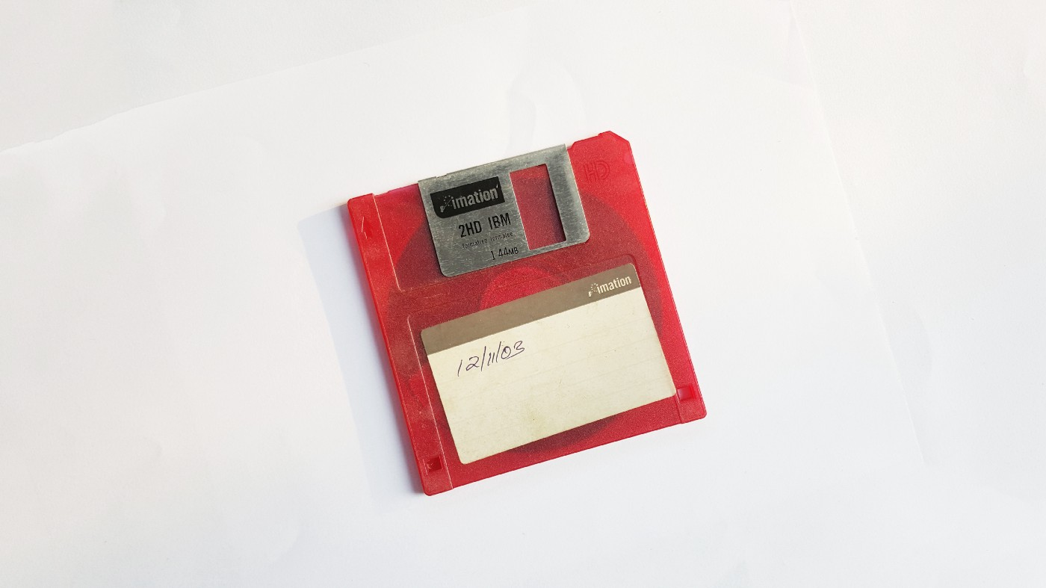

A guest post by the [Decentralised Public Library](https://medium.com/the-decentralised-public-library)

Today we’ll be paying tribute to some of the weirdest and most wonderful museums, archives, and historical collections around. These obscure gems demonstrate that for every subject matter, there are people who joyfully dedicate their lives to preserving its treasures. As it’s our mission at Arweave to preserve the digital treasures of our time, we can proudly say that we’re also guilty of hoarding an artefact or two! Here is our top pick of weird and wonderful museum collections from around the world:

# ****Secret sex cabinets****

Hidden cabinets of risqué art, documents, and objects have been housed within respectable institutions for many decades now. Often tucked away behind velvet curtains, wooden shutters, or cupboard doors, typically access was permitted only for certain societal groups (mainly well-off, educated men), under the assumption that only they would be able to resist their morally corrupting effects!

Take, for example, the historically infamous ‘[Cupboard 55](https://www.telegraph.co.uk/culture/4717695/The-secrets-of-Cupboard-55.html)’, of the Secretum at the British Museum, London. The Secretum itself was created in 1865 as a ‘Cabinet of Obscene Objects’ to house all objects, artworks, and documents that the British Museum thought were frankly too saucy for the general public.





The Bodhisattva Tara, from Sri Lanka, 8th century CE. Once hidden away in the Secretum, here it is on proud public display in 2009

However, with the advent of the sexual revolution in the 1960s which radically changed authorities’ and the general public’s view on ‘obscene materials’, the collection was gradually redistributed throughout the rest of the museum where the pieces remain today.

The British Museum make take a more measured approach towards public access to historic erotica in present day, however there’s still restrictions applied to some interesting items — for example a collection of Japanese erotic art including a painting titled ‘Finishing school for tarts’, which is [only accessible to visitors](https://www.telegraph.co.uk/culture/museums/10141910/British-Museums-Japanese-erotic-art-show-only-for-over-16s.html) under the age of 16 if they are accompanied by an adult.

# ****Breathtaking buildings inside buildings!****

Among a vast array of excellent museums on ‘Museum Island’ in Berlin, Germany lies [The Pergamon Museum](https://www.smb.museum/en/museums-institutions/pergamonmuseum/home.html) — one of the most well-respected and controversial museums in Europe. As you step into The Pergamon, you are awestruck at the scale of the pieces they have diligently collected, transported, and lovingly reassembled, sourced from the far corners of the Earth.



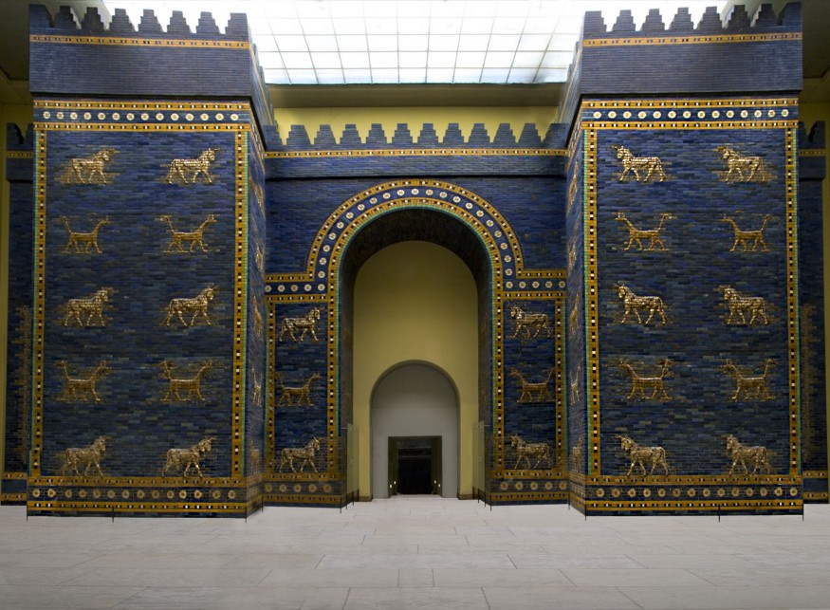

The stunning Ishtar Gate stands at almost 50 feet tall, covered in brilliant blue glazed brickwork, depicting ferocious lions and mythical creatures

For example, The Ishtar Gate pictured above was painstakingly deconstructed from its original location in modern-day Iraq (built in 575 AD, it was once the eighth gate to the city of Babylon), and reconstructed within The Pergamon Museum in Berlin. The truly unique museum contains other structures too, a vast 2nd century AD ancient Roman market gate, the base of a huge Neo-Assyrian palace originally constructed in the 12th century BC, and the more modern but truly stunning 17th century ‘Aleppo Room’ containing perfect panels of pristine wooden engravings of Christian scenes.

Although unique in the world for it’s astonishing collection of structures, The Pergamon has been controversial throughout its vivid history, as a vast number of the pieces on display are not German in origin but collected from around the world. In 2013, Turkey demanded a return of its artefacts that it claimed had been seized and exported illegally over a century ago from Turkey. For a flavour of the intensity of this debate, check out this [confrontational interview](http://arweave.net/Yl7s3z8bPolFXH1ifa9nfRBCBiAj0BoKyQsuHu0FuLE) where a reporter from German newspaper Der Spiegel interviews Turkish Culture and Tourism Minister Ömer Çelik about the return of allegedly stolen artefacts from the Ottoman Empire, accusations of chauvinism, and potential bias in how Turkey grants archeological permits to foreign dig teams.

# ****A little bit of ‘British magic’****

[The Museum of Witchcraft and Magic](https://museumofwitchcraftandmagic.co.uk/visit/), based in Cornwall, UK, boasts an impressive and eclectic collection of art, documents, and items related to ‘British magical practice’.





Just one of the many odd curiosities on display at the Museum of Witchcraft and Magic

Unusually for a museum, the collections suffered dramatic and aggressive reactions from locals at multiple previous locations in Berkshire and Gloucestershire, forcing the museum to relocate to Cornwall due to the hostility from local residents, where thankfully their collections are more welcome.

Their diligent cataloging of beautiful (and sometimes disturbing!) images, documents, and artefacts, allow you to easily browse their ancient, mystical collections by various factors including by associated cult! Check out this wonderful illustration of the mythical mandrake plant — it’s both disturbing and enchanting, literally! Additionally the MWM has a special online archive available by application to researchers, which again is highly commendable.

# [****The Deutsches Currywurst Museum****](http://arweave.net/4rHfgQdk-z--r6AGdklhEZy43YDnHaObLSLzuNYicKM)

Currywurst is a firm favourite of Berlin snack food culture, consisting of a chopped up bratwurst sausage, tomato sauce, and curry powder and typically served with a bread roll or fries (or on its own in a little saucy cup!).





Currywurst Museum (courtesy of Deutsches Currywurst Museum)

Originally invented in the 1940s in wartime Berlin from the meager ingredients available from British troops, today the currywurst remains incredibly popular, with approximately 70 million consumed per year in Berlin alone. Cheap, convenient, simple to make, and very popular — you can begin to see why there might be a whole museum dedicated to the humble currywurst, for now at least…

Sadly, the Currywurst Museum closes its doors for good on the 21st of December this year, which is now just a week away! We would thoroughly recommend a trip paying homage to a humble sausage snack, where all tickets include a tasty little currywurst to polish off your visit, naturally.

# [****The Museum of Bad Art (MOBA)****](http://museumofbadart.org/)

There are thousands upon thousands of museums showcasing glorious masterpieces of the art world, from every corner of the globe, but there’s only one who has taken on the challenge of curating and promoting ‘bad art’…





‘The better to see you, my dear’ courtesy of the Museum of bad art

Browsing the vibrant digital collections the MOBA proudly displays via its website is a fun exercise, the pieces are largely vibrant and striking to say the least! Furthermore, the experience is somewhat humbling, with much of the ‘bad art’ donated by the original artist themselves — at the MOBA no one takes art too seriously, which is surprisingly refreshing and enjoyable.

The MOBA’s full collections are currently available online, including: ‘zoo’ (often unsettling animal-related art), ‘poor traits’ (get it, por-traits?), and ‘oozing my religion’ (theologically-themed pieces). It’s worth mentioning that you might never look at a pug the same way again, after experiencing the painting titled ‘[Ronan the Pug](http://museumofbadart.org/zoo/)’, by Erin Rothgeb, from the MOBA’s ‘zoo’ collection…

**So there you have it, our top pick of the world’s most unusual, weird and wonderful archives, museums and collections. If there’s any you’d like to share with us, leave a comment below— and be sure to archive your favourite finds on [Arweave](https://chrome.google.com/webstore/detail/arweave/iplppiggblloelhoglpmkmbinggcaaoc)!**

# Arweave CEO’s End of Year Update

[](https://arweave.medium.com/?source=post_page-----e9a8b86f71f2--------------------------------)

[The Arweave Project](https://arweave.medium.com/?source=post_page-----e9a8b86f71f2--------------------------------)

[Dec 22, 2018·6 min read](https://arweave.medium.com/arweave-ceos-end-of-year-update-e9a8b86f71f2?source=post_page-----e9a8b86f71f2--------------------------------)

Hi all,

Here is an update as to where we are, and what you can expect early next year. These are my personal opinions and expectations, as I am aware it has been a while since I personally updated you all, and there will be wider updates issued by the community staff in the new year.

# Where we are

The network is now strong and responsive enough for us to start wider adoption, inside and outside of the crypto space. The beginning, non-optimal, phases of the network that always occur for newly released decentralised networks is over. I recently reviewed the launches of a number of other blockchain platforms that were written from scratch, and I personally think we scored about an 8 out of 10 — could have been a bit better, could have been an awful lot worse. For example, shortly after Ethereum launched in 2015, the recommended number of blocks to confirmation was 6000 (yes, really!), dropping to 375 after a while[0]. They also had to perform 4 hard forks on the blockchain to fix critical issues within 3 months, as well as issuing a torrent of security updates[1]. Bitcoin fared even worse — plagued with money printing bugs, consensus forking issues, and even acceptance of blocks without validating them. A contemporary example is EOS, whose chain repeatedly stalled [4], rewound transactions and went offline during the early days. By comparison, I am happy about how Genesis -> block 100,000 went for Arweave. We had some teething issues, but almost all were in the realm of software performance, not consensus/security. This is not to disparage these other projects — I personally hold each of them in the upmost respect and regard — they are truly pioneers(!), but without comparisons to other projects we would not be able to fairly assess our own performance.

The changes to the network software, and the influx of miners downloading the weave and joining the network when the main mining rewards started gave us a chance to see two of the Arweave’s core (and novel) incentive mechanisms at play in the real world. The number of miners in the network growing by 400% within a few weeks led to considerable stain on the network to distribute the data to everyone as miners clamoured to produce as many replications of the data in the network as possible (in order to maximise their personal rewards). At the time, we were laser focused on helping improve the software for the miners and making it easier to join. But with the benefit of time since this incident, I am extremely happy to be able to say this: the incentives work exactly as planned. The miners that offered faster data serving to other members of the network had more of their candidate blocks accepted, therefore they received higher rewards. Miners worked together to tune their rigs to be better Arweave miners, serving the greater needs of the Arweave network (massive data redundancy, fast serving of data on-demand), exactly as we had planned. When all was said and done, the Arweave became the data storage network that offers the highest number of redundant copies out of any available on Earth, as far as we can ascertain[5]. This is significant because while economic incentives can be rationally argued in a clear, mathematical way, humans are innately irrational, so their behaviour is hard to predict. This unique period of massive network growth gave us a glimpse of the behaviour of the incentive mechanisms under stress, and we were very pleased with the results.

# Where we are going

Now that the foundation is in order, it is time to look outward. In late January, we will be re-launching our website, with a focus on describing the advantages of, and how to use, the Arweave’s permaweb. The permaweb is the decentralised, incentivised web that lives on the Arweave. It is the first decentralised web hosting project that offers incentives to participants in the network to store the data inside it, and it is ready to use today.

Along with the new Arweave website, we will also be launching an extremely simple tool that users (inside and outside of the crypto world) can utilise to launch their own Arweave permaweb pages and applications. This tool will form the critical next step in the important process of opening up the network to new users and making it easier for them to deploy applications on the Arweave. At the same time, in order to ease adoption for those unfamiliar with the world of tokens, we will be launching a simple interface that will offer a tiny number of tokens to new users that can be used to deploy their first apps (you will be amazed how far a single AR can go). Our aim here is to become the single easiest web app deployment tool in the world, within the next few months. We will start with a friendly command line tool that will be simple for experienced web developers to use, then expand to GUI based options.

The core differentiating factors of the Arweave’s web hosting are as follows:

- Hosting is exceedingly cheap (just a few pence — fiat equivalent — per web app). Because we take a serverless approach to hosting, we cut out almost all of the overhead that makes it expensive, saving developers hundreds or thousands of dollars over just the first year.  
- Zero server configuration is required, deployment is simple enough for even a monkey to do it. This factor alone saves developers countless hours of tedious and often frustrating work.  
- Zero upkeep is required. Arweave web apps are forever: developers can ‘set them and forget them’. There are no recurring fees to pay, and no annoying security patches to remember to install.

The first partners are already using the Arweave’s permaweb hosting, and we will be on-boarding more in the near future. We are excited to tell you about these as they progress in the next few months.

On the technical side, we have been working recently on a new work algorithm that we eventually intend to replace the hashing that is currently used underneath Arweave’s Proof of Access algorithm. The core of this new algorithm is a random program generation and execution engine that ensures Arweave will remain a CPU and hard disk mining operation, making Arweave mining available to everyone with a simple computer, forever. There is much to say about ProgWork that we will detail in blog posts in the months to come, but the system essentially provides ASIC and GPU mining resistance by ensuring the only way to build a better piece of hardware for mining ProgWork is to build a better general purpose CPU. We achieve this by tailoring the algorithm to the strengths of existing CPUs, and focusing on things that more ‘specific’ pieces of hardware (ASICs, GPUs) find difficult.

The core of ProgWork is already implemented and has been running on a private test network since early December — stay tuned to this blog for updates.

Finally, we have also been working with a major new partner to solve their decentralised storage problems by applying the permanent storage incentives that Arweave offers to other decentralised networks that lack storage incentives. If I may quote the response of our first partner for this feature: ‘Holy sh*t, this is brilliant guys. This truly does solve a major pain point for us and many other dapps out there’. Watch this space!

Thank you all for reading! If you find these blog posts helpful or interesting, let us know and I will be sure to do more of them in the future. I wish you all a merry and relaxing holiday season.

All the best,  
-arweave-sam

[0] <http://arweave.net/8NboQw_HvJpD6gs5J8sT8Urki9RwPX5RxaGEaavYJQ0>  
[1] <http://arweave.net/wUMbCTDfSzmyL8lMAjy3pzTdFS30pJYAPeHHpkXODPA>  
[2] <http://arweave.net/n8KG8mTDBX9yDg6JWYRHv31PPNHOfpvqJovGgEDaqXU>  
[3] <http://arweave.net/4zlX4kAolFEFiTuwyPsla_eXS6dPJNx8XMns-1ufG00>  
[4] <http://arweave.net/r8d1Y0g3DnCH7_9OEhEpnSK3q3J9cifhZWZKgQZ84z0>  
[5] There is always the possibility that secret government/corporate networks contain more redundant copies, but this information is not public. If you do have disclosable information about private systems with over 100 redundant copies, we would be delighted to hear from you — [team@arweave.org](mailto:team@arweave.org).

# Welcome to the Permaweb

[](https://arweave.medium.com/?source=post_page-----ce0e6c73ddfb--------------------------------)

[The Arweave Project](https://arweave.medium.com/?source=post_page-----ce0e6c73ddfb--------------------------------)

[Jan 29, 2019·4 min read](https://arweave.medium.com/welcome-to-the-permaweb-ce0e6c73ddfb?source=post_page-----ce0e6c73ddfb--------------------------------)

Today we’re happy to announce the official launch of the [permaweb](https://www.arweave.org/): an immutable, decentralised web that puts the power back in the hands of the masses. The permaweb is the only one of its kind, offering incentivisation and information permanence across a globally distributed network. It’s the web you can own and run.

Think back to the humble beginnings of web 1.0, where information sharing was revolutionised. The web was intended to be open, without a central controlling node, with no single points of failure. Today, monolithic power structures (such as Amazon, Google, Verizon, etc.) have dominated the infrastructure of the web, turning open networks into a place where information and freedom of speech are vulnerable to censorship and loss.

On the permaweb, your voice lives forever. Only when you imagine how the web began and how it has grown to transform our lives, can you fully comprehend the possibilities of the permaweb.

# ****Permawhat?!****

To put it simply: for users the permaweb looks just like the traditional web, except everything published on the permaweb is available forever — no more 404s! For content creators, the permaweb offers low-cost, zero maintenance, permanent hosting of their web apps and web pages. Now, Arweave’s permaweb enables you to store information and build websites that live forever on a smart blockchain, all while keeping costs low and speeds high.

The permaweb is a layer built on top of the Arweave’s global permanent hard drive. For the nerds (like us!) among you, this is similar to how HTTP is the protocol that exposes the web, which itself is built on top of TCP/IP. This may sound confusing, but don’t worry — you don’t need to know how it works in order to benefit from it, just like the traditional web!



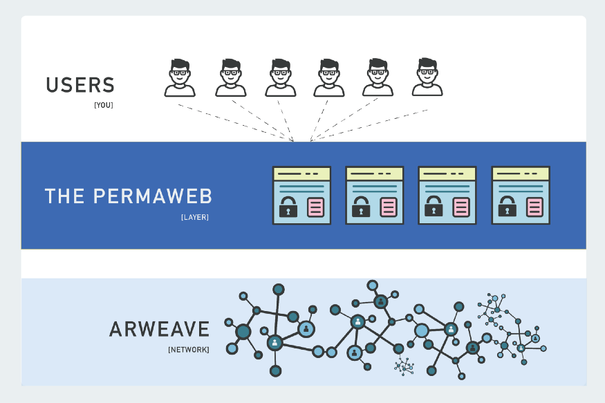

The permaweb is all of the connected sites and apps on the Arweave network

# ****Incentivisation****

One of the most groundbreaking aspects of the permaweb is that it is run by people like you! In order for data to remain freely accessible to everyone, somebody, somewhere must have an incentive to store and serve it. In the case of the current web, entities (like Google and Facebook) are incentivised to store, perform queries on, and return your data, because they can use your personal information to generate revenue. However, miners in the Arweave network are incentivised to [serve the permaweb](https://medium.com/@arweave/building-the-decentralised-web-part-two-the-components-97409d1fe545) by earning tokens for putting their unused storage space to work. This system provides an incentive to store your data without compromising your privacy, solving one of the [key issues facing the current web](https://medium.com/@arweave/building-the-decentralised-web-part-one-the-problem-9766f1987c91).

# ****A web without servers?!****

The traditional web is backed by millions of under-utilised, overpriced servers. These machines sit in warehouses waiting for requests to provide you with web pages, often owned by huge companies like Google and Amazon. This means that website creators are often paying for capacity they never use — this is not the case with the permaweb. The permaweb’s serverless structure is much more efficient, saving you time and money. Just like Uber or AirBnB lets you make money from your unused car or home, Arweave helps you make money from your spare hard drive space by connecting you with people that need web hosting.

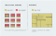

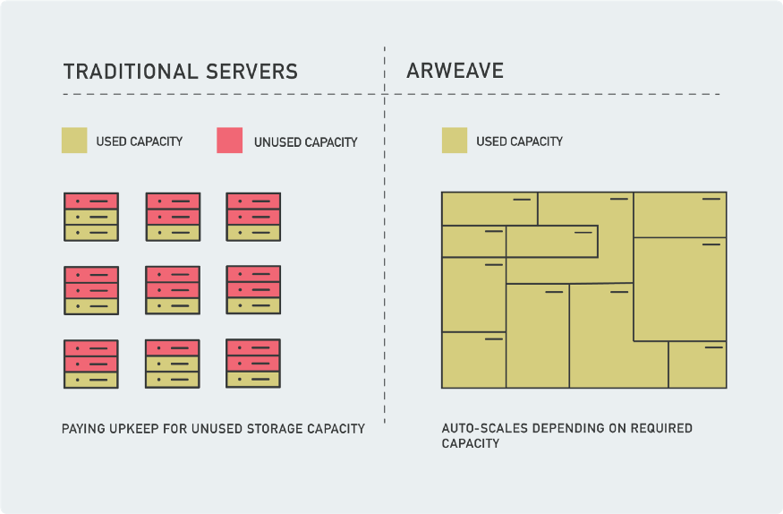

Arweave’s serverless architecture is much more efficient, optimising network utilisation

# ****Information freedom****

The emergence of the traditional web enabled billions of people to create and disseminate information freely around the world. However, what started as a grand experiment in the free-flow of information has become increasingly controlled, monitored, and modified by governments and corporations alike who abuse their power to censor information. This is hugely alarming because the web has become so central to our way of life — it has become an integrated part of our thinking and decision making.

Take for example, the Kerch Strait incident that happened in late November. When the incident occured, initial statements from both Ukrainian and Russian official sources were published online. Thanks to the Arweave community, the statements were immediately archived on the permaweb just moments after publication. Recently, we discovered that Sputnik International silently removed one of these articles from their website, but no matter how much Sputnik attempts to censor and deny this information, it will [always be available](http://arweave.net/RVdjqnXGwpPBLWe8SuADGNmVDYlxCnF5J9LlA_hAv-g) via the Arweave’s permaweb. Permanence matters.



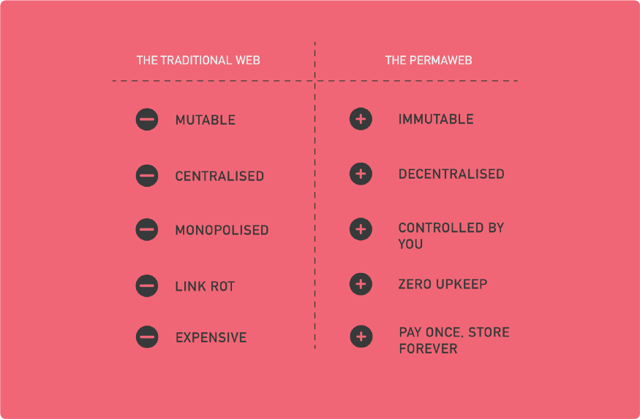

# ****How do I get involved?****

Since 2018, you have been able to [transfer existing web pages](https://medium.com/@arweave/introducing-the-arweave-web-extension-2-0-dd706d1c9523) onto the permaweb. Today, we’re proud to launch a brand new deployment tool that allows developers to publish apps and sites on the permaweb directly! Permaweb hosting is quick and simple: once you’ve uploaded your application using our brand new deployment tool, your site or app will be hosted instantly and permanently.

Become a permaweb pioneer now and help build the next web — let’s keep information control firmly in hands of the many. Claim your free tokens to deploy your application [here](https://www.arweave.org/hosting.html)!

**Over the coming weeks and months we’ll be sharing lots of innovative projects and companies who are already using the permaweb for their own infrastructure. Stay tuned to find out more!**

**Community Spotlight: Archive.Earth**

[](https://arweave.medium.com/?source=post_page-----27dcc988c589--------------------------------)

[The Arweave Project](https://arweave.medium.com/?source=post_page-----27dcc988c589--------------------------------)

[Feb 13, 2019·3 min read](https://arweave.medium.com/community-spotlight-archive-earth-27dcc988c589?source=post_page-----27dcc988c589--------------------------------)



At Arweave, it has always been our goal to enable a decentralised network that is driven by our community, ultimately becoming rich in knowledge and encouraging unobstructed, free-flow of information. The last few months at Arweave HQ have seen us focus on development of the permaweb and partnership integrations; however, some of our community have been busy working on their own projects using the Arweave protocol.

We’d like to introduce [Archive.Earth](https://archive.earth/): an open system for critical environmental data that needs to be internationally distributed and permanent. A project conceived and advanced by some of our community members, Archive.Earth provides dedicated access to the Arweave for high-importance data to help ensure critical environmental knowledge remains protected in permanent and accessible infrastructures. The system is now being enhanced in functionality to encourage participation (submission, review, and fact-checking) by anyone, anywhere, anytime, aiming to protect us from generational amnesia about environmental degradation, known as the “[shifting baseline syndrome](https://www.youtube.com/watch?v=Hui5YH-D6Go&feature=youtu.be&t=8)”.

Its goals are to:

* *Help evidence-based methods to repair/maintain the planetary environment*
* *Support a push to reproducible science; improving methods and research*
* *Answer the call for more robust computer media*

**What is Archive.Earth?**

Today, the trusted position of government scientific institutions has become vulnerable to political interference. Critical data can be deleted, overwritten, or redirected, without precautions that are beyond the awareness and technical ability of most people. The organizations supporting Archive.Earth want to ensure that public knowledge remains adequately protected and accessible, by creating an independent, open-access digital portal for critical, at-risk information to be permanently archived — averting risk of destruction or manipulation by national politics.

Together with Arweave’s technology, Archive.Earth has built a platform in which environmental statistics can be collected, stored, and protected. They will work with communities and groups to curate high quality, trusted information useful for democratic governance, scientific reproducibility, and encourage ‘planetary-scale’ innovation. Anybody can submit information (maps, documents, images, data, etc), and store them permanently, though subsidized archiving requires approval by a (relevant) curation team. Features of the system include:

*● Permanence: Uses Arweave’s decentralized data storage technology to prevent information loss*

*● Catalogued: All data gets a unique, unchanging Archived.Earth address to ensure easy content recall and organization*

*● Uncensorable: The system prevents any data from being altered or censored*

*● Open: Everyone can upload data onto the platform. Data can be set for public view on the permaweb*

*● Collaborative: Features to crowdsource, crowdfilter, and crowd-apply archives*

*● Governance: All submitted data is subject to peer-review and voting before archival*

For us at Arweave, it’s great to see projects such as Archive.Earth utilising our technology to build platforms that endeavour to leave positive impact on the planet. We hope this is the first of many apps, projects, and platforms to implement the Arweave protocol and we can’t wait to see what other projects our community are building.

To find out more about Archive.Earth, head over to their [website](https://archive.earth/).

***If you think that permanent, distributed data storage could be the key to your project,***[***get in touch***](http://team@arweave.org/)***with us — we wanna hear more!***

**Building SILO: a truly private internet**

[](https://arweave.medium.com/?source=post_page-----556c860222ca--------------------------------)

[The Arweave Project](https://arweave.medium.com/?source=post_page-----556c860222ca--------------------------------)

[Feb 21, 2019·5 min read](https://arweave.medium.com/building-silo-a-truly-private-internet-556c860222ca?source=post_page-----556c860222ca--------------------------------)

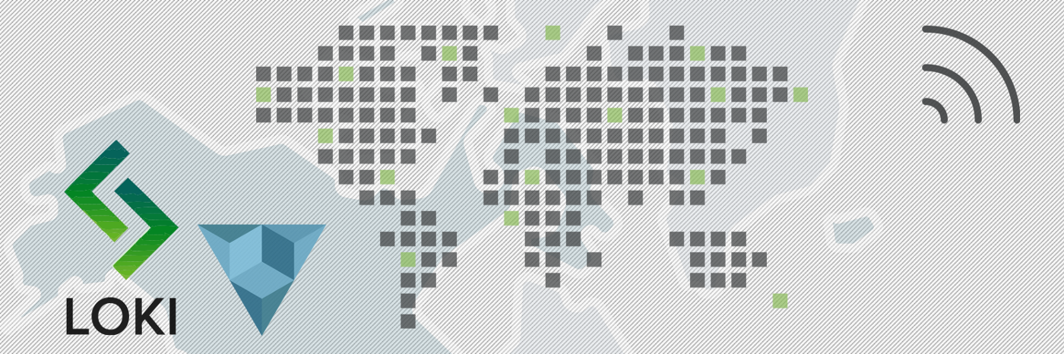

Today we’re pleased to announce that we’ve teamed up with [Loki](https://loki.network/) to bring you SILO: a privacy layer for the permaweb. With SILO, communication on the permaweb is possible without interception from any external entity. This means that all data transmitted is private between the publisher and the receiver; there is no third party access, and no snooping of your data by corporations or governments.

Loki is a decentralised network that allows users to transact and communicate privately over the internet, providing a suite of tools to help maintain user privacy while browsing and communicating online. Combining Arweave and Loki’s capabilities, SILO presents a truly private, and permanent online communication.



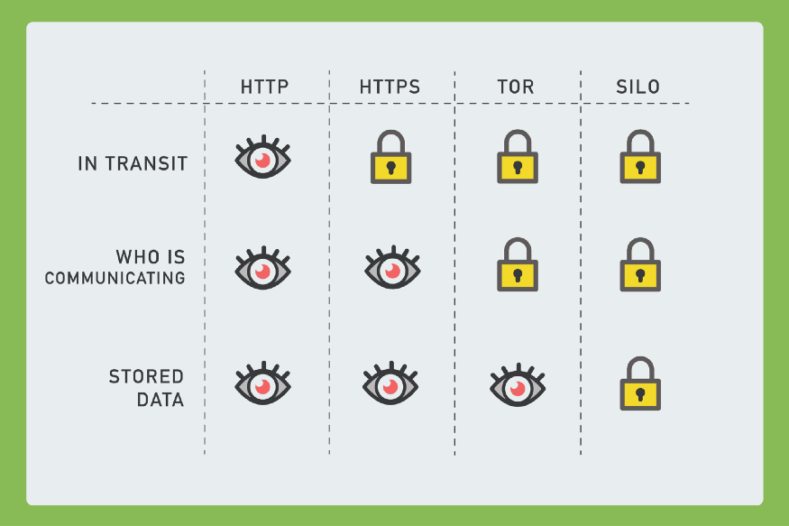

Common communication protocols on the current web: what can and cannot be seen by external entities

To understand the significance of SILO, we must first understand how common communication protocols work on the current web:

**HTTP:** is used to send and receive web pages and files on the internet. However, when you use HTTP everyone intercepts your data as it’s moving — everybody can see who is communicating with who, and what is being said. HTTP is fully transparent.

**HTTPS:**is the same as HTTP, except that it is secured by an SSL connection that encrypts and decrypts data being sent and received. When two people are communicating online, others will be able to see that they are communicating, but not what they’re saying.

**Tor:**enables anonymous online communication via ‘onion routing’ — instead of sending data directly from the sender to the recipient, Tor first sends the information on a random path (through other nodes) before it reaches its destination. This makes it very difficult to tell where data came from or where it’s going, but someone with access to the server where the data is being stored is likely still able to see the web pages on disk.

**SILO:**unlike Tor, offers complete privacy across the network. This means that nobody can see your data in transit, nor can they see who is communicating with who, and nodes storing the data are also unable to see what they are storing. Only the publisher/sender and the people they have given the name to can find and decrypt SILO pages — outside of this, the data cannot be found anywhere. It’s almost like it doesn’t exist.

**Explain like I am 12: How does it work?**

SILO uses a kind of symmetric encryption scheme to ensure that SILO pages can only be accessed by those that have its name. In the case of SILO, the publisher and accessor both share the same key for encryption and decryption.

Think of it like this — you want to organise a protest in an increasingly authoritarian country. Doing so on the traditional web will put both yourself and others at risk because of censorship, government surveillance and potential disruption. In order to successfully organise your protest, you need a page that can easily be shared amongst others but one that is secret from the prying eyes.

From the publisher’s perspective, they simply deploy their SILO page using the normal Arweave command line deployment tool (GUIs coming in the future!), making sure to specify the SILO name during upload. Those with the SILO name and the Arweave web extension installed can then simply type the ‘web+SILO://’ and the name in their browser and will be taken directly to the page.

Here is what your browser does under-the-hood when connecting you to a SILO page:

1. The user enters a SILO site name into the URL bar. It will look something like this: web+SILO**://mypage.15**
2. Your page name will be hashed 2n times*,* where ’n’ is the number at the end of your SILO page name.
3. The output of the hashing is 32 seemingly (to a human) random bytes. By splitting this value, we are able to derive the ‘SILO-ID’ and the ‘key’.

*[The number you give your page determines how secure it is. The higher the number, the harder it is to derive the key and ID pair, making it even more difficult for an attacker without the name to access that data.]*

4. The Arweave web extension then asks the network for the transaction related to this SILO-ID, communicating via the Loki privacy network. In order to decrypt the page, an observer must have the SILO-ID *and* the key, so sending the ID to the hosting Arweave node does not expose its content to the hoster.

5. Once the data transaction has been retrieved, the content is decrypted using the secret ‘key’, then rendered in the user’s browser.

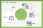

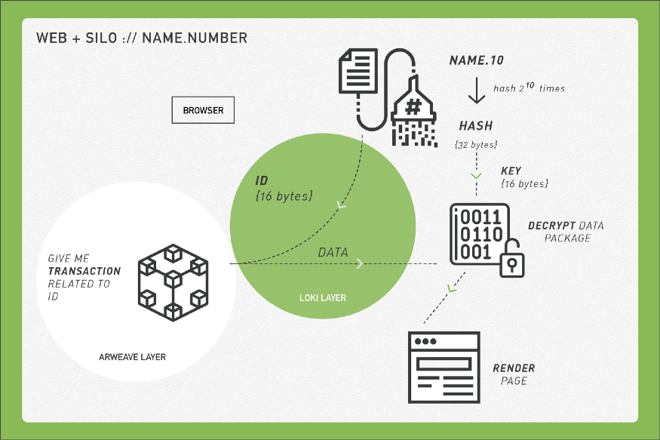

SILO under-the-hood

**Accountability**

As ever, whenimplementing such privacy protocols we think carefully about accountability. To put it simply: in SILO, if the name of the page becomes public knowledge then it could be traced back to the publisher via their wallet address.

The page is only as secret as its name.

If the name is released outside the circle of people you share it with, it’ll be forever available and the publisher will be accountable for it.

For some miners, storing unknown data sources can be problematic. To accommodate all miners in the Arweave network, we will be implementing an opt-out function before the full release of SILO so that miners can choose whether they wish to store these encrypted files or not. It is worth noting that other decentralised data storage platforms require you to store encrypted files, therefore giving miners no control over the data that they store.

**Current State**

The Arweave-side of the SILO protocol is already implemented and shipped in the Arweave deploy script and web extension, with the Loki side coming soon.

***Stay tuned as we be announce more exciting permaweb partnerships in the coming weeks!***

# Link Rot: The Web is Decaying

[](https://arweave.medium.com/?source=post_page-----cc7d1c5ad48b--------------------------------)

[The Arweave Project](https://arweave.medium.com/?source=post_page-----cc7d1c5ad48b--------------------------------)

[Feb 22, 2019·4 min read](https://arweave.medium.com/link-rot-the-web-is-decaying-cc7d1c5ad48b?source=post_page-----cc7d1c5ad48b--------------------------------)

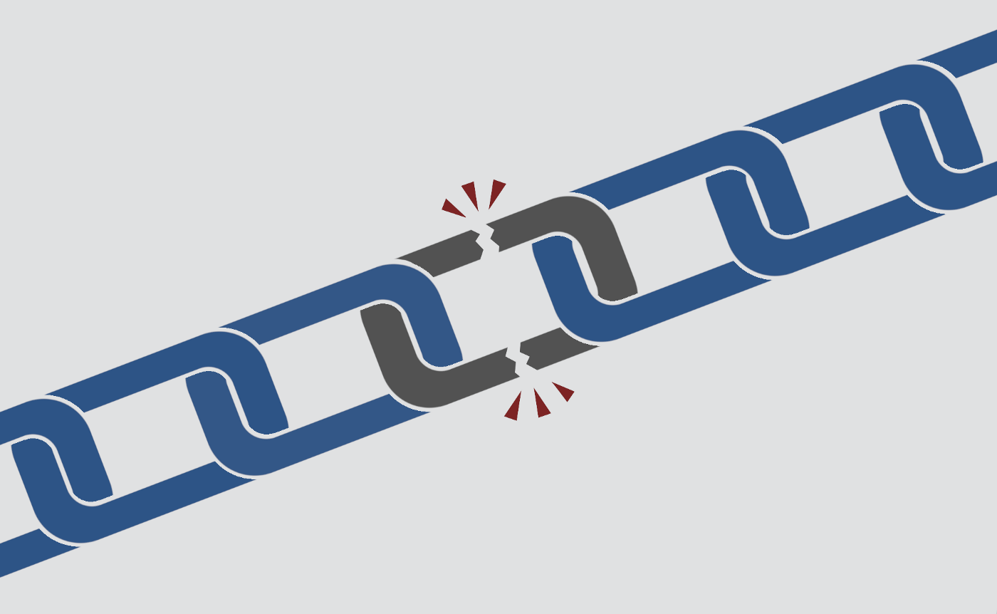

This is a guest blog post from the [Decentralised Public Library](https://medium.com/the-decentralised-public-library), an Arweave initiative.

# What is link rot?

We’ve all been there — you’re trying to access a page online and you suddenly receive the dreaded 404 error — ‘Page not found’. Just like that, a piece of unique internet history is gone. This phenomenon is called ‘link rot’.

Link rot is surprisingly common — across major social media platforms 30% of shared links are [totally dead within two years](https://link.springer.com/chapter/10.1007/978-3-642-33290-6_14). We all imagine the internet to be timeless — after all, sometimes it seems like removing something from the internet is [nearly impossible](http://arweave.net/fm69KUk6_o1hWXsE3MqPC4RtX1W-zTZMTnPYBBmzBJQ). However, this is simply not true — the traditional web is shockingly fragile and not at all immortal.

Over 20 years, [98.4% of web links suffer from rot](http://libres.uncg.edu/ir/uncg/f/F_Oguz_URL_2016.pdf), becoming totally inaccessible to future generations.

It’s not just casually-shared social media links that are at risk of rot though. Even the most prestigious institutions in the world really struggle with link rot — [50% of U.S. Supreme Court opinions contain dead links, and so do 70% of Harvard academic journals](http://arweave.net/rDtcbUMIDoN8vwb-UuqbZEPtvV2tOjvl9ycJ8wrMQ2U). Both legal judgements and academic research rely very heavily on access to historic evidence decades into the future — link rot jeopardises this.

# Why do links rot?

The most common causes of link rot are pretty mundane. Perhaps the original creator has lost interest in their old hobby and let the domain registration expire, or perhaps they ran out of time and money to keep the site active. Sadly, this isn’t just a problem for small-scale hobbyist websites — many huge websites that have been acquired by tech giants are promptly shut down in the years after their acquisition. Sometimes this is because they’re not profitable enough to keep online, and sometimes it’s because the parent company wants to reduce competition for their own original products. This is exactly what happened with Google’s [acquisition](http://arweave.net/NKNa66gSn80TaDe69wcbHq8o3Id5Q5TV6wkl3S7_O-w) of photo-sharing site Picasa in 2004, and then its subsequent [shutdown](http://arweave.net/vJU8zAWy66A7KtmMvr5CZsyWbZ5kPcjVV64xqRYbLq4) of the site in 2016, automatically migrating its entire userbase to their native product, Google Photos. In cases like this, any URLs linking back to Picasa content will have broken when the service and its domain were retired.

Websites don’t maintain themselves, and ultimately unless people work to preserve them and keep them accessible, they will all fall offline eventually.

Something as simple as a site changing its domain name will trigger any links back to the old domain to rot away, often with no way for the reader to find the new location.

Although more rare, there are also deeply sinister, political causes of link rot, like government censorship. Some governments dedicate a huge amount of time and resources to information control, attempting to take down websites to hide information from their citizens. For instance, China’s government has targeted scientific and academic publications extensively for takedowns of specific articles in recent years, and both [Springer](http://arweave.net/Br9-nVQNH8rvt9mBQGPYWipS8l6fC9mqywQQIhy5mHY) and [Cambridge University Press](http://arweave.net/pJsC_6tPUpnaFen5f970eTE3AiIfYzkDOCyXpTSSFeU) have bowed to this pressure. Even the USA has been accused of [censoring climate change information](http://arweave.net/hOwLczpdIB5v67lPPsZ8Jj5yXq_V1jyjqAdSCbhfsLo) from government websites for political reasons.

# How can we fight link rot?

There are a range of things we can all do to reduce the frequency of link rot across the web.

Firstly, we should be aware of the important work of projects like the [Internet Archive’s Wayback Machine](https://archive.org/web/web.php), which crawls the web and makes backups of millions of websites. If you encounter a 404 error out in the wild, you should always check the URL with the Wayback Machine to see if there’s an archived version available. They even have a nifty browser extension (for [Chrome](https://chrome.google.com/webstore/detail/wayback-machine/fpnmgdkabkmnadcjpehmlllkndpkmiak) and [Firefox](https://addons.mozilla.org/en-US/firefox/addon/wayback-machine_new/)) that automatically replaces broken links with archived sites, if they happen to have a backup of that page. There are also national web archives that perform similar functions — for example, the [UK Web Archive](https://webarchive.org.uk/)), though they focus heavily on UK websites, and aim to capture pages just once per year. Remember, most web archiving projects accept requests so let them know if a site you need backed up is missing!

Also, you can begin to permanently archive the decaying traditional web yourself! One option is the Arweave web extension for [Chrome](https://chrome.google.com/webstore/detail/arweave/iplppiggblloelhoglpmkmbinggcaaoc?hl=en-GB), which allows you to permanently capture snapshots of webpages storing them immediately on the ‘permaweb’.

The permaweb is similar to the traditional web, except permaweb content cannot be lost, altered, or purposefully deleted. The links never change, so you know that you won’t suffer from link rot!

Also, for content creators and developers it’s brilliant, because you don’t have to waste your time configuring servers, maintaining domains, or repeatedly paying to host content year after year. You can check out more about the permaweb [here](https://medium.com/@arweave/welcome-to-the-permaweb-ce0e6c73ddfb), and play around with some **free** archiving tokens [here](https://tokens.arweave.org/). As you may have noticed, most of the links in this article are actually permaweb snapshots of traditional webpages, placing them beyond the reach of accidental and intentional alteration and loss.

**Once you’ve claimed your free tokens, it’s super easy to start archiving with the Arweave web extension. Check out our handy step-by-step guide here:**[**https://docs.arweave.org/info/archiving/step-by-step-beginners-guide**](https://docs.arweave.org/info/archiving/step-by-step-beginners-guide)

No more 404!

# Banned Books: A complicated history

[](https://arweave.medium.com/?source=post_page-----a23ce123a81c--------------------------------)

[The Arweave Project](https://arweave.medium.com/?source=post_page-----a23ce123a81c--------------------------------)

[Feb 26, 2019·7 min read](https://arweave.medium.com/banned-books-a-complicated-history-a23ce123a81c?source=post_page-----a23ce123a81c--------------------------------)



This is a guest blog post from the [Decentralised Public Library](https://medium.com/the-decentralised-public-library), an Arweave initiative.

This week we are proud to support Canada’s Freedom to Read Week! This event is a celebration of Canada’s constitutional commitment to intellectual freedom, and a reminder to us all of the importance of freedom to publish and to disseminate knowledge. This blog post will explore some of the challenges to these freedoms, many of which continue to threaten our literature even today.

# Why are books banned?

Reasons for attempted book bans are incredibly diverse, with some of the most common being: the inclusion of controversial religious or moral themes, obscenity, and politics.

However, moral outrage is not reserved for low-budget, risqué, or underground publications. Some of the most beloved and well-respected books of the 20th century have been banned at some stage.

At least 46 of the Radcliffe Publishing Course Top 100 Novels of the 20th Century have been the victim of ban attempts, [according to the American Library Association](http://www.ala.org/advocacy/bbooks/frequentlychallengedbooks/classics)(ALA).

**Obscenity**

Obscenity laws in the UK and USA have traditionally been heavily involved in censorship attempts and successes in the 19th, 20th, and even 21st centuries.

The now-classic novel ‘Ulysses’ by James Joyce was the subject of various legal wrangling when it was first published, typically under obscenity laws. Although Joyce’s novel has some words and phrases that would make many wince even today (including the remarkable descriptor ‘scrotumtightening sea’!), the [British Library comments](https://www.bl.uk/20th-century-literature/articles/ulysses-and-obscenity)) that any affront caused by the novel’s language was compounded by “…its bawdily irreverent treatment of the British royal family and its sacrilegious attitude to the Roman Catholic Church…”.

Simply put, it ruffled some religious and establishment feathers, as well as prudish ones too! In fact, when Ulysses was originally serialised in the journal The Little Review, its instalments were promptly and dramatically ceased when the two joint editors were successfully prosecuted under obscenity laws in the UK. Though some censors justified their actions as being for the ‘protection of women’, the irony that the two prosecuted editors were women themselves, Margaret Anderson and Jane Heap, may have escaped them.

Happily, Joyce’s Ulysses is now officially public domain in many countries! This means that the work is out of copyright restriction, and so it can be modified, re-used, and adapted without royalties to the original author (or their estate). This means that you can legitimately [download a copy for free](http://www.gutenberg.org/ebooks/4300)today! Note: if you’re in the EU you may have trouble accessing Project Gutenberg (a fabulous resource for free ebooks) without a VPN, so try [this link](http://www.planetpdf.com/planetpdf/pdfs/free_ebooks/Ulysses_NT.pdf) instead.

Following a very similar journey, the novel ‘Lady Chatterley’s Lover’ by D. H. Lawrence, was formally banned from its publication in 1928 until 1960, when a High Court ruling found the publishers not guilty of violating UK obscenity laws on the grounds that the work was of ‘literary merit’. Again, happily, Lady Chatterley’s lover is also officially public domain in the UK. Download your own version of this once-banned book yourself [right here](https://arweave.net/GjT0X89P1Q5J-wb42XedvQ-LukoObse4Eo55Bd7X82g)!

**Religion**

When published books offend religious sensibilities, the consequences can be dire. The reaction to publication of the magic realism novel ‘The Satanic Verses’ by Salman Rushdie has resulted in multiple serious injuries and even deaths. The book was wildly controversial, as many Muslims believed the text was severely blasphemous. Shortly after publication, a fatwa (‘death sentence’) was declared on the author, resulting in Rushdie and his family living in hiding for many months. In the many [protests that followed](https://www.chicagotribune.com/news/ct-xpm-1989-02-13-8903050026-story.html0), some turned deadly, including in Pakistan where [five people were killed and 80 wounded](https://www.nytimes.com/1989/02/13/world/muslims-storm-us-mission-in-pakistan.html?mtrref=undefined&gwh=6932A2C9C4CFCE1D63653D10073FDF65&gwt=pay). Rushdie later apologised for the distress caused by his book, but this was outright rejected, with Ayatollah Khomeini’s office stating, “Even if Salman Rushdie repents and become the most pious man of all time, it is incumbent on every Muslim to employ everything he has got, his life and wealth, to send him to Hell.”. Perhaps unsurprisingly, the book was banned in a raft of nations, including Rushdie’s home country India, and in Pakistan.

Surprisingly, children’s books are commonly also the target of banning attempts on religious grounds, commonly from parents seemingly attempting to protect their children from outside influence and ideas. Take the explosively popular Harry Potter series, which was one of the most challenged books or series according to the [ALA’s Office for Intellectual Freedom in 2001, 2002, and 2003](http://www.ala.org/advocacy/bbooks/frequentlychallengedbooks/top10) for inclusions of ‘occult/satanic’ themes. I suspect many who have read Harry Potter will readily dismiss these accusations, given the strong themes of friendship, familial love, and loyalty found throughout the series (and the lack of satanism, of course). Ironically, JK Rowling herself has confirmed that the Potter series has strong Christian themes, which she discusses at length [in this piece](http://www.mtv.com/news/1572107/harry-potter-author-jk-rowling-opens-up-about-books-christian-imagery/), where she confirms that she is in fact Christian herself, and attends church regularly.

**Politics**

For centuries, literature has been incredibly vulnerable to censorship on political grounds. Sometimes a book can be heavily challenged or banned simply because the author is believed to have specific political leanings, even if the book in question doesn’t appear to contain any mention of politics. For instance, after its publication in 1903 ‘Call of the Wild’ by Jack London was banned by authoritarian governments in Italy (1929), Yugoslavia (1929), and in Germany (it was publicly burned in 1933), supposedly due to London’s personal belief in socialism. Perhaps conversely, others have suggested that the book’s narrative promotes an idealistic individualism and bravery, themes which can often contribute to authoritarian regimes’ desire to restrict access. Call of the Wild is now in the public domain, so feel free to download a copy [right here](https://arweave.net/VuFHIDp6l9q6zws3K8HzbYiQtZQ1n2BvqtVzQH0BOGg)! Similarly, John Steinbeck’s classic ‘Of Mice and Men’ (1937) has fielded [challenges](https://arweave.net/0TYdysuq9l_Uo0c4-iMgDTFtcr5lh1ijvS_ka7tqCZc) due to Steinbeck’s perceived ‘anti-business attitude’, and ‘questionable patriotism’.

However, book bans and other attempts to restrict people’s freedom to read continue to this day. If we want to preserve these liberties we must consistently defend against attempts to silence controversial works. Prior to the publication of Michael Wolff’s ‘Fire and Fury: Inside the Trump White House’ in 2018, President Trump’s own lawyers sent a [cease and desist letter](https://apps.washingtonpost.com/g/documents/politics/read-trump-lawyers-letter-to-michael-wolff-and-steve-rubin/2695/)on the grounds of libel to the publisher insisting that the book [not be published at all](http://nymag.com/intelligencer/2018/01/trumps-scary-lurch-into-book-banning.html%5d). The publisher has labelled this action [unconstitutional](http://time.com/5092923/fire-fury-michael-wolff-publisher-trump-unconstitutional/).

# Freedom to read in prisons

As you might expect, compared to those of us walking free, prisoners have dramatically reduced access to books and other media, despite their potential rehabilitative impact. Prisons are equipped with libraries, the quality of which depends on the prison in question and its security level of course. However, practical obstacles often impinge prisoners’ ability to access said libraries, including availability of staff to accompany their visit. As you might expect, prison libraries do not hold the full range that a typical library would, with certain topics deliberately withheld for the prison’s stability or for prisoners’ safety. However, restrictions of freedom to read inside prisons are not always entirely reasonable.

For some time, prisoners in Britain were banned from purchasing or receiving books at all, as part of a crackdown on prisoners’ ‘perks and privileges’. In 2014, this rule was found to be unlawful by the High Court and prisoners were [permitted to purchase books](https://arweave.net/9O6Ku8HMBNxKTucps9Is2Xkf9Zc8qL8HCd5VjhEzikk) from four specific retailers, who would send the volumes to prisons directly.

Furthermore, prisoners in the USA have to deal with unintuitive and restrictive rules on exactly what reading material they’re allowed to access, which can [vary wildly from state to state](https://qz.com/1176515/exactly-what-gets-a-book-banned-from-prisons-in-one-us-states-spreadsheet/). For instance, certain ‘self-help’ or ‘personal development’ books have been outright banned from prisons in Utah, Texas, and Pennsylvania. ‘Body Language 101’ by David Lamber, ‘The Elements of Persuasion’ by Richard Maxwell and Robert Dickman, and ‘The 48 Laws of Power’ by Robert Greene have all been banned from US prisons out of fear they may teach prisoners to become better manipulators or liars. Additionally, many programming and IT educational texts are disallowed from American prisons, including ‘C+ for Dummies’, with authorities citing the possibility that these could cause ‘a security threat to the prison’, This is perhaps particularly baffling, given that California prisons have been [teaching prisoners to code](https://arweave.net/mzYdF4rpLx6qeuIQZg5OjBDGlJcllgtUJIWgZKv-Jg0), rather than denying them the chance to learn!

# Freedom to read in schools

When reading the number of [book bans and attempts](http://www.ala.org/advocacy/bbooks/frequentlychallengedbooks) it’s immediately obvious that a vast majority of such challenges in the USA at least come from parents petitioning local school districts in attempts to either remove a book from the curriculum, or from the school’s library.

One example of a heavily challenged book in schools is ‘To Kill a Mockingbird’ by Harper Lee (1960), which was the [7th most challenged book in 2017](https://arweave.net/8xZ8N33s9PlN9uLnxT5rIREU55uzm4c6xiY0duKeT3w). Many of these challenges come from parents petitioning school districts to remove the book from reading lists and school libraries. Mockingbird has been consistently controversial since its publication in 1960, and despite being a well-loved classic and Pulitzer Prize winner, remains heavily challenged to this day. In recent decades challenges have often cited the fact that Mockingbird includes the use of racial slurs, despite the overall message of the book being deliberately anti-racist.

**So, as we head into this week, we should take some inspiration from the**[**Freedom to Read Foundation**](http://www.freedomtoread.ca/)**, and seize this opportunity to reaffirm our commitment to intellectual freedom. Join our mission to preserve knowledge now and**[**try our**](https://docs.arweave.org/info/archiving/step-by-step-beginners-guide)**permanent archiving tool!**

# ****Storing human history on a blockchain: Arweave <> Everipedia****

[](https://arweave.medium.com/?source=post_page-----c876a6d01cc0--------------------------------)

[The Arweave Project](https://arweave.medium.com/?source=post_page-----c876a6d01cc0--------------------------------)

[Feb 28, 2019·3 min read](https://arweave.medium.com/storing-human-history-on-a-blockchain-arweave-everipedia-c876a6d01cc0?source=post_page-----c876a6d01cc0--------------------------------)

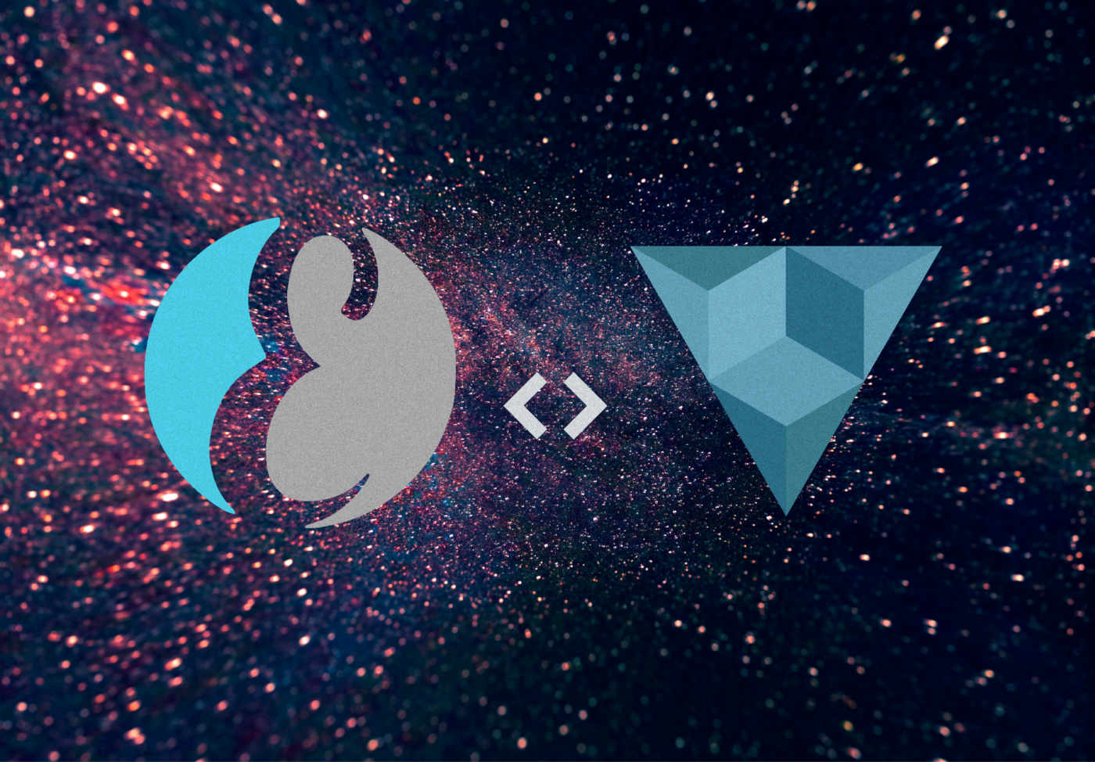

Next in our series of permaweb partnerships, we’re delighted to announce that we’ve teamed up with wiki-based encyclopedia [Everipedia](https://everipedia.org/) — a project involving founders from [Wikipedia](https://www.wikipedia.org/) and [Genius.com](https://genius.com/). We’ll be storing the wealth of knowledge that Everipedia preserves on the Arweave, and together, we strive to forever preserve human history on the permaweb.

# ****What is Everipedia?****

Everipedia is the largest online English encyclopedia, modernised and re-designed for the digital age; it is similar to Wikipedia except all information is stored and incentivised on a blockchain (as opposed to the hierarchal model that Wikipedia has where users have certain privileges over others). The Everipedia editing interface makes creating and editing wiki’s as easy as using Facebook, and enables users to publish pages containing links, pictures, and videos. Like Wikipedia, Everipedia heavily relies on contributors from all over the world.

The decentralised nature of Everipedia means that users in Turkey, Iran, or China are, for the first time, able to access a plethora of knowledge that has previously been denied; Everipedia has Wikipedia imported and therefore it encompasses all of Wikipedia’s English language content, and much more. Just like Arweave, Everipedia is serverless and there are no gatekeepers controlling the narrative of human knowledge — anybody can make a page, as long as it’s well cited.

# ****Enabling the knowledge economy****

Community members are held accountable for submissions to Everipedia but unlike Wikipedia — where thousands of editors labour for free — Everipedia’s editors get an incentive from the points system, whereby creating articles and approved edits amasses “IQ.” Using EOS blockchain technology, Everipedia converts IQ scores to a token-based currency, giving all existing editors an allotment proportionate to their IQ — and giving them a real, financial stake in the platform.

To prevent bad actors from trying to cash in with ill-founded or deliberately false articles and edits, Everipedia require users to put up a token of their own in order to submit. If their work is accepted, they get their tokens back, plus a little bit extra for their contributions; if not, their tokens get slashed, which essentially means it takes longer for the tokens to be returned to their account to reuse. All holders of IQ are incentivised to create quality, neutral content and to work together in building the reputation of the network.

The model aims to make feasible a fully-autonomous encyclopedia that does not need to rely on advertisements or donations.

# ****Current state****

Already, we’re storing the articles that account for 80% of the Everipedia traffic on the permaweb and as the wealth of knowledge on the platform grows, we look forward to being part of the mission to preserve human history for future generations.

**Want to help guarantee the safety of humanity’s knowledge and earn tokens at the same time? Why not try**[**running an Arweave node**](https://docs.arweave.org/info/mining/mining-guide)**!**

# ****March Hackathon Roundup****

[](https://arweave.medium.com/?source=post_page-----e5db0e117c6d--------------------------------)

[The Arweave Project](https://arweave.medium.com/?source=post_page-----e5db0e117c6d--------------------------------)

[Mar 20, 2019·3 min read](https://arweave.medium.com/arweave-hackathon-x-eth-paris-e5db0e117c6d?source=post_page-----e5db0e117c6d--------------------------------)

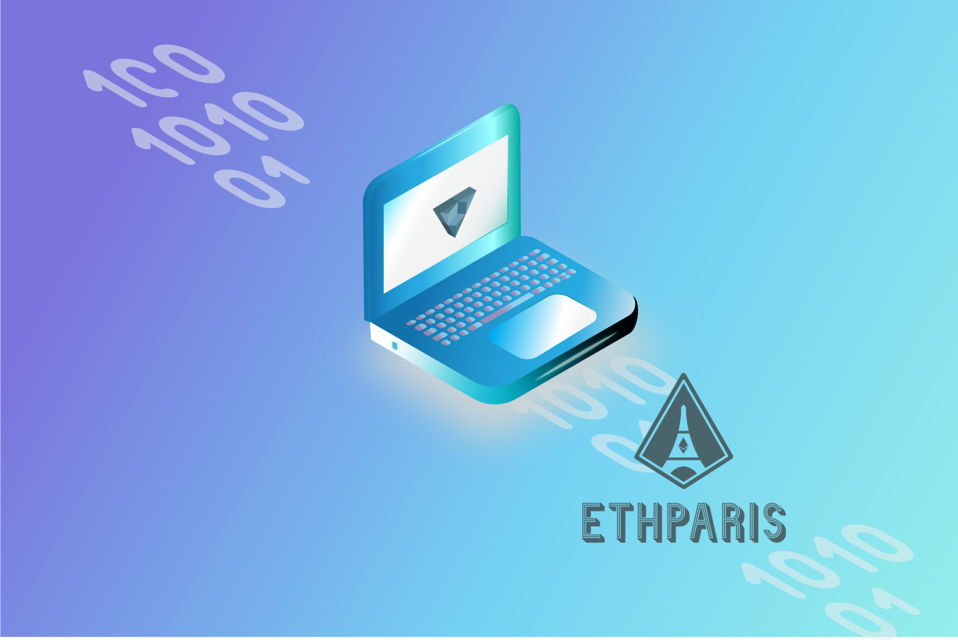

A few weeks ago, we ran our very own internal hackathon and following this, we sponsored and took part in ETHParis (an ETHGlobal hackathon). Our plan with these hackathons was to get as much real-world experience with building Arweave apps as we could in a short period, which would help us identify the complexities in the on-boarding process for new developers into the permaweb ecosystem — and indeed it did.

The key lesson that we learnt during the hackathons is that it is just as easy as we hoped to build useful permaweb apps! For our internal hackathon, within just one week our team was able to build a bunch of well-featured permaweb apps addressing a range of real-world use cases. Then, at ETHParis, members of the wider Ethereum community were able to quickly get onboard using Arweave as a storage platform for their dApps. We believe that the quality and ease of a developer’s first time using a platform will be vital in determining which decentralised platforms will be successful in the fight for adoption. As such, we’re thrilled at how smooth the onboarding process is for developers joining the permaweb, and believe this is a very positive sign for the future.

However, nothing is perfect (yet ;) !). Among the areas for improvement in the developer experience we identified that the permaweb deploy environment was not intuitive to emulate on a developer’s local machine. This is mainly due to the way that browsers treat HTML files served from the local hard drive in comparison to those served from a remote server (CORS headers, etc.). Further, even if the user started a local HTTP server and used this to test their permaweb app, the pages served through it would still act differently than if they were served through the Arweave web extension or a permaweb gateway. This is due to the fact that web pages not served over HTTPS are unable to use various Javascript libraries — most critically, the SubtleCrypto library that is required to sign Arweave transactions, amongst many other things.

In order to address these issues, @arweave-kyle has been hard at work building an `arweave serve` feature into the web app deployment tool that we released back in January, so that developers can trivially start an environment that perfectly matches the permaweb, right from their own machine. We are excited to ship this update in the coming weeks!

Another interesting lesson that we learnt was this: the permaweb makes a great hosting environment for the web apps that often serve as the user interfaces to smart contract systems. One of the things that excites us as developers most about Ethereum (and other smart contract platforms), is the idea that we can build apps that run indefinitely, without maintenance, upkeep, etc. This is very cool, but typically these smart contracts are only useful if the UI that is associated with them is still online. Currently, the typical method for hosting these smart contract web UIs is Amazon’s S3 service, or at best, using a centralised IPFS node (although this is never fast enough to use in practice). If the developer stops paying for hosting or the server goes offline, you lose your UI and these contracts are basically just byte code and non-human readable machine state. Without a user interface to interact with, the usefulness of these contracts is highly limited.

The permaweb is a perfect fit here, as the web apps stored inside are just as permanent as the dApps that they are supporting. This means that when you use Arweave to store your dApp UI, you can be confident that at some point in the future you will not end up with an ‘eternal’ smart contract that nobody can understand or interact with. Neat!

Stay tuned to this blog as we will be showcasing some of the experiments that were built at these hackathons in the near future!

**-arweave-team**

Deploy your dApp on the permaweb [now >](https://www.arweave.org/hosting.html)

# ****Hackathon: Showcase part 1****

[](https://arweave.medium.com/?source=post_page-----4f06f403ce7d--------------------------------)

[The Arweave Project](https://arweave.medium.com/?source=post_page-----4f06f403ce7d--------------------------------)

[Mar 27, 2019·3 min read](https://arweave.medium.com/hackathon-showcase-part-1-4f06f403ce7d?source=post_page-----4f06f403ce7d--------------------------------)

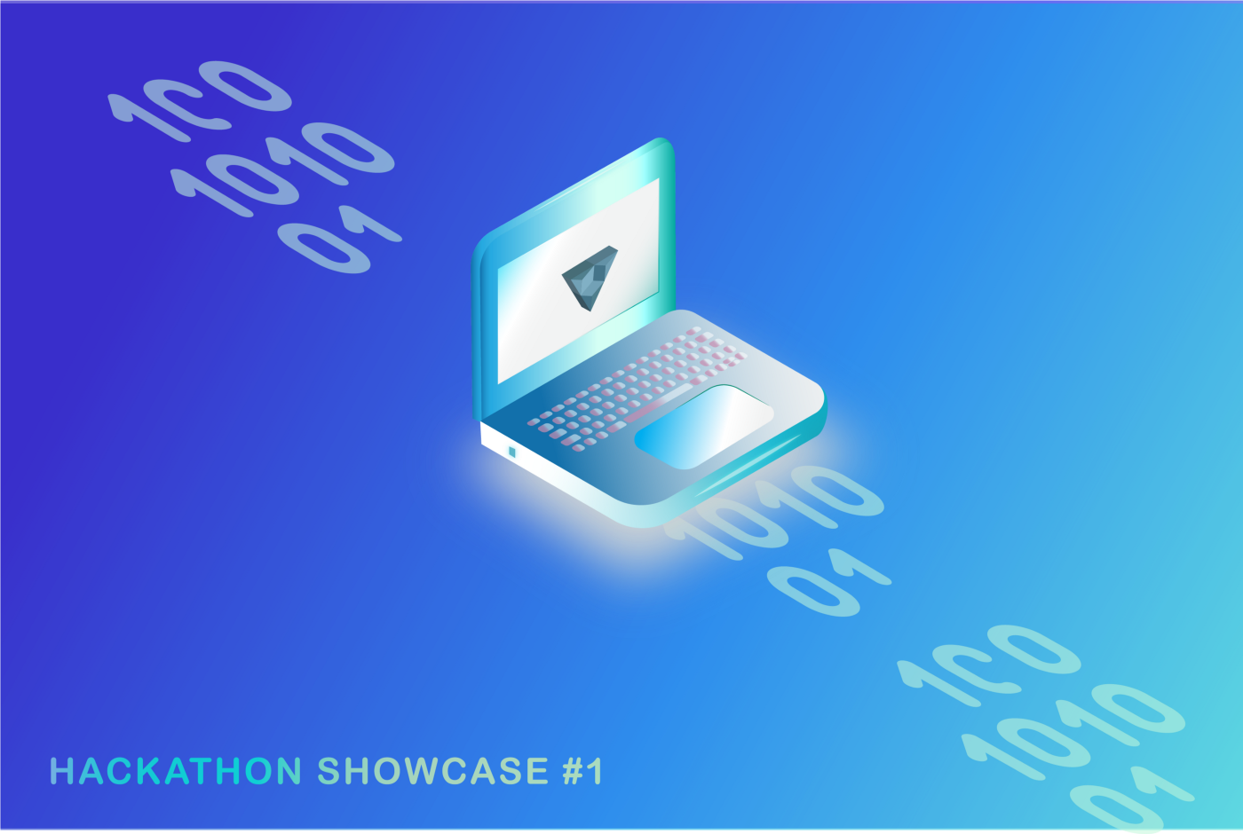

Last week we brought you an [update](https://medium.com/@arweave/arweave-hackathon-x-eth-paris-e5db0e117c6d) surrounding the hackathons we’ve recently been involved in. Today, we’ll take a look at some of the awesome things that the Ethereum community have been building on the permaweb. Check back tomorrow for an overview of the web apps we built during our own internal hackathon!

# ****ClaimIt****



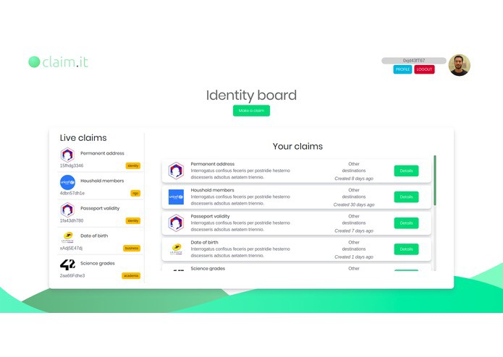

[ClaimIt](https://github.com/Blockchainpartner/claim.it) is a tool produced at the ETHParis hackathon for making and managing claims on the Ethereum blockchain. Building on the wider Ethereum community’s work with ERC 725 and ERC 735, ClaimIt provides (in the developers own words) ‘easy-to-deploy dev tool to monitor and interact with standardized claim systems’. As well as providing the developer tools needed to work with the growing on-chain claims infrastructure, ClaimIt also provides a simple and user-friendly web application (hosted on the Arweave) for managing these claims, complete with push notifications and live UI updates. Neat! As mentioned in our previous blog post, we are very excited about this user case of storing the web apps associated with smart contract systems on the Arweave’s permaweb — making the UIs people need to interact with the systems as permanent as the systems themselves.

Check out ClaimIt on GitHub [here >](https://github.com/Blockchainpartner/claim.it)

# ****KiwEth****

[KiwEth](https://devpost.com/software/kiweth-9ta4y6) is a Docker configuration generator for simply building and destroying test Quorum blockchains. The web app offers the user a simple set of options for configuring the blockchain deployment in such a way that it is easy for developers who are new to blockchain to get up and running. As the developers of KiwEth correctly identified, easily building and deploying test blockchains is still a major issue for those getting started with blockchain development. KiwEth addresses this by offering a simple step-by-step interface for building dockerized blockchain environments quickly and simply. KiwEth also uses Arweave’s web application hosting features to serve the web pages that make up the ‘wizard’ UI that produces the Docker images.

As the generator requires access to private configuration data, KiwEth makes use of Arweave’s decentralised and trustless nature to ensure that once published and audited, the Arweave TXID that relates to the web app will always return a safe web app that does not steal these details. That is, once published, the author cannot change the web app to send the private data to a server, add intrusive ads, or change the offering. This hints at a powerful feature of permaweb apps: consumer integrity. We are excited to share some more of our thoughts about this in an upcoming blog post!

Check out KiwEth on DevPost [here >](https://devpost.com/software/kiweth-9ta4y6)

# ****On-going: NuCypher virtual hackathon****

After ETHParis, we were very excited to join NuCypher’s tech stack for their on-going virtual hackathon! [NuCypher](https://www.nucypher.com/) is a proxy re-encryption scheme for building a privacy infrastructure for data handling in decentralised applications. If you want to get involved with the community and get hacking an Arweave+NuCypher app, why not check it out [here](https://coinlist.co/build/nucypher). They have a generous grand prize on offer, too!

Here is a workshop we recently gave for the NuCypher hackathon explaining how to get started with Arweave web app development for dApps:

Remember to check back tomorrow for more showcases of some of the apps living on the permaweb!

**Hackathon: Showcase part 2**

[](https://arweave.medium.com/?source=post_page-----9d792872935a--------------------------------)

[The Arweave Project](https://arweave.medium.com/?source=post_page-----9d792872935a--------------------------------)

[Mar 28, 2019·5 min read](https://arweave.medium.com/hackathon-showcase-part-2-9d792872935a?source=post_page-----9d792872935a--------------------------------)



Yesterday we showcased some of the [awesome things](https://medium.com/@arweave/hackathon-showcase-part-1-4f06f403ce7d) that the Ethereum community built with Arweave during the recent ETHParis hackathon. Today, we are excited to show you some of the apps that the core Arweave team also built on the permaweb during a recent internal hackathon. [As we explained](https://medium.com/@arweave/arweave-hackathon-x-eth-paris-e5db0e117c6d) in our introductory blog to this series, the purpose of our hackathon was not so much to build working products, but to stretch and test the bounds of the [permaweb](https://medium.com/@arweave/welcome-to-the-permaweb-ce0e6c73ddfb) app development toolkit that we released a couple of months ago. As it turned out, all of the apps and integrations that we list below are fully functional, and give a good feel for the kinds of decentralised web apps that people can easily build with the Arweave. Without further ado…

**Weavemail**



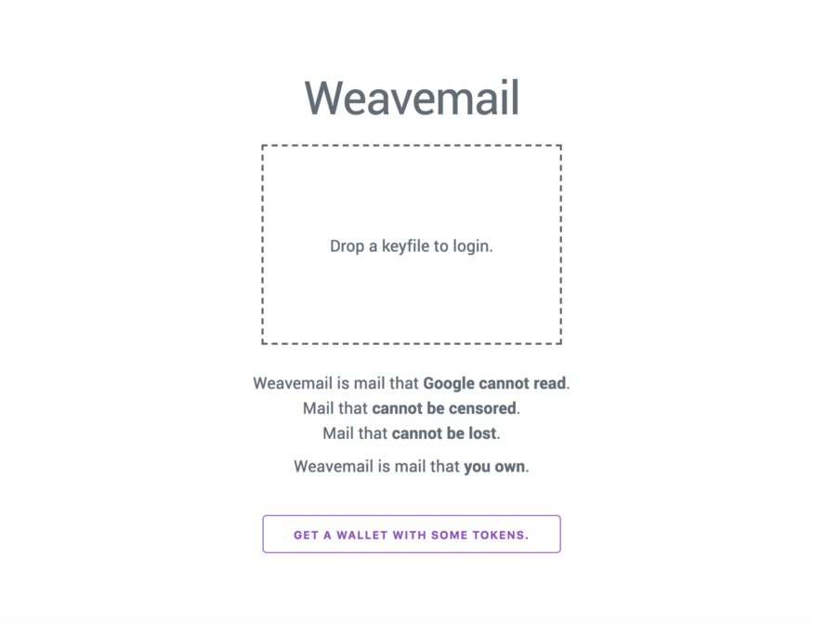

<https://weavemail.app/>

Weavemail is simple: it’s a decentralised and permanent email replacement. It is a fully decentralised mechanism for sending and receiving mail using the Arweave’s permaweb as its host. As we will outline in our upcoming blog post about ‘consumer integrity’ and permaweb apps, one of the most exciting facets of this system is that now that it is launched, you will *always* be able to return to it in its current form. This means that we (the developers) cannot:

*- Remove your access to it*

*- Change it to send your private messages to us — only you can see them*

*- Change it to add intrusive adverts*

For the critical web infrastructure that we use in our daily lives, these guarantees are extremely valuable. By contrast, when you give your Gmail address to people, your access to that mail, and under what conditions (is your data private? Are there many adverts?) is totally at Google’s discretion.

Weavemail is also extremely simple — built of 186 lines of JS, and 126 lines of HTML and CSS. We are pretty excited that you can build such complex decentralised apps in so few lines on the permaweb, but do be aware that you should not currently use weavemail for serious purposes. If you are interested in building weavemail out into a production-ready product, we would love to hear from you! We would be very excited to setup a generous bounty to see this built. Contact at the weavemail address below!

@arweave-sam’s weavemail address is: **vLRHFqCw1uHu75xqB4fCDW-QxpkpJxBtFD9g4QYUbfw**

We’re offering 10 AR to the first 100 people to send their first Weavemail. Click the link [here](https://weavemail.app/) to get started.

**Chronolock**

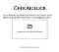

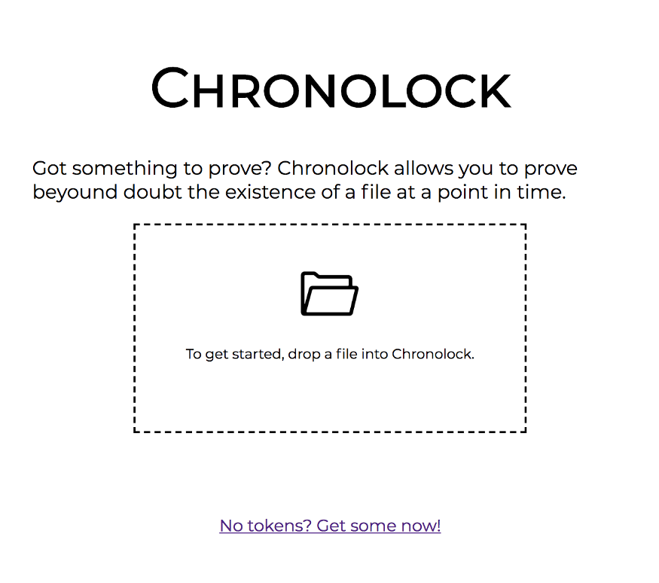

[https://arweave.net/xqx3Ua8VBQLgdKqlI4gtZdVoXxLLF8csKn5in-joJqo](http://arweave.net/xqx3Ua8VBQLgdKqlI4gtZdVoXxLLF8csKn5in-joJqo)

Ever had the need to prove to someone that a document existed at a certain point in time? Perhaps you have used this kind of functionality at an old school notary. Chronolock is a simple, and exceptionally cheap, way of proving that a piece of data existed at a certain point in time — ‘locking’ it chronologically into the blockweave.

Simply drop your file onto the web page, then your low-balance Arweave keyfile (see note on permaweb app security models below!). After your transaction has been mined into a block, a record of the existence of this file will be permanently available from the blockweave, buried under vast quantities of computational work. Then, any time that you want to prove that this file existed at an earlier point, simply drop the file onto the page again and the details of when it was first mined will be recalled.

Check out Chronolock here: [https://arweave.net/xqx3Ua8VBQLgdKqlI4gtZdVoXxLLF8csKn5in-joJqo](http://arweave.net/xqx3Ua8VBQLgdKqlI4gtZdVoXxLLF8csKn5in-joJqo)

**Zapier Integration**





Zapier <> Arweave

Zapier invite link: <https://zapier.com/developer/public-invite/9821/9d6e8c37b909a1196ab98aedab967b5d/>

**Competition prize:**1000 AR (see terms below)

[Zapier](https://zapier.com/) is a simple, no-programming web tool that allows you to join together events and actions between APIs. The Arweave integration with Zapier allows users to chain together actions on other services (for example, a new tweet on Twitter) with Arweave’s permanent archiving, as well as triggering other events on different services in response to new Arweave transactions.

Because of Zapier’s advanced integrations with thousands of other APIs, you can now build an almost endless variety of different Arweave apps with zero programming required. For example, we now have a ‘whale watch’ bot that allows us to track when large amounts of AR are moving through the system, as well as an automated archiver of @realDonaldTrump’s tweet. These are just a couple of the different integrations you can build with Arweave+Zapier, and to help you start building awesome apps on the permaweb, **we are offering a prize of 1000 AR** to the best Zapier+Arweave integration!

**Competition rules:**

* *Submissions (either as a short video showing what it does, or a brief text guide with some screenshots) should be made by Friday 19th April 2019*
* *Submissions should be sent to*[*team@arweave.org*](http://team@arweave.org/)
* *Multiple submissions per person are allowed*

Tomorrow we will be publishing another article taking you through the process of building your first Zapier+Arweave apps, so watch out for that!

**Note on permaweb app security models**

The current permaweb app security model is to generate a new, low balance wallet for each application that you use. Remember to only store as many tokens in these wallets as you feel comfortable trusting the application with, as they will have access to the full amount of funds in the wallet. We are working on a bridge that allows the developer to call out to the gateway or the Arweave web extension to sign transactions there, delegating trust to these components of the ecosystem rather than the app itself.

Stay tuned to this blog for further discussion of how we see this playing out over the long-term, and how you can get involved! For now, imagine that these permaweb apps are like early web ecommerce sites — don’t give them your credit card details if you don’t trust them! (And if you do trust them, only use a wallet that has a balance you are comfortable sharing with the app owner).

*Remember to check back tomorrow for guides and videos on how to build your first Arweave+Zapier apps!*

**Build permaweb apps without code: 3 Arweave+Zapier tools you can make in less than 5 minutes**

[](https://arweave.medium.com/?source=post_page-----e1837f1d3fea--------------------------------)

[The Arweave Project](https://arweave.medium.com/?source=post_page-----e1837f1d3fea--------------------------------)

[Mar 29, 2019·3 min read](https://arweave.medium.com/build-permaweb-apps-without-code-3-arweave-zapier-tools-you-can-make-in-less-than-5-minutes-e1837f1d3fea?source=post_page-----e1837f1d3fea--------------------------------)



Yesterday[we showcased](https://medium.com/@arweave/hackathon-showcase-part-2-9d792872935a) some of the neat hackathon builds that were published onto the permaweb over the past few weeks — one of those projects being the Zapier integration for Arweave. [Zapier](https://zapier.com/) is a simple ‘point and click’ (no programming) service for building integrations between thousands of web service APIs. Zapier’s seamless integration model means that you can now build an unprecedented number of Arweave apps on the permaweb, without writing even a single line of code.

In this post we will take you through the process of building your first Arweave+Zapier ‘Zaps’, and showcase some of the neat things that you can build. To energise/kick-start your venture into the world of ‘Zaps’, we’re giving away **1000 AR** to the coolest Arweave+Zapier integration. More details about this can be found at the bottom of this article.

**#1 Auto-archive @realDonaldTrump’s new tweets**

**Implementation time:** 1 *minute 34 seconds*

Love them or hate them, Donald Trump’s controversial tweets are now important historical documents about our turbulent age. Unfortunately, a number of these tweets have been [deleted](https://projects.propublica.org/politwoops/user/POTUS) from the president’s timeline. The above video takes you through the process of building an automated tweet archiver, so that Trump’s tweets are immediately timestamped, logged, and added to our communities’ [growing archive](https://medium.com/@arweave/storing-human-history-on-a-blockchain-arweave-everipedia-c876a6d01cc0) of valuable historical documents.

**#2 Weavemail to email bridge**

**Implementation time:** 2 *minutes 20 seconds*

As much as we love [Weavemail](https://weavemail.app/), it has yet (early days 😉) to replace the existing centralised and non-privacy-protecting web mail infrastructure from the likes of Google/Yahoo/Microsoft. The Zap displayed in the video above helps you setup a simple Arweave network monitor that notifies you when you receive a new weavemail. Remember, We’re offering **10 AR** to the first 100 people to send their first Weavemail — send your [weavemail](https://weavemail.app/) now so that you don’t miss out!

@arweave-sam’s weavemail address is: **vLRHFqCw1uHu75xqB4fCDW-QxpkpJxBtFD9g4QYUbfw**

Click the link [here](https://weavemail.app/) to get started.

**# 3 Arweave whale watcher**

**Implementation time:** *2 minutes 53 seconds*

When large quantities of tokens are in transit on the Arweave network, we like to keep track of them. With this ‘whale’ watcher, we receive a Slack message every time a large transaction happens. Integrations like these show how simple and easy it is to get notified of events inside the Arweave network.

**What will you build?**

The above examples are just a few of the near-endless tools that you can very quickly build with Arweave+Zapier. Now you’re set! We’re super excited to see what you guys come up with, so don’t forget to share your Zap projects with us [@ArweaveTeam](https://twitter.com/ArweaveTeam).

**Zapier <> Arweave competition rules:**

* *Submissions (either as a short video showing what it does, or a brief text guide with some screenshots) should be made by Friday 19th April 2019*
* *Submissions should be sent to*[*team@arweave.org*](http://team@arweave.org/)
* *Multiple submissions per person are allowed*

Let your creative run wild!

***Arweave + Zapier integration link:***[*https://zapier.com/developer/public-invite/9821/9d6e8c37b909a1196ab98aedab967b5d/*](https://zapier.com/developer/public-invite/9821/9d6e8c37b909a1196ab98aedab967b5d/)

# Data Spotlight: Women’s History

[](https://arweave.medium.com/?source=post_page-----9a78575337a4--------------------------------)

[The Arweave Project](https://arweave.medium.com/?source=post_page-----9a78575337a4--------------------------------)

[Mar 31, 2019·7 min read](https://arweave.medium.com/data-spotlight-womens-history-9a78575337a4?source=post_page-----9a78575337a4--------------------------------)



This is a guest blog post from the [Decentralised Public Library](https://medium.com/the-decentralised-public-library), an Arweave initiative.

As we come to the end of Women’s History Month, we thought it would be a good time to reflect upon the variety of women’s history already stored forever on the permaweb!

# Women and Human Rights: The Suffragettes





Votes for Women poster by Hilda Dallas, 1909

Across the world, women have had to fight for generations to live, work, and vote on the same legal basis as men. On many issues in many places, women and their allies still fight these battles.

In Britain, one of the most monumental legal battles for women’s rights was for the right to vote in public elections. Although partial voting rights were granted to women — those over 30 who owned property — in 1918, this only accounted for around 40% of women. It wasn’t until 1928 that the remaining 60% of adult women gained voting rights in the UK.

The Suffragettes or the ‘Votes for Women’ movement is a vital part of our shared social history, its members fighting fiercely for women’s voting rights for decades. Interestingly, the term ‘suffragettes’ was originally coined as a somewhat derisive term for women suffragists. However, the Votes for Women movement happily adopted the moniker, even naming one of their publications after it.





One all-women household boycotts the 1911 census in protest

The suffragettes employed a range of civil disobedience methods to achieve their goals, including boycotting the census, refusing to pay certain fines and fees, marches, protests, and picketing. Above you can see an image of a returned census form from an all-women household that has been voided in protest, reading, “No persons here, only women!”. The message being that these women refuse to comply with other legal obligations (such as census completion) while they are simultaneously denied equal rights under the law.





Poster by Alfred Pearce for the Women’s Social and Political Union, 1910

When imprisoned for these activities, many suffragettes undertook hunger strikes which the British government met with tortuous force-feeding of the detained women. The practice was much discussed and featured in many political posters, campaigns, and protests as depicted here.

Detained suffragettes were denied the label of political prisoners, which further exacerbated tensions. See the below image of a 1912 petition demanding that suffragette protesters be granted political prisoners status, and the “cruel and dangerous” practice of force feeding be stopped.



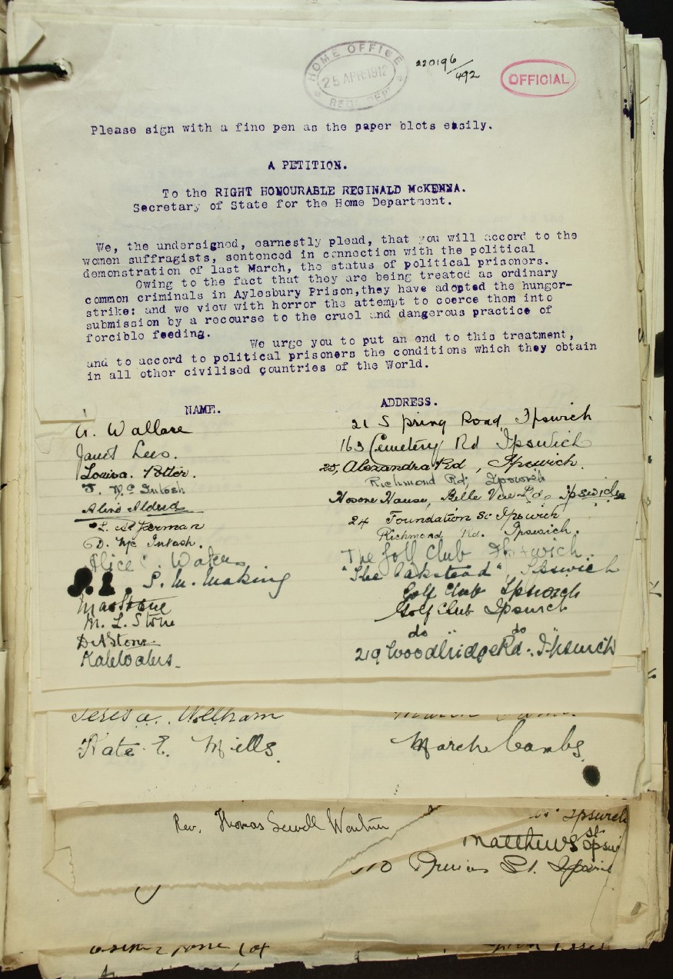

Petition for end of force feeding of detained suffragettes and grant of political prisoner status, 1912

If you’d like to learn more about the British suffragette movement, we recommend the British Library’s [collection of NUWSS pamphlets](https://www.bl.uk/collection-items/nuwss-pamphlets), and their [Votes for Women collection](https://www.bl.uk/votes-for-women).

The place of women in UK society has changed monumentally over the past 100 years (as you might hope!). For instance, the UK has now had two women Prime Ministers of course, and the UK government regularly publishes analyses on women’s representation in government. For the latest of these reports, check out [this permaweb link](https://arweave.net/NtU-mGHrkSZQij4_9BPLl2Tyhydcop-P2CPzlXmGO5I). Today, women account for approximately 30% of MP candidates and 32% of sitting MPs in the UK, the highest percentages ever.

# Women and Literature: Jane Austen

To pick just one female author to represent this category is very difficult, as you might imagine! However, since the publication of her first novel, Jane Austen has been a remarkably popular author, so we feel it’s fitting to showcase her work today and store it for future generations on the permaweb.



Austen’s name is notably missing here, 1811

Sense & Sensibility, Austen’s first published novel, was released in 1811 with the author’s name recorded as ‘By A Lady’ rather than Austen’s own. At that time, women were unable to act as their own signatory for legal contracts, and so Austen’s brother Henry helped her finalise her first publication. Later publications of her books were noted to be by, ‘The Author of Sense and Sensibility’, given that the novel was popular despite publications penned by women being a distinct rarity.

In her lifetime, Austen’s novels received favourable reviews, especially for their realism. Even today they are remarkably accessible and easy to read, despite her first publication being over 200 years ago!

Austen overcame significant legal and societal barriers to become a successful author, and many would agree that her young death was a huge loss to the literary world. If you’d like to learn more about Austen’s internal world and personal life, this publication of [her letters](https://arweave.net/pHvKYPHZ6mA_LreICOVhhTq174Kqjy8lTgdi0kxEYlk) should offer more of an insight. Additionally, for a specific exploration of Austen’s place in women’s literature, and discussion of whether it’s accurate to refer to her as a feminist specifically, check out [this article](https://www.globalcitizen.org/en/content/was-jane-austen-a-feminist/).

Today, thanks to brave women like Jane Austen, best-selling authors are commonly women though notably the majority of the New York Times Best Sellers list remains consistently male. For further exploration of the gender split on the NYT Best Sellers list, please check [this great blog post](https://pudding.cool/2017/06/best-sellers/) on the topic!

Austen’s works are now all in the public domain, meaning they’re free and open to use, duplicate, edit, and adapt without fear of copyright infringement. As such, please check out the following permaweb links to Austen’s work:

**Sense and Sensibility**: <https://arweave.net/jm2qhVPY0zQXjkpdjKgKT-vWqX393jtegPFfxnWB7ww>

**Pride & Prejudice**: <https://arweave.net/onQlCfKnz2FZeRP6MyKB0DpWVBkmcfmi3rhBRuK6Zog>

**Mansfield Park**: <https://arweave.net/PPS1G6E-4bs2VHr0OKEutMbvRNMnYA7SM21ED-GAS5I>

**Emma**: <https://arweave.net/XkkGKjTbPkWGkFJZPzMuxUv37hKAsshT7r1OsiA7-6k>

**Northanger Abbey**: <https://arweave.net/PRzkp47tvuDbotsZReoM21l7G8G9RlnbktEgSlraea8>

**Persuasion**: <https://arweave.net/>eQfkxTQLk2tOCmvZlZYDjJjKlvC4knZ7PV4L6RpM8ts

**Lady Susan**: <https://arweave.net/M8DxhvLCFlBTGQFk14NbBPMmzzGEMdu-C2Xg07whq6w>

**The Letters of Jane Austen**: <https://arweave.net/pHvKYPHZ6mA_LreICOVhhTq174Kqjy8lTgdi0kxEYlk>

# Women and Science: Dr. Marie Curie, née Skłodowska

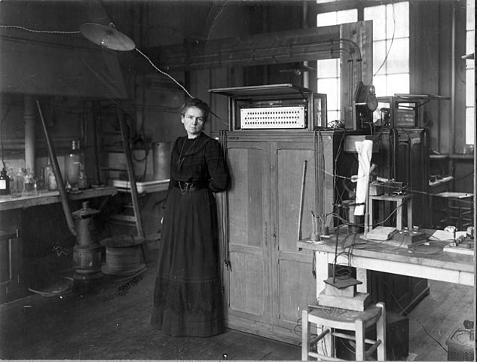

Dr. Curie in her own laboratory, 1911

Marie Curie is probably the best-known female scientist and Nobel Prize winner. Dr. Curie was, in fact, the first person and only woman to win two Nobel Prizes, and in different fields — jointly in Physics in 1903 (for assisting Becquerel’s radiation research), and independently in Chemistry in 1911 (her discovery of radium and polonium). Earning her doctorate and first Nobel Prize in the same year, Curie was truly a remarkable scientist and researcher. One of Curie’s doctoral assessors remarked that her doctoral thesis had contributed more to science than any other they had seen.

Curie’s success was a result of fighting long and hard against many societal expectations of what women should and should not concern themselves with. Marie Curie [almost missed out on her first Nobel Prize](https://arweave.net/JA2g1GQZN51LjfGMfQfBCKBRXlWSypy1uClV007tnOI) due to these societal norms, as she was not originally nominated for the prize along with her husband and their colleague Henri Becquerel. When alerted to the situation, Pierre Curie wrote to the nominating committee alerting them that it would be a “travesty” if Marie was not also jointly awarded the prize. As you know, the committee capitulated and awarded the Nobel jointly to the three researchers, with Marie on equal terms with her colleagues.



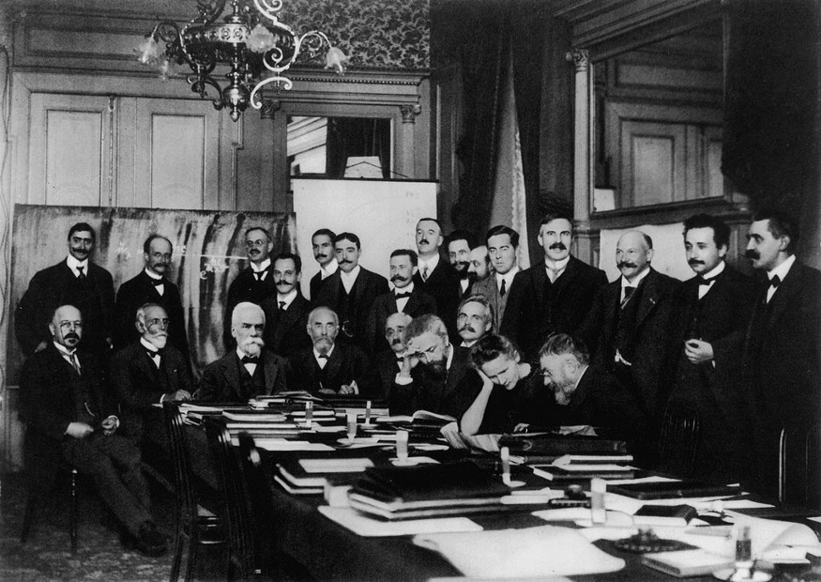

Curie at the 1911 Solvay Conference, pictured with Poincaré, Rutherford, and Einstein, among others.

Curie’s own bravery and dignity in the face of much — often negative — press attention was recognised by Albert Einstein himself. In a [letter to Curie](http://www.openculture.com/2017/12/read-the-dont-let-the-bastards-get-you-down-letter-that-albert-einstein-sent-to-marie-curie-during-a-time-of-personal-crisis-1911.html) following a press scandal regarding her personal life, Einstein informed her that he admired her greatly, and to keep her chin up and ignore her critics as the “reptiles” they were.

Curie continued her work into her final years, especially focusing on lobbying government to increase funding for scientific research. Her lobbying work has been described as follows:

“She could argue fervently, but her appearance alone was the strongest argument. A frail and aging woman dressed in black, already a legendary figure, she had — as one observer put it — the appearance and moral force of a Buddhist monk.” — [Stéphane Lauzanne, editor of La Martin, 1920](https://arweave.net/_wUPk5iqs2nF41Re76kW2UK5oHMvwKb2WxHO63WJsx0)

If you would like to further explore female Nobel Prize winners in the sciences, we highly recommend the [Nobel Prize website](https://www.nobelprize.org/womenwhochangedscience/) itself which offers an array of woman laureates’ stories, and even offers a fun tool matching you with a woman laureate based on your interests!

If you liked this article, consider following us here on Medium, and over on [Twitter](https://twitter.com/The_DPL)! Or, drop [india@decentralisedpubliclibrary.com](mailto:india@decentralisedpubliclibrary.com) a mail with an interesting open data or public domain dataset you’d like us to perma-archive (for free!) or include in a future ‘data spotlight’ blog.

To learn more about the Decentralised Public Library’s mission and motivations, please check out their [opening blog post here](https://medium.com/the-decentralised-public-library/welcome-to-the-decentralised-public-library-38b5cf3ab532).

Written by: India Raybould, Head of the DPL

# Appendix

A list of permaweb URLs for the documents and images contained in this blog post (plus a few extras!):

Votes for Women poster by Hilda Dallas, 1909: <https://arweave.net/OIl0g9SFE7PCbNpN3zw1fp04YyjLF5t0hb2o2-5x7To>

One all-women household boycotts census in protest, 1911: <https://arweave.net/vmjuolR_dFoC1Myy9WTnoimNqdLESrBNT-SyHVHuYf0>

Poster by Alfred Pearce for the Women’s Social and Political Union, 1910: <https://arweave.net/PY06pAqZiFOjzeBjWoD9ofVjAylCQqNO_6ZY1h4MEWA>

Petition for end of force feeding of detained suffragettes and grant of political prisoner status, 1912: <http://arweave.net/ClOgY7_i5ZDp3T_fg504K_cvbTfBd9Wj0vpR2QVelVY>

Austen’s name is notably missing from Sense and Sensibility title page, 1811: <https://arweave.net/qie7FqB_t7wf_OcQYPnbXB6b5SPpaPEv0fHmLzNro4s>

[Not in article] Letter demanding the cessation of force-feeding and the granting of political prisoner status for detained suffragettes: <https://arweave.net/EaGHwhURv0QhhuWfRAtI10asf6Lr7AMxFs-Xtztx70Y>

[Not in article] Poster depicting the force-feeding of American suffragette Alice Paul, 1909: <https://arweave.net/UVMgZCgOKgcW5pwNLi48wdcYB3dw0QvueMoodmey8X0>

UK Government Report ‘Women in Parliament and Government’ 4th March 2019: <https://arweave.net/NtU-mGHrkSZQij4_9BPLl2Tyhydcop-P2CPzlXmGO5I>

Dr. Curie in her own laboratory, 1911: <https://arweave.net/hywT5EIHVEY2ovveimLGzt2IjbdEQOlTSC4oWYApxY0>

Dr. Curie at the 1911 Solvay Conference, pictured with Poincaré, Rutherford, and Einstein, among others: <https://arweave.net/q0guGYtxx-4HkVYijyfPcnXMv7OTKSRu7CvzvG_24e4>

**Jane Austen eBooks**

Sense and Sensibility: <https://arweave.net/jm2qhVPY0zQXjkpdjKgKT-vWqX393jtegPFfxnWB7ww>

Pride & Prejudice: <https://arweave.net/onQlCfKnz2FZeRP6MyKB0DpWVBkmcfmi3rhBRuK6Zog>

Mansfield Park: <https://arweave.net/PPS1G6E-4bs2VHr0OKEutMbvRNMnYA7SM21ED-GAS5I>

Emma: <https://arweave.net/XkkGKjTbPkWGkFJZPzMuxUv37hKAsshT7r1OsiA7-6k>

Northanger Abbey: <https://arweave.net/PRzkp47tvuDbotsZReoM21l7G8G9RlnbktEgSlraea8>

Persuasion: <https://arweave.net/eQfkxTQLk2tOCmvZlZYDjJjKlvC4knZ7PV4L6RpM8ts>

Lady Susan: <https://arweave.net/M8DxhvLCFlBTGQFk14NbBPMmzzGEMdu-C2Xg07whq6w>

The Letters of Jane Austen: <https://arweave.net/pHvKYPHZ6mA_LreICOVhhTq174Kqjy8lTgdi0kxEYlk>

# Arweave Newsletter

[](https://arweave.medium.com/?source=post_page-----6d32d9052597--------------------------------)

[The Arweave Project](https://arweave.medium.com/?source=post_page-----6d32d9052597--------------------------------)

[Apr 2, 2019·3 min read](https://arweave.medium.com/arweave-newsletter-6d32d9052597?source=post_page-----6d32d9052597--------------------------------)

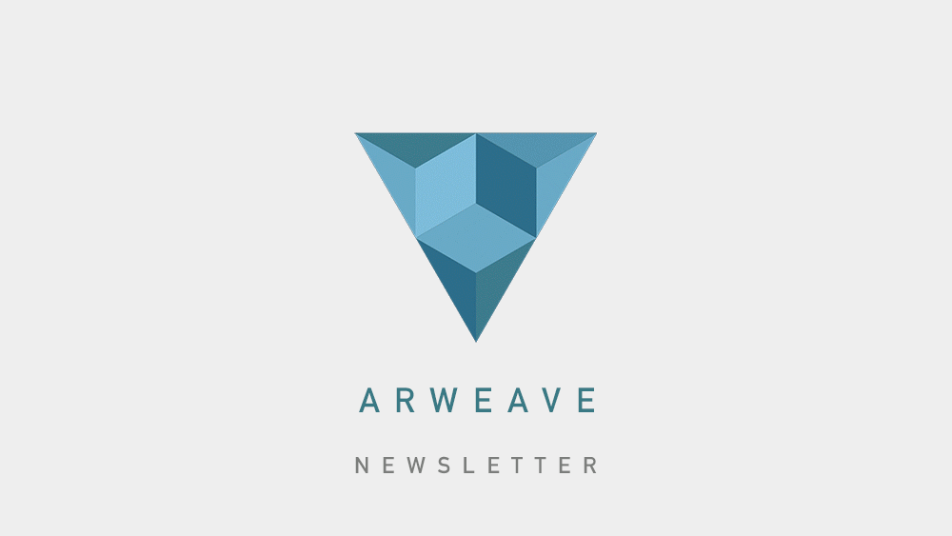

This month the team have been out and about spreading the message of decentralisation and bringing Arweave to even more communities worldwide. Here’s a rundown of what we’ve been achieving!

# ****[Hackathons]****

Watch this to find out more about the Arweave internal hackathon

**Arweave internal hackathon:**

Firstly, we ran an internal hackathon within the Arweave team itself. The idea was to stress-test the dApp developer experience and see how we can improve it for others, in turn accelerating developers’ adoption of Arweave. While doing so, we built a number of cool, fully functional Arweave dApps ourselves, including ‘weavemail’, a decentralised email service! [Click here](https://medium.com/@arweave/hackathon-showcase-part-2-9d792872935a) to find out more and see if you are one of the lucky few who can use weavemail to win some free tokens…

**ETHparis:**

Next, we sponsored [ETHParis](https://ethparis.com/) — an ETHGlobal hackathon — and helped teams compete to build the best brand new, innovative dApps using Arweave for decentralised storage. [Head over to our blog](https://medium.com/@arweave/hackathon-showcase-part-1-4f06f403ce7d) to read more about our findings and see what some of the Ethereum community built!

**On-going: NuCypher virtual hackathon**

After ETHParis, we were very excited to be invited to join NuCypher’s tech stack for their on-going virtual hackathon! Check out our [introductory video](https://youtu.be/YKADcG7xJy4) on how this works now. [NuCypher](https://www.nucypher.com/) is a proxy re-encryption scheme for building a privacy infrastructure for data handling in decentralised applications. If you want to get involved with the community and get hacking an Arweave+NuCypher app, why not check it out [here](https://coinlist.co/build/nucypher). They have a generous grand prize on offer, too!

# ****[Challenges, Competitions & Rewards]****

We are offering **1000 AR** for the best Zapier <> Arweave integration. Check out out our [blog post](https://medium.com/@arweave/build-permaweb-apps-without-code-3-arweave-zapier-tools-you-can-make-in-less-than-5-minutes-e1837f1d3fea) for more details, and to find out what you can build in under five minutes without any code at all.

The first 100 people who send a weavemail will receive 10 AR! Be sure not to miss out, there are loads of weavemails flying around the permaweb already! Find out how to send and receive weavemail in our blog post [here](https://medium.com/@arweave/hackathon-showcase-part-2-9d792872935a).

# ****[Permaweb Adoption Spotlight]****

**Everipedia:**

As you may have heard earlier this month, we recently announced teaming up with [Everipedia](https://everipedia.org/), a wiki-based encyclopedia involving founders from [Wikipedia](https://www.wikipedia.org/) and [Genius.com](https://genius.com/). Everipedia is the largest online English encyclopedia, modernised and re-designed for the digital age; it is similar to Wikipedia except all information is stored and incentivised on a blockchain, without restrictive page creation policies. Arweave will provide the data storage for Everipedia, preserving this vast wealth of information forever on the permaweb. Find out more [here](https://medium.com/@arweave/storing-human-history-on-a-blockchain-arweave-everipedia-c876a6d01cc0).

# ****[Arweave In the wild]****

Come meet us and stay up to date on latest talks from Sam and the team:

Sam, our CEO, recently appeared on the excellent Zero Knowledge podcast, with Parity CTO Fredrik Harrysson to deep dive into decentralised storage, the incentives we harness to achieve this, and much more! <https://www.zeroknowledge.fm/69>

At Token2049 in Hong Kong, Sam presented a wide array of Arweave dApps to a packed crowd. One of these novel dApps was weavemail, the decentralised, immutable email service! You can try this out for yourself today at: <https://weavemail.app/>.

This month Arweave was invited back to Blockchain UA, in Kiev, Ukraine for the third time! There, we showcased how the permaweb can be used to battle for freedom of information in countries where this is currently under threat. We’ll be sharing a video of this talk, so keep an eye out for this soon!

Coming up soon on the 3rd of April, Sam will be speaking at Landing Festival, Berlin, when he will be live coding on the permaweb! Be sure to join us if you can — tickets are still available at the festival website (<https://landingfestival.com/>).

# ****[Upcoming]****

Now you’re up to date with what kind of web applications are being seamlessly built on the permaweb, we’d love to hear what our community has been building, or wishes to build in the near future. If you’ve any feedback on our tools, get in touch at [team@arweave.org](mailto:team@arweave.org)

**-Arweave-Team**

# The Permaweb for Journalists

[](https://arweave.medium.com/?source=post_page-----434d01298614--------------------------------)

[The Arweave Project](https://arweave.medium.com/?source=post_page-----434d01298614--------------------------------)

[Apr 2, 2019·6 min read](https://arweave.medium.com/the-permaweb-for-journalists-434d01298614?source=post_page-----434d01298614--------------------------------)



This is a guest blog post from the [Decentralised Public Library](https://medium.com/the-decentralised-public-library), an Arweave initiative.

Journalism is a crucial tool in any democracy — the work you do is vital in holding powerful individuals, corporations, and governments accountable for their actions. To do this effectively, journalists and fact checkers like yourself rely on a vast array of evidence and documentation, much of it from ephemeral web sources.

However, the methods we rely on for citing and storing web evidence today are deeply flawed. In turn, this can limit the perceived reliability and trustworthiness of the stories you’re telling.

Here, we will explore how these problems can be solved by using the permaweb, and the [Arweave web extension archiving tool](https://chrome.google.com/webstore/detail/arweave/iplppiggblloelhoglpmkmbinggcaaoc) specifically.

# The Problem: Link rot and lost sources

When citing or referencing a piece of information, we typically link to the content with a URL (‘unique resource locator’). URLs on the traditional web simply point your web browser to the location of your web source. However, traditional web links are not truly permanent, and are subject to loss and change at [an alarming rate](https://medium.com/@arweave/link-rot-the-web-is-decaying-cc7d1c5ad48b). When this happens it’s very difficult or even impossible to relocate your web evidence.

When a link ‘breaks’ and no longer points to an active web page, this is known as ‘link rot’. When this happens you’ll often find a [‘404 error’ like this one](https://www.rollingstone.com/politics/politics-news/how-the-new-york-times-sandbagged-bernie-sanders-189129/2/), which ironically I found in this article about online news accountability [here](http://fortune.com/2016/03/16/nyt-editing/).



Link rot is surprisingly common, affecting even the most prestigious media outlets. Just in researching for these blog posts alone, we have found link rot in online news publications from the New York Times, Washington Post, BBC News, the Guardian, and many more. Furthermore, studies repeatedly demonstrate that link rot is surprisingly common in: [U.S. Supreme Court opinions, Harvard law journal articles](https://papers.ssrn.com/sol3/papers.cfm?abstract_id=2329161), [world-renowned scientific publications](https://journals.plos.org/plosone/article?id=10.1371/journal.pone.0115253), [links shared on social media](https://journals.plos.org/plosone/article?id=10.1371/journal.pone.0167475), and even [Library of Congress reports](https://blogs.loc.gov/thesignal/2015/08/cooking-up-a-solution-to-link-rot/).

Link rot may even make it [more difficult for investigative journalists to hold governments accountable for potential war crimes](http://cdn.harvardlawreview.org/wp-content/uploads/2014/03/forvol127_zittrain.pdf).

Of course, when you encounter a 404 error, you can try searching for the content elsewhere on the web (for example with the [Wayback Machine](https://archive.org/web/web.php)), but this is time consuming and definitely not guaranteed to be successful. Ultimately, things can simply be deleted or lost from the web, [despite what some may wish](https://arweave.net/fm69KUk6_o1hWXsE3MqPC4RtX1W-zTZMTnPYBBmzBJQ).

Causes of link rot are varied, including an organisation moving to a new domain name, restructuring their site map, or deleting pages. We explore some of these reasons in more depth [here](https://medium.com/@arweave/link-rot-the-web-is-decaying-cc7d1c5ad48b).

Naturally, your work as a journalist relies heavily on reliable access and linking to web sources. As research has repeatedly shown, traditional web links are simply not resilient enough for you and your readers to rely on.

# The Solution: Use permaweb links

The permaweb is designed to offer a solution to link rot. By using the Arweave web extension, all archived pages are automatically given a truly unique, truly permanent identifier that will never, ever change. This means you can say goodbye to link rot! Here’s an example of a permaweb link with a unique identifier: <https://arweave.net/saYqBP_aEVTlpc62xaCOtWgmVKPdQe566Z5Wiz_kRFs>.

Quite rightly, you might wonder — surely that arweave.net link could rot too? Well, that’s correct, one day far into the future the arweave.net domain might indeed become inaccessible — perhaps we stop hosting it for some reason, or perhaps your internet provider or even your government might restrict access to it. That’s okay though, anyone can set up a new ‘gateway’ domain and use the very same unique identifier (‘saYqBP_aEVTlpc62xaCOtWgmVKPdQe566Z5Wiz_kRFs’, in our example) to access the very same content. This means that these identifiers can outlive the Arweave project itself, indefinitely. Ultimately, this gives the content a vastly longer lifespan and solves link rot not just for ourselves, but for our children and our grandchildren too!

# The Problem: Content drift and changing web pages

As well as ‘link rot’, links on the traditional web can also suffer from ‘content drift’. Content drift is subtly different than link rot, though both have serious negative consequences. With link rot, the original URL no longer functions at all, but with content drift the URL still takes the user to a functioning web page, but the content has changed significantly since it was originally cited. It’s a common problem, too — [one study found](https://journals.plos.org/plosone/article?id=10.1371/journal.pone.0167475) that 75% of scholarly articles suffered from content drift in their references.

The reasons for unreliable, changing content on a web page are numerous, ranging from innocent updates provided to a breaking news article to the more sinister phenomenon of stealth editing. A discussion of how stealth editing can undermine trust in media and journalists can be found [here](https://medium.com/the-decentralised-public-library/do-stealth-edits-jeopardise-trust-in-media-b6960aed9e45).

As you might imagine, content drift can be a major problem when you’re citing web sources to support an investigative journalism piece. Readers will likely be unaware that content drift has occurred, and if the new content doesn’t match the reason for your citation it may give them reason to doubt the accuracy of your reporting.

When you write an important piece of journalism and sink so much of your time and care into it, you need its sources to live just as long as the piece itself — the permaweb can help with this.

# The Solution: Permaweb snapshots of pages

When you archive a page onto the permaweb using the Arweave web extension, it essentially stores a permanent, frozen snapshot of the page’s contents as it was at the time of archiving. This means that you don’t have to worry about the page being lost, its contents changing subtly (or dramatically!), or it being deleted. Your web evidence will remain on the permaweb forever, as it was when you archived it. Just like with link rot, the permaweb offers a genuine solution to content drift that you can rely on.

Once a web page or PDF is perma-archived, it cannot be altered, edited, or otherwise tampered with.

This provides extra confidence and reliability in your vital web evidence. Whether the page was perma-archived yesterday or a year ago, you know with mathematical certainty that what you’re viewing hasn’t changed since it was archived.

# The Problem: Maintaining backups

When trawling the web for evidence or research, one time-consuming challenge can be finding efficient and reliable methods of storing and organising said evidence. Yes, you can store lists of URLs from the traditional, impermanent web, but as we’ve demonstrated they will eventually suffer from link rot and content drift. Alternatively, I’m sure many people print physical copies and/or use your browsers built-in ‘Print to PDF’ function. These copies and a sufficient number of backups then have to be stored somewhere, which can be very inconvenient and unreliable, especially with physical copies.

# The Solution: Lots of automated, permanent backups

The permaweb offers approximately 150 automated backups as standard, and the technology is designed to gradually increase this number over the coming months, years, and generations! Simply put, this means you don’t have to worry about maintaining your own backups! The permaweb will automatically fuel the creation of an increasing number of replications of your backups, with no extra cost to you at all.

So, in summary, the permaweb is a very powerful tool for any journalist. By providing truly permanent links and snapshots of vital web sources to backup your work forever, the permaweb allows future generations to learn from your important work.

**If you want to try out some perma-archiving for yourself, you can do so for free by following the steps in our**[**very beginner-friendly guide here**](https://docs.arweave.org/info/archiving/step-by-step-beginners-guide)**.**

# The Permaweb for Researchers

[](https://arweave.medium.com/?source=post_page-----bd324756a11a--------------------------------)

[The Arweave Project](https://arweave.medium.com/?source=post_page-----bd324756a11a--------------------------------)

[Apr 3, 2019·5 min read](https://arweave.medium.com/the-permaweb-for-researchers-bd324756a11a?source=post_page-----bd324756a11a--------------------------------)

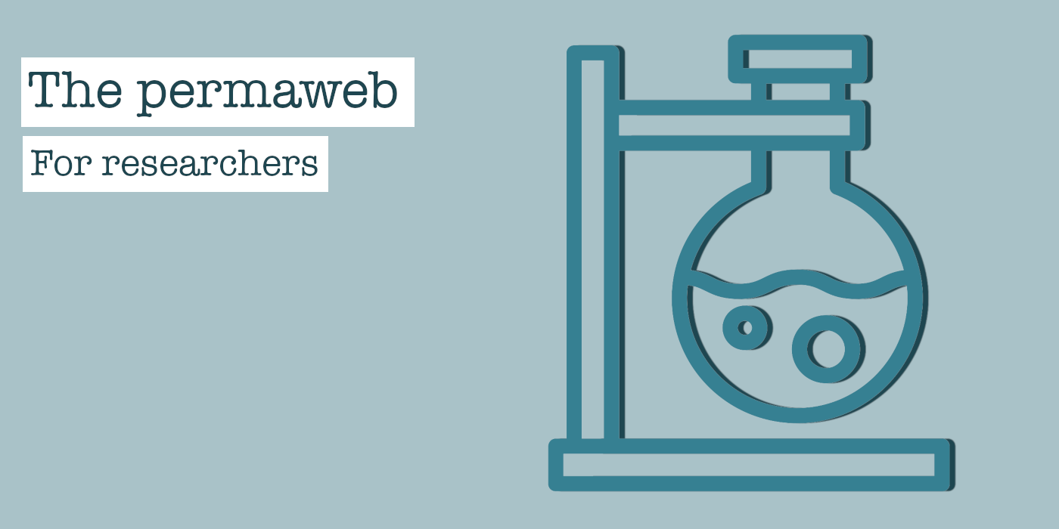

The traditional web has provided a wealth of new opportunities for all researchers and scientists. From accessing new populations for study recruitment, to distributing findings to far greater audiences, the web has been a catalyst for an explosion of knowledge discovery and exchange.

However, there are some significant problems with the methods we use to share, cite, and store web citations and online publications today. In turn, these flaws limit the reliability, replicability and future value of our own research.

Here, we will explore how to solve these problems by using the permaweb, specifically, with the [Arweave web extension](https://chrome.google.com/webstore/detail/arweave/iplppiggblloelhoglpmkmbinggcaaoc).

# The Problem: Link rot and lost sources

When citing a web source in research, we typically simply link to the content with a URL (‘unique resource locator’). URLs then simply point your web browser to the location of your cited literature. However, traditional web links are not truly permanent, and are subject to loss and change at an alarming rate, and when this happens it’s very difficult or even impossible to find the cited evidence or research again.

When a link ‘breaks’ and no longer points to an active web page, this is known as ‘link rot’. When this happens you’ll often find a ‘404 error’ like the one below from the BBC, or if the whole domain is now dead, something that looks a little [like this](https://images.drivereasy.com/wp-content/uploads/2017/08/img_598ea283c6fa9.png), depending on your browser.

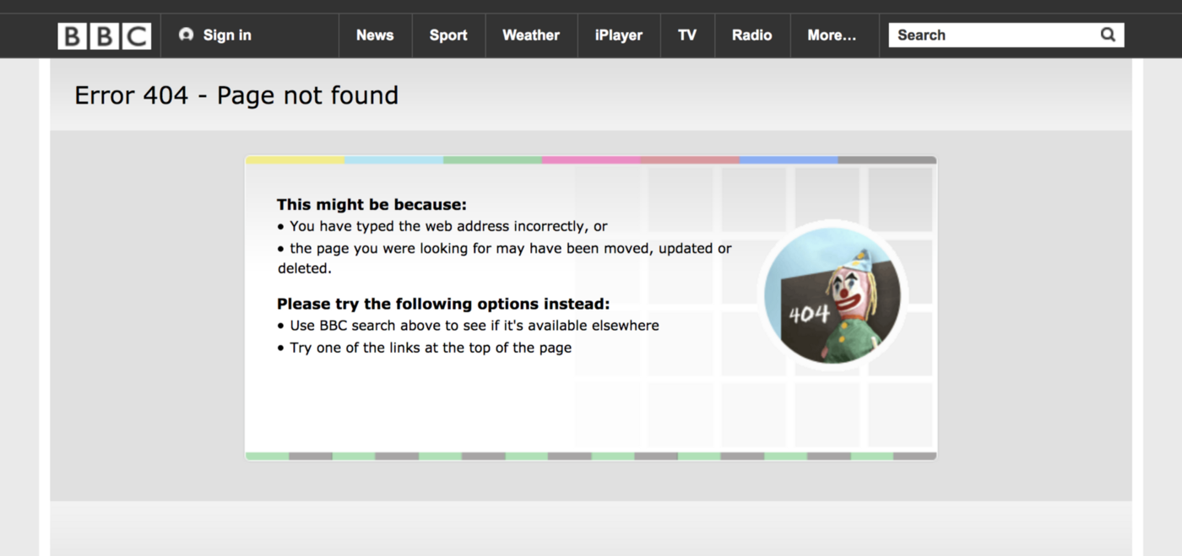

404 errors like this can be a major problem for web citations

Link rot is surprisingly common, affecting even the most prestigious research institutions. In fact, 70% of all scholarly articles have a [reference section containing link rot](https://journals.plos.org/plosone/article?id=10.1371/journal.pone.0115253)!

Although your research is timeless, your web citations will not be —[after 20 years only 1.6% of web links remain functional](https://onlinelibrary.wiley.com/doi/full/10.1002/asi.23561).

The causes of link rot are varied, and can include an organisation moving to a new domain name, restructuring their site map, or deleting pages. We explore some of these reasons in more depth in [this blog post](https://medium.com/@arweave/link-rot-the-web-is-decaying-cc7d1c5ad48b).

As we all know, previous research is the cornerstone of future research. If the vast majority of citations and references rot over the coming years and decades, how will future generations of scientists and researchers ‘stand on the shoulders of giants’?

# The Solution: Use permaweb links

The permaweb is designed to offer a solution to link rot. By using the Arweave web extension, all archived pages are automatically given a truly unique, truly permanent identifier that will never, ever change. This means you can say goodbye to link rot! Here’s an example of a permaweb link with a unique identifier: <https://arweave.net/saYqBP_aEVTlpc62xaCOtWgmVKPdQe566Z5Wiz_kRFs>.

Quite rightly, you might wonder — surely that arweave.net link could rot too? Well, that’s correct, one day far into the future the arweave.net domain might indeed become inaccessible — perhaps we stop hosting it for some reason, or perhaps your internet provider or even your government might restrict access to it. That’s okay though, anyone can set up a new ‘gateway’ domain and use the very same unique identifier (‘saYqBP_aEVTlpc62xaCOtWgmVKPdQe566Z5Wiz_kRFs’, in our example) to access the very same content. This means that these identifiers can outlive the Arweave project itself indefinitely! Ultimately, this gives the content a vastly longer lifespan and solves link rot not just for ourselves, but for our children and our grandchildren too!

# The Problem: Content drift and changing web pages

As well as ‘link rot’, links on the traditional web can also suffer from ‘content drift’. Content drift is subtly different than link rot, though both have serious negative consequences. With link rot, the original URL no longer functions at all, but with content drift the URL still takes the user to a functioning web page, but the content has changed significantly since it was originally cited.

[75% of web links in scholarly writing suffer from content drift](https://journals.plos.org/plosone/article?id=10.1371/journal.pone.0167475).

The reasons for unreliable, changing content on a web page are numerous, ranging from innocent updates provided to a breaking news article, to the more [sinister phenomenon of stealth editing](https://medium.com/the-decentralised-public-library/do-stealth-edits-jeopardise-trust-in-media-b6960aed9e45).

As with all scholarly research, your published work relies on accurate, reliable citations to give your studies transparency and legitimacy — the permaweb can help you with this.

# The Solution: Permaweb snapshots of pages

When you archive a page onto the permaweb using the Arweave web extension, it essentially stores a frozen snapshot of the page’s contents as it was at the time of archiving, immutably. This means that you don’t have to worry about the page being lost, its contents changing subtly (or dramatically!), or it being deleted. Your reference will remain on the permaweb forever, as it was when you archived it. Just like with link rot, the permaweb offers a genuine solution to content drift that you can rely on.

Once a web page or PDF is perma-archived, it cannot be altered, edited, or otherwise tampered with. This provides extra confidence and reliability in your vital references. Whether the page was perma-archived yesterday or a year ago, you know with mathematical certainty that what you’re viewing is the same now as it was when archived.

# The Problem: Maintaining backups

When trawling the web for evidence or research, one time-consuming challenge can be finding efficient methods of storing and organising said evidence.

Yes, you can store lists of URLs from the traditional, impermanent web, but as we’ve demonstrated they will eventually suffer from link rot and content drift. Alternatively, I’m sure many people print physical copies and/or use your browsers built-in ‘Print to PDF’ function. These copies have to be stored somewhere, which can be very inconvenient (and insecure), especially with physical copies.

# The Solution: Lots of automated, permanent backups

The permaweb offers approximately 150 automated backups as standard, and this number is intended to increase steadily over time, many years, decades, and generations into the future. Simply put, this means you don’t have to worry about maintaining your own backups! The permaweb will automatically fuel the creation of an increasing number of replications of your backups, with no extra cost to you at all.

If you want to try out some perma-archiving for yourself and see how it can help your research, you can do so **for free** by following the steps in our very beginner-friendly guide [right here](https://docs.arweave.org/info/archiving/step-by-step-beginners-guide).

So, in summary, the permaweb is a very powerful tool for any researcher. By providing truly permanent links and snapshots of vital web citations to backup your work forever, the permaweb allows future generations to learn from your important work.

**If you want to try out some perma-archiving for yourself, you can do so for free by following the steps in our**[**very beginner-friendly guide here**](https://docs.arweave.org/info/archiving/step-by-step-beginners-guide)**.**

# The Permaweb for Legal Professionals

[](https://arweave.medium.com/?source=post_page-----9c0b4e8a738f--------------------------------)

[The Arweave Project](https://arweave.medium.com/?source=post_page-----9c0b4e8a738f--------------------------------)

[Apr 3, 2019·5 min read](https://arweave.medium.com/the-permaweb-for-legal-professionals-9c0b4e8a738f?source=post_page-----9c0b4e8a738f--------------------------------)

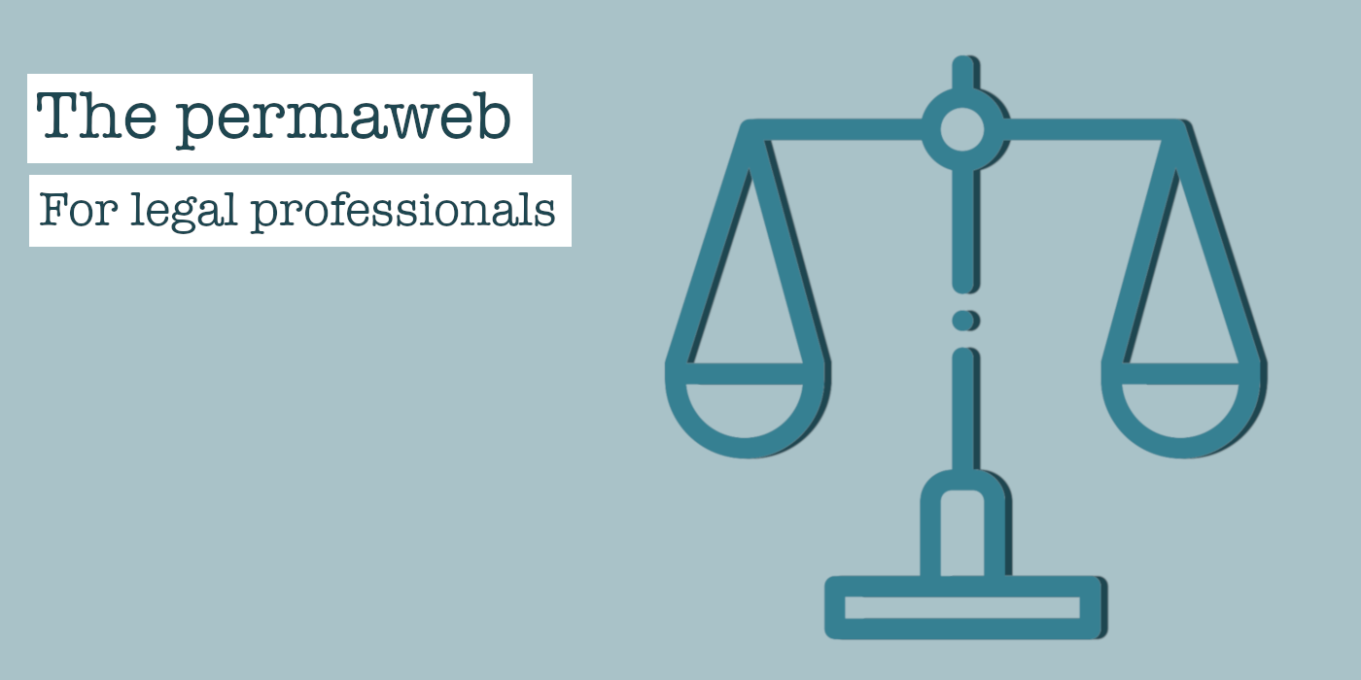

This is a guest blog post from the [Decentralised Public Library](https://medium.com/the-decentralised-public-library), an Arweave initiative.

The traditional web provides a wealth of crucial evidence to those in the legal profession, helping to determine the outcome of cases and the fates of plaintiffs daily, worldwide.

Although today the web is the cornerstone of our justice system, the methods we use to store and reference web evidence today have many flaws. These flaws limit the reliability and trustworthiness of said evidence.

Here, we will explore these problems and explain the solutions offered by the permaweb, specifically, Arweave’s archiving [web extension](https://chrome.google.com/webstore/detail/arweave/iplppiggblloelhoglpmkmbinggcaaoc).

# The Problem: Link rot and lost sources

When citing or referencing a piece of web evidence or research, we typically link to the content with a URL (‘unique resource locator’). URLs on the traditional web simply point your web browser to the location of your web evidence. However, traditional web links are not truly permanent, and are subject to loss and change at an alarming rate, and when this happens it’s very difficult or even impossible to relocate your web evidence.



When a link ‘breaks’ and no longer points to an active web page, this is known as ‘link rot’. When this happens you’ll often find a 404 error like the one above, or if the whole domain is now dead, something that looks a little [like this](https://images.drivereasy.com/wp-content/uploads/2017/08/img_598ea283c6fa9.png), depending on your browser.

70% of Harvard law journal articles and 50% of U.S. Supreme Court rulings [suffer from link rot](http://cdn.harvardlawreview.org/wp-content/uploads/2014/03/forvol127_zittrain.pdf).

Of course, when you encounter a 404 error, you can try searching for the content elsewhere on the web (for example with [the Wayback Machine](https://archive.org/web/web.php)), but this is time consuming and you are definitely not guaranteed to be successful. Ultimately, things can simply be deleted and lost from the internet, despite what [some may wish](https://arweave.net/fm69KUk6_o1hWXsE3MqPC4RtX1W-zTZMTnPYBBmzBJQ). Naturally, when you’re preparing for a case, disappearing web evidence is the last thing you need. You need a reliable, permanent way of storing and sharing online evidence.

Causes of link rot are varied, including an organisation moving to a new domain name, restructuring their site map, or deleting pages. We explore some of these reasons for link rot in more detail [here](https://medium.com/@arweave/link-rot-the-web-is-decaying-cc7d1c5ad48b).

Clearly, if you’re relying on access to web evidence for your work link rot can be a serious roadblock. It’s vital to retain access to your web evidence now and far into the future, given that rulings will impact case law and future rulings potentially for decades.

# The Solution: Use permaweb links

The permaweb is designed to offer a solution to link rot. All pages archived with the Arweave web extension are automatically given a truly unique, truly permanent identifier that will never, ever change. This means you can say goodbye to link rot! Here’s an example of a permaweb link with a unique identifier: <https://arweave.net/saYqBP_aEVTlpc62xaCOtWgmVKPdQe566Z5Wiz_kRFs>.

Quite rightly, you might wonder — surely that arweave.net link could rot too? Well, that’s correct, one day far into the future the arweave.net domain might indeed become inaccessible — perhaps we stop hosting it for some reason, or perhaps your internet provider or even your government might restrict access to it. That’s okay though, anyone can set up a new ‘gateway’ domain and use the very same unique identifier (‘saYqBP_aEVTlpc62xaCOtWgmVKPdQe566Z5Wiz_kRFs’, in our example) to access the very same content. This means that these identifiers can outlive the Arweave project itself indefinitely! Ultimately, this gives the content a vastly longer lifespan and solves link rot not just for ourselves, but for our children and our grandchildren too!

# The Problem: Content drift and changing web pages

As well as ‘link rot’, links on the traditional web can also suffer from ‘content drift’. Content drift is subtly different than link rot, though both have serious negative consequences. With link rot, the original URL no longer functions at all, but with content drift the URL still takes the user to a functioning web page, but the content has changed significantly since it was originally cited.

The reasons for unreliable, changing content on a web page are numerous, ranging from innocent updates provided to a breaking news article to the more sinister phenomenon of stealth editing. A discussion of how stealth editing can undermine trust in media and journalists can be found [here](https://medium.com/the-decentralised-public-library/do-stealth-edits-jeopardise-trust-in-media-b6960aed9e45).

Content drift is a very worrying phenomenon as your case relies on reliable, accurate citations of web evidence for transparency and legitimacy.

# The Solution: Permaweb snapshots of pages

When you archive a page onto the permaweb, it essentially stores a frozen snapshot of the page’s contents as it was at the time of archiving, immutably. This means that you don’t have to worry about the page being lost, its contents changing subtly (or dramatically!), or it being deleted. Your web evidence will remain on the permaweb forever, exactly as it was when you archived it. Just like with link rot, the permaweb offers a genuine solution to content drift that you can rely on.

Once a web page or PDF is perma-archived, it cannot be altered, edited, or otherwise tampered with.

This provides extra confidence and reliability in your vital web evidence. Whether the page was perma-archived yesterday or a year ago, you know with mathematical certainty that what you’re viewing hasn’t changed since it was archived.

# The Problem: Maintaining backups

When trawling the web for evidence or research, one time-consuming challenge can be finding efficient methods of storing and organising said evidence. Yes, you can store lists of URLs from the traditional, impermanent web, but as we’ve demonstrated they will eventually suffer from link rot and content drift. Alternatively, I’m sure many people print physical copies and/or use your browsers built-in ‘Print to PDF’ function. These copies have to be stored somewhere, which can be very inconvenient and unreliable, especially with physical copies.

# The Solution: Lots of automated, permanent backups

The permaweb offers approximately 150 automated backups as standard, and this number is intended to increase steadily over time, many years, decades, and generations into the future.

Simply put, this means you don’t have to worry about maintaining your own backups! The permaweb will automatically fuel the creation of an increasing number of replications of your backups, with no extra cost to you at all.

So, in summary, the permaweb is a very powerful tool for any legal professional. By providing truly permanent links and snapshots of vital web evidence and citations to backup your work forever, the permaweb can help you and future generations in your fight for justice.

**If you want to try out some perma-archiving for yourself, you can do so for free by following the steps in our**[**very beginner-friendly guide here**](https://docs.arweave.org/info/archiving/step-by-step-beginners-guide)**.**

# Avoiding Consumer Lock-ins with the Decentralised Web

[](https://arweave.medium.com/?source=post_page-----c618f28241ab--------------------------------)

[The Arweave Project](https://arweave.medium.com/?source=post_page-----c618f28241ab--------------------------------)

Follow

[Apr 9, 2019](https://medium.com/hackernoon/avoiding-consumer-lock-in-with-the-decentralised-web-c618f28241ab?source=post_page-----c618f28241ab--------------------------------) · 4 min read



This is the third blog post in our series exploring aspects of the Arweave’s decentralised, [permanent web](https://www.arweave.org/). You can catch up with the other parts [here](https://medium.com/arweave-updates/building-the-decentralised-web-part-one-the-problem-9766f1987c91) and [here](https://medium.com/arweave-updates/building-the-decentralised-web-part-two-the-components-97409d1fe545).

If you are like me, you have been an avid user of Google’s Gmail service since the first few months of the ‘private’ beta over a decade ago. Over this time, Google has rendered a fantastic service to us, with consistent releases of new features, fast and reliable service (I can only remember it being offline once when I needed it), and the simplicity that only great products can provide.

Over this period, I have also given out my personal Gmail email address to hundreds of people — many of whom only have this mechanism of contacting me. Google has also sold access to my profile (pseudonymously), mined the messages that my friends and I exchange, and (sometimes inadvertently) exposed my communications to dozens of governments around the world.

When Gmail began, these privacy violations were yet to be enumerated, or even (by me, naïvely) imagined. Yet, very shortly after Gmail was launched I begun giving my friends my Gmail address as the primary source of getting in touch — perpetually attaching myself to a service whose integrity I could not be sure of and perhaps should not have trusted. Google’s advertising and data privacy policies have shifted just as frequently as the [manipulation](https://arweave.net/9meIy81noZ1zKetIbzy7deHQ5dt22Ky7nxcpF8mJ-Ew) of their search engine results. Once I had begun to give this address to my contacts, I (the consumer) was ‘locked-in’ to using the service provided by Google, whatever that might entail, until I informed all of my contacts of a new mail address to reach me at. Even if I had changed provider and burdened all of my friends with the confusion of multiple addresses for one person in their contact list, I could never be sure that this new mail provider would continue to avoid the same practices that led me to switch away from Gmail in the first place.

Such is the way of the centralised web.

# ****Developer and Consumer integrity****

In her [recent blog post](https://www.usv.com/blog/the-distributed-computing-update-3), Dani Grant enumerated the potential effects of ‘developer integrity’ on decentralised technology adoption. Dani’s point is that centralised products and services lack ‘developer integrity’, because they can make sweeping changes in their protocol at a moment’s notice. These changes can cause huge problems for developers, breaking products built on top of these centralised services, in turn disrupting any business they have built around these integrations. Decentralised networks, however, cannot easily or rapidly make such changes, and so have more ‘developer integrity’ as developers can place more trust in their offerings. This increased integrity will therefore accelerate adoption of decentralised technology.

[Permaweb](https://www.arweave.org/) apps apply this concept not just to developers, but to consumers, too. As well as giving developers confidence that their applications will not be shut down or broken without warning, consumers of permaweb apps can also be confident that developers cannot deny access or worsen offerings to end-users. With a permaweb app address, as a consumer what you see is what you always get. This is not to say that developers cannot update permaweb apps — they can — but once published, previous versions of the app cannot be retracted or altered, new versions can only be added to the permaweb.

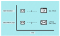

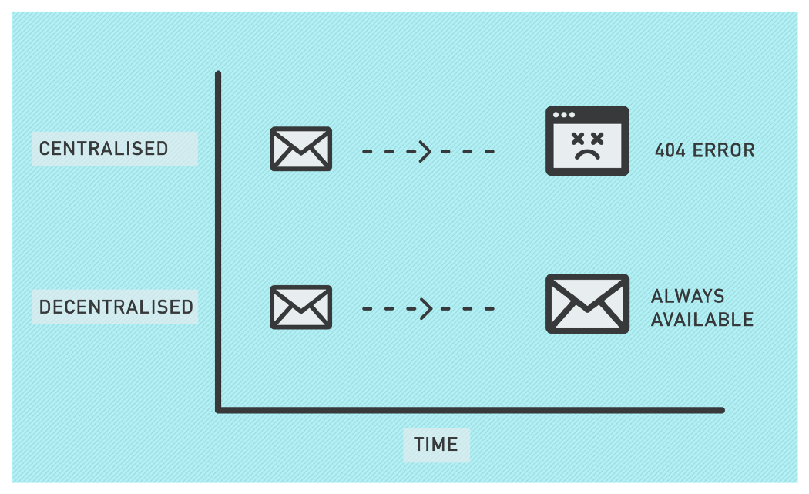

Centralised Vs Decentralised platforms

To make this point explicit, consider [Weavemail](https://weavemail.app/), a service that we quickly hacked together in order to test the limits of the permaweb app development framework that we [recently released](https://medium.com/arweave-updates/welcome-to-the-permaweb-ce0e6c73ddfb). Anyone with an Arweave wallet can use Weavemail to send and receive messages, in a (mostly[1]) private and totally decentralised manner. Because Weavemail lives on Arweave’s permaweb, you can be confident that as long as you know the address of [this transaction](https://arweave.net/z9fqD4pMrNFj-iMJ9k04XbBmMne31sdAv6h9ne1qirQ), and there is an available Arweave node to serve it to you, your access to this mail client as it currently exists simply cannot be denied, or changed.

This means that in future, no matter what we the developers desire, we cannot add intrusive ads to the page, nor sell your data to any interested parties.

With this permaweb address safely bookmarked, you can be sure of the integrity of your access to this service. While this kind of ‘consumer integrity’ may not be useful for all webapps — perhaps we do not care if our access to the ‘[I has a bucket](http://ihasabucket.com/)’ website is changed or denied — this can certainly make a difference for the services with which we entrust our core online presence for long periods of time. It is our expectation that in the same way developer integrity will drive developer adoption of decentralised networks, consumer integrity will drive consumer adoption of decentralised versions of the core web services that we all depend upon.

**Fancy trying out [Weavemail](https://weavemail.app/)? Grab some tokens**[**here**](https://tokens.arweave.org/#/wallet)**and shoot me a mail at vLRHFqCw1uHu75xqB4fCDW-QxpkpJxBtFD9g4QYUbfw. We’re offering 10 AR to the first 100 people to send their first Weavemail!**

All the best,

-arweave-sam

[1] While Weavemail message contents are private, some metadata is publicly available: anyone, anywhere, can track which addresses are sending and receiving Weavemail, and how many characters those messages contain. We do not recommend that you use Weavemail for important communications at the moment, as it is currently just a prototype. Weavemail’s current limitations could be easily overcome by the implementation of a slightly more complex cryptographic protocol. If you are interested in making an improved version of Weavemail, why not [fork the Github repo](https://github.com/ArweaveTeam/weavemail)?

# Decentralised storage: Incentives vs Contracts

[](https://arweave.medium.com/?source=post_page-----b74ee0b7eff1--------------------------------)

[The Arweave Project](https://arweave.medium.com/?source=post_page-----b74ee0b7eff1--------------------------------)

Follow

[Apr 16, 2019](https://blog.goodaudience.com/decentralised-storage-incentives-vs-contracts-b74ee0b7eff1?source=post_page-----b74ee0b7eff1--------------------------------) · 5 min read



**TL;DR:** Contracts for decentralised storage make people feel safer than incentives do, but the statistics tell a totally different story.

One of the questions that we often receive when explaining the Arweave’s proof of access mechanism to people is ‘so the storage of my data is probabilistic? Doesn’t that mean that it can get lost?’. In this post we outline some of the numbers around this issue, and why an incentive based approach (like Arweave) is actually statistically safer in practise than contractual approaches (as taken by most other decentralised storage projects).

# ****Incentive based storage****

In Arweave, miners compete to store as much of the blockweave as they can, in order to receive block and transaction reward pool tokens in the network. The more blocks they store, the higher their likelihood of receiving a reward while mining (more information in our lightpaper [here](https://www.arweave.org/files/arweave-lightpaper.pdf)). In this post we will be referring to the average proportion of blocks that each miner stores as the ‘replication rate’. For example, if we had a blockweave with 10 blocks, of which each miner held 5, we would have a replication rate of 0.5.

Our quest is to find the probability that there exists a block in the network that no single node has access to, at any given time. First, we need to calculate the probability that a given node will have access to a specific block:

P(can_access(node, block)) = replication_rate

Simple enough, but we want the inverse of this — the probability that a given node will not have access to a given block:

P(not can_access(node, block)) = 1-replication_rate

Fine. Now we need to calculate the probability that any given set of nodes does not have access to an individual block:

P(not can_access(nodes, block)) = (1-replication_rate)^count(nodes)

To make this step simpler to digest, let’s imagine a network with 2 nodes and a replication rate of 0.5. From the above, we know that the likelihood of a node not having the data is 50%. We can then see that the likelihood of both nodes not having the data is 50% of 50% — 25%. If we add a third node, this trend continues — 50% of 50% of 50% — 12.5%. When we think about this in terms of the probabilities, we can see that this pattern (0.5*0.5*0.5=0.125) extrapolates to the formula above as we add more nodes.

Next up, let’s calculate the probability that a given block is on at least one node in the network:

P(can_access(nodes, block)) = 1-((1-replication_rate)^count(nodes))

Simple. And finally, the probability that every block in the blockweave is available from at least one node in the network:

P(can_access(nodes, blocks)) =  
 1-((1-replication_rate)^count(nodes))^count(blocks)

Theory aside, here is how the probabilities come out: If we imagine a modestly sized Arweave network with 200 nodes, and a replication rate of 50% and 200,000 blocks, the probability that a single block in that network is not available is 6.223*10^-61 (0. followed by sixty-one consecutive zeroes and a six). In the current Arweave network, the probability of a single block not being available is 4.498*10^-290. Not very likely.

Even if the replication rate were to dramatically drop to just 20% (remember: storage is cheap relative to hashing, so miners are highly incentivised to optimise storage before spending money improving hashing rate) the probability of a single block being unavailable is tiny: 0.000000000000000829.

All of these calculations assume the default Arweave node’s random block selection mechanism. When we move to a more intelligent block selection mechanism in the future, as long as available network storage > weave size (our storage pricing and TX reward pool mechanics take care of this), the probability of data unavailability theoretically drops to zero. In practice however, the probability is much higher that we will accidentally introduce a subtle error into the block selection agent that causes block unavailability, hence our reluctance to do this long before it is necessary.

# ****Contract based storage****

Most other decentralised storage networks take a different approach. In these trustless decentralised networks (Sia, Storj, Filecoin, etc) users create a storage contract with the (potential malicious) miners in the network that specifies a duration and number of replications of the data that the storer desires.

The probability that malicious actors in these contract based networks will be able to withhold or delete your data is quite simple to calculate. We will assume random assignment of storage to the nodes in the network, as is normal.

P(can_perform_withholding_attack) = (unfaithful_actors/(faithful_actors+unfaithful_actors))^replications

In the simple case where we have only requested one copy of the data to be stored in the network, the likelihood that any data can be withheld from us (or deleted) is simply equal to the proportion of bad actors in the network. For each subsequent replication, we need to take into account the likelihood of being assigned all bad actors to store your data (hence the exponential factor).

If we ask for 6 replications of a file in such a network (seems safe, right?), and the network suffers from a 10% bad actor rate, we can see that the probability of an attacker being able to deny access to our file is 0.000001.

This situation becomes worse when one considers that these statistics are only for a specific file in the network. The likelihood that there exists a single file in the network that is susceptible to data withholding attacks like these is of course proportional to the number of files that the network contains. Most contract based storage networks employ a system of collateral to dissuade miners from performing such attacks, however in practice the value of these collaterals are typically far smaller than the true value to the user that would satisfy them if their data was lost — most 1 TB chunks of data are worth more to the storer than the collateral of ~$0.21.

Perhaps the key take away here is not so much that incentives > contracts (although we do think that, too), but that all truly decentralised networks operate on probabilities — and that is just fine. To be clear, we are not attempting to imply that the contract based networks are likely to lose your data — all of the probabilities in this post are exceptionally small — but we do think the probabilities around these networks are interesting and often misunderstood.

**What are your thoughts on incentives vs contracts? Leave a comment below! Try out the Arweave network and grab your**[**free tokens now**](https://tokens.arweave.org/#/wallet)**.**

# Arweave Newsletter: April

[](https://arweave.medium.com/?source=post_page-----686e8ec6e749--------------------------------)

[The Arweave Project](https://arweave.medium.com/?source=post_page-----686e8ec6e749--------------------------------)

[Apr 25, 2019·2 min read](https://arweave.medium.com/arweave-newsletter-april-686e8ec6e749?source=post_page-----686e8ec6e749--------------------------------)



April at Arweave has seen us focus on network updates and community initiatives. Here is the latest:

# ****[Network]****

🎉 Since we last updated you in February this year, the number of nodes in the network has grown by 184%! 🎉

This month we released a new version of the Arweave mining software, which increased the efficiency of mining significantly. The conjoined result of the influx of new miners in the network and the more efficient mining software has raised the average amount of work in the production of each block by over 100 fold — greatly increasing the security of the network.

# ****[Community builds]****

Our awesome community have been busy building apps on the permaweb. Check out some of their integrations:

[**Chronobot:**](https://chronobot.io/arweave/)A visual representation of Arweave network statistics

[built by Discord member: **@tiamat**]

[**WeaveWatcher**](https://arweave.net/5LR3D7IfnKXB5UPAxQ4ggOSCa5PfPJMa2hYXBazwCVc)**:**Generates a preview of new transactions on Arweave

[built by Discord member: **@Mazzz**]

[**Arweave Archiver**](https://twitter.com/ArweaveArchive)**:**Tweets each time a new web page is archived on Arweave

[built by Discord member: **@theoxys**]

[**Arweave Whale Watch**](https://twitter.com/ArweaveWhale)**:**  
Automatically Tweets whenever a large volume of tokens are moved across the Arweave network

[built by Discord member: **@crypto**]

**Wanna get involved? Why not check out**[**our docs**](https://www.arweave.org/hosting.html)**, or**[**get started building**](https://medium.com/arweave-updates/build-permaweb-apps-without-code-3-arweave-zapier-tools-you-can-make-in-less-than-5-minutes-e1837f1d3fea)**a Zapier+Arweave app in less than 3 minutes!**

# ****[Learn more]****





**Hackernoon:**[Avoiding consumer lock-in with the decentralised web](https://hackernoon.com/avoiding-consumer-lock-in-with-the-decentralised-web-c618f28241ab)



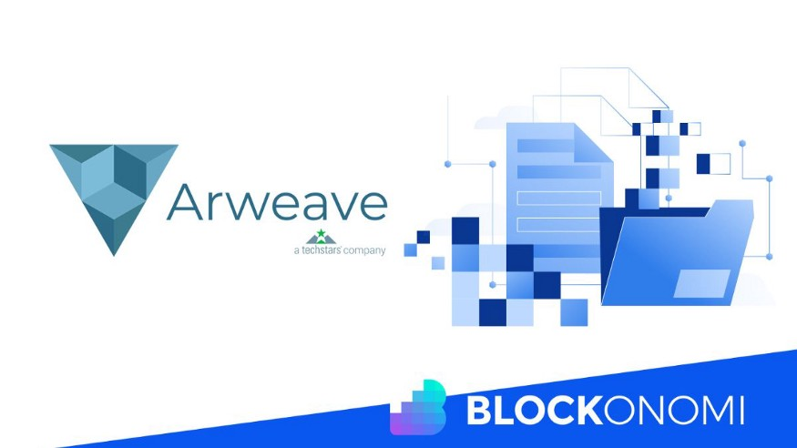

**Blockonomi:**[Arweave permaweb guide](https://blockonomi.com/arweave-guide/)





**Good Audience:**[Incentives vs Contracts](https://blog.goodaudience.com/decentralised-storage-incentives-vs-contracts-b74ee0b7eff1)

# ****[In the wild]****

[Blockchain UA](https://www.youtube.com/watch?v=QAGOGAoTrXQ&feature=youtu.be)**:**Showcasing the permaweb in Ukraine

[Token2049](https://youtu.be/FwV_GdK6cU0)**:**Here, we present a wide array of Arweave dApps

[Loki <> Arweave](https://www.youtube.com/watch?v=2149OiDAP7g&feature=youtu.be)**:**Sam chats to Loki’s Simon Harman about SILO

# ****[Have your say]****

If you have a minute to take part in our [super short survey](https://arweave.typeform.com/to/ZOXgEL?source=med), we’d love to hear more about what you’d like to see from Arweave in the coming months.

As we move towards further community initiatives and adoption of the network in the coming weeks and months, we look forward to bringing you more updates and seeing what awesome projects are being built on the permaweb!

See you on the permaweb:  
**-Arweave-Team**

<https://weavemail.app/> | Address: **vLRHFqCw1uHu75xqB4fCDW-QxpkpJxBtFD9g4QYUbfw**

# Towards an Open Source Web

[](https://arweave.medium.com/?source=post_page-----9ffe201fc044--------------------------------)

[The Arweave Project](https://arweave.medium.com/?source=post_page-----9ffe201fc044--------------------------------)

[May 17, 2019·4 min read](https://arweave.medium.com/towards-an-open-source-web-9ffe201fc044?source=post_page-----9ffe201fc044--------------------------------)



**You can read this blog post directly from the permaweb using Arweave community member benjo’s new permaweb blogging platform,**[**here**](https://arweave.net/egqLRAbESk4BvrPZGwNM-koJZZU3_xYRb_G9-CYCvFs)**!**

**TL;DR**: Arweave’s permaweb enables the creation of a brand new type of web app ecosystem that is not organised around companies, but around open source software. The consequences of this for the new web could be enormous, resulting in a far better user experience for all.

In the early days of general-purpose computers, software was open source by default. Companies and developers sold their code directly to end users, and when you purchased a new computer the code for its software was usually bundled with it. This direct access to open source code allowed savvy users to hack, modify, and upgrade software as they liked.

By contrast, something entirely different happened at the birth of the web: applications were closed by default. While server software has often been open source (Apache, Nginx, etc.), we never had the expectation that the services we use on the web would be open source, too. One of the reasons for this — amongst any others — appears to have been that computation for web services typically happened on servers paid for by the company that ran the service. This computation itself (and the storage, bandwidth, etc. that came with it) was expensive. Subsequently, the developer of a successful web service was pushed to immediately find a mechanism of funding their work — or they would need to shut it down. In practice this has led to web developers either seeking VC funding (who intend to extract value later in the product lifecycle), or heavy monetisation through advertising.

Whichever path the developer chooses, they typically avoid open sourcing their code, in order to protect their ability to fund the ongoing operation of the service.

# An open web

Because the permaweb is cheap to publish to, and in the default model users pay for their own usage (with micro transactions so small they barely notice), major opportunities are presented for open source communities to disrupt the traditional web services market.

When publishing is cheap and developers don’t pay for maintenance, open source web services become possible.

In order to launch an open source web service on the permaweb, developers simply have to submit a single transaction to the network containing their app, then **users can run it whenever they like, indefinitely, at no extra cost to the publisher.** When contrasted with the traditional model, which would require the open source publisher to pay considerable maintenance fees (scaling with usage of the project) each month to keep the service online, the difference is stark.

For example, consider [AskWeave](https://arweave.net/GImMiq_Z2PEiHFIZT-1FgSw2-g2FIpNac2VDP8PMC48), a social question-and-answer application with economic rewards for good responses, built by Arweave community member @Lyner. @Lyner paid a fraction of a penny to store the application, and will never pay another Winston for it. AskWeave’s users can now submit questions for an imperceptibly small fee, and answerers can earn tokens for giving helpful responses. You can find the source code [here](https://github.com/shenwilly/querweave) and make your own fork if you like! You can checkout more awesome open source permaweb apps on the new ArweaveApps site, built by Zeus, one of our Discord community members: <https://arweave.net/35IFq9BcIgpSPti9YDYDiaQy4wMfMIKZ25t7hHZrhek>

Permaweb apps do not have to be open source of course, but we strongly believe that this new, lower barrier for entry will help fuel the development of open source alternatives to existing web services.

The open source philosophy can have the same impact on the new web as it did on early desktop computing: greater competition and openness, leading to greater choices and higher quality for end-users.

# ****Encouraging the open source permaweb ecosystem****

We’re passionate about the opportunities and advantages that an open source web ecosystem brings to users and developers alike. As such, we’re taking two exciting steps to encourage and nurture this novel environment.

**Firstly, we have started a new initiative — a perpetual open web hackathon!**This ongoing hackathon is designed to encourage and reward developers building open source permaweb apps that address real use cases. Read all about the hackathon [here](https://medium.com/@arweave/the-open-permaweb-hackathon-8515c02b8762).

Secondly, as well as using the permaweb to decentralise data storage and access, we are also experimenting with ways that the community can decentralise the ownership of a permaweb app. To demonstrate and play with how this might work in practice, we are turning the governance of weavemail into a DAO (decentralised autonomous organisation). Contributors to the weavemail repositories will receive governance tokens that they can use to vote on whether to accept contentious new features, and how any potential future revenues will be spent. More on this soon…

These are just two starting points for building up the open source ecosystem on the Arweave. What next? Join the discussion on [our Discord server](https://discord.gg/DjAFMJc) and get involved in the open web hackathon!

-arweave-sam

# The Open Permaweb Hackathon

[](https://arweave.medium.com/?source=post_page-----8515c02b8762--------------------------------)

[The Arweave Project](https://arweave.medium.com/?source=post_page-----8515c02b8762--------------------------------)

[May 17, 2019·2 min read](https://arweave.medium.com/the-open-permaweb-hackathon-8515c02b8762?source=post_page-----8515c02b8762--------------------------------)



**You can read this blog post directly from the permaweb using Arweave community member benjo’s new permaweb blogging platform,**[**here**](https://arweave.net/egqLRAbESk4BvrPZGwNM-koJZZU3_xYRb_G9-CYCvFs)**!**

Since we launched the permaweb back in January this year, we have seen just how immensely [powerful](https://medium.com/arweave-updates/hackathon-showcase-part-1-4f06f403ce7d) [hackathons](https://medium.com/arweave-updates/hackathon-showcase-part-2-9d792872935a) can be to bring more people into the Arweave permaweb community and to get new permaweb apps built quickly! We are super excited to continue expanding these efforts (come and see us at ETHNewYork!) but we also want to go further: in-person hackathons are a local phenomena, while crypto and decentralisation are global by their very nature.

We always enjoy meeting community members face-to-face at events like ETHParis and ETHNewYork, but we know that 99% of those in the Arweave ecosystem won’t be able to physically attend. Further, because of the physical nature of in-person hackathons, they incur significant costs like travel, venue rental, catering, on top of sponsorship fees and prizes etc.. This can make in-person hackathons practically inaccessible to many would-be community developers and too resource-intensive for some projects to arrange.

So, we have recently been experimenting with a different approach: a perpetual, [open source permaweb app hackathon via Gitcoin](https://gitcoin.co/issue/ArweaveTeam/Bounties/1/3184). The idea is simple: **Anyone can submit an idea for a permaweb app they would like to build and gain a $250 reward in ETH, as well as $150 in AR, if they build it, launch it, and open source it.** This makes our Arweave hackathon open to everyone, at any time, and substantially more cost effective than traditional hackathons, given the overhead costs associated with in-person events. Hackers can also take their time and build whenever suits them — night owls and early birds included. You can head straight to Gitcoin to check out all of the details [here](https://gitcoin.co/issue/ArweaveTeam/Bounties/1/2929).

We are still experimenting with this approach and will adapt it as things progress, but the initial results are promising. Over 25 people have already applied, and many of those are already working on awesome new open source permaweb apps right now! Check out our new index of Arweave apps, itself a hackathon project running on the permaweb and built by community member @Zeus, for a sample of some of the awesome things people are building: <https://arweave.net/35IFq9BcIgpSPti9YDYDiaQy4wMfMIKZ25t7hHZrhek>

What next? [Come over to Discord and join the discussion](https://discord.gg/DjAFMJc)! We’re looking forward to hearing your ideas and helping you along!

-arweave-team

# Arweave Newsletter: May

[](https://arweave.medium.com/?source=post_page-----9de22fa3700e--------------------------------)

[The Arweave Project](https://arweave.medium.com/?source=post_page-----9de22fa3700e--------------------------------)

[May 27, 2019·3 min read](https://arweave.medium.com/arweave-newsletter-may-9de22fa3700e?source=post_page-----9de22fa3700e--------------------------------)

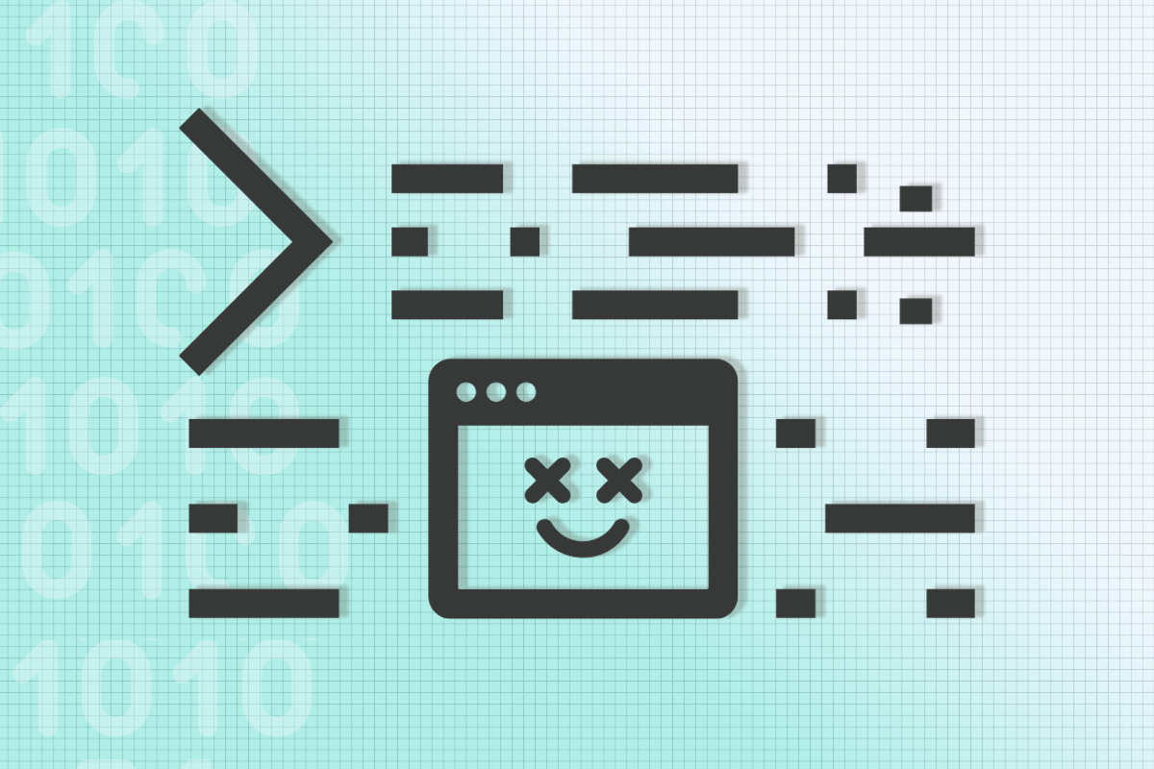

# ****[Open web hackathon]****

This month we saw an explosion of new apps and activity in the permaweb eco system. As an ongoing initiative, we’ve decided to run a [perpetual open-web hackathon](https://medium.com/@arweave/the-open-permaweb-hackathon-8515c02b8762), whereby community members — old and new — can build and submit permaweb apps and gain a hackathon prize. To find out more about our open-web hackathon, head over to our [Gitcoin page](https://gitcoin.co/issue/ArweaveTeam/Bounties/1/2929).

**Here are just some of the exciting apps that we have welcomed in the last month:**

[**Scribe**](https://arweave.net/VOKAC_SYiUzbJrEaIY5SEBh1pf0bGQOd8c7G68nzet4#/) is an article publishing platform inspired by platforms such as Medium andSteemit.

**[built by @Benjo]**

[**Querweave**](https://arweave.net/8VMStbyiUZ54ts9u5xntvcciVlLX5Sf0fWKlVFUa8zg) is a permaweb Quora-like question & answer platform. It is currently looking for a new name, help choose one [here](https://arweave.net/8VMStbyiUZ54ts9u5xntvcciVlLX5Sf0fWKlVFUa8zg?q=4eWxtXxWDM2ISlvE-mMs1HtvwM6UQPtwY6wGhm4lhFc)!  
**[built by @NewestName]**

[**Archive**](https://arweave.net/KFuRkviGbpQdHiPdRRIifmoPnyrvFxjr3sXfrteIl8A)is a permaweb explorer. Find out what other people are archiving right now on the blockweave!

**[built by @Zeus]**

[**EdLock**](https://arweave.net/mbuZApNPM--bUQz4ASwopv43Ohn1_AFO9DmERWy115g) securely time locks your files on the permaweb with threshold encryption and collusion resistant mechanism design.

**[built by @JustMaier, with input from Vitalik Buterin at ETH NYC!]**

[**Arweave ID**](https://arweave.net/fGUdNmXFmflBMGI2f9vD7KzsrAc1s1USQgQLgAVT0W0) is ArweaveID is a permaweb identity service. Claim your permaweb username today, or link up your email address, Twitter handle, ETH address, and Discord ID!

**[built by @NewestName]**

[**Message in a bottle**](https://arweave.net/wKLYLzSKwRgDuq_nuD6ZpZhMlUFH_T6tX-uyOTPvcqQ) stores an encrypted copy of the message you write & publish onto the permaweb. Someday, that encryption will probably be broken — permanently, publicly, publishing your message to the world.Head over to the [ArweaveApps](https://arweave.net/35IFq9BcIgpSPti9YDYDiaQy4wMfMIKZ25t7hHZrhek) index (a permaweb app itself) built by @Zeus and discover all apps published on the permaweb. It’s a great place to start exploring what people are building.

# ****[Community challenge]****



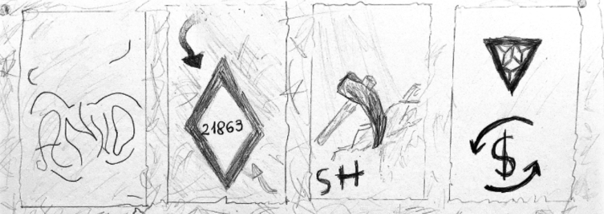

Feeling smart today?! Last week, our long-time community member @Tiamat set a [puzzle](http://arweave.net/byT7l6tkFq8mzqshwmju8fVi1rp8H9mYanlxzsJ7RjQ) on the permaweb, with 1000 AR encrypted inside the page. Within just 8 hrs, the first puzzle was solved, seeing over 200 entrants and dozens of Weavemails sent in search for clues. The second puzzle was solved a day later, and now, **the 3rd puzzle has just been posted**. [Get involved now](https://arweave.net/VLJIGuTJewofKx8ad4JYQs93nEuGnkgjrIt_Sd2QPYw)!

To request clues, drop Tiamat a line on[Weavemail](https://weavemail.app/): **ZQuGMtKrSxMQKw5EWcBQ4khWObI6ajfWmUo1xwTUw2s**

# ****[Network]****

**Since our last newsletter, the number of nodes in the network has grown again, this time by 32%**🚀 Find out how to join them [here >>>](https://docs.arweave.org/info/mining/mining-guide)

# ****[Learn more]****





[**Towards an Open Source Web:**](https://medium.com/@arweave/towards-an-open-source-web-9ffe201fc044)  
Arweave’s permaweb enables the creation of a brand new type of web app ecosystem that is not organised around companies, but around open source software. The consequences of this for the new web could be enormous, resulting in a far better user experience for all.

[**The Open Permaweb Hackathon:**](https://medium.com/@arweave/the-open-permaweb-hackathon-8515c02b8762)  
Since we launched the permaweb back in January this year, we have seen just how immensely [powerful](https://medium.com/arweave-updates/hackathon-showcase-part-1-4f06f403ce7d)[hackathons](https://medium.com/arweave-updates/hackathon-showcase-part-2-9d792872935a) can be to bring more people into the Arweave permaweb community and to get new permaweb apps built quickly!

# ****[In the wild]****

[**Blockchain Brad**](https://www.youtube.com/watch?v=ey7YT7RPgEY)**:** New exclusive interview with Sam discussing all-things Arweave

[**Zero Knowledge Podcast:**](https://www.youtube.com/watch?v=s-d3AJDYIFE)Here, we discuss our novel approach to decentralised storage

[**DPL Youtube Series**](https://www.youtube.com/watch?v=wvL1g_Me59g&list=PL2nQaVnO6V_MEljJcXo7mU-D5zX-pIUuM)**:**Find out more about the Decentralised Public Library

See you on the permaweb:  
**-Arweave-Team**

Got feedback or suggestions? Drop us a line at: <https://weavemail.app/> Address: **vLRHFqCw1uHu75xqB4fCDW-QxpkpJxBtFD9g4QYUbfw**